
Assessment Cover Sheet

Due Date
19-5-2026
Course Code
IT8510
Assessment Title
Project
Course Title
Threat Intelligence and Threat Hunting
Internal Moderator’s Name
Dr. Ayman Alani
External Examiner’s Name
Dr. James Egan
Not must-pass
Group
Uncontrolled
Assessment Type

Instructions:
1. This cover sheet must be completed (section in blue below) and attached to your assessment before submission in hard copy/soft copy.
2. Submit the project report on Sunday, 19-May-2026, before 11:55 PM via Moodle.
3. If an assessment is submitted late, the maximum result the student can achieve is 60% in that assessment. The cut-off time for submitting an assessment will be 3 calendar days after the assessment is due. After this, students will get 0%.
4. Students will have to work in as a group project, and each group can have max four members.
5. Each group must prepare a report and submit it on Moodle. Only the group leader is required to submit the report on behalf of the group.

Programme Title
Learner ID

Date Submitted
20/5/2026
Learner Name
Threat Intelligence and Threat Hunting
IT8510
Abdulelah slais,
Programme Code
Lecturer’s Name
Sehrish Shahid

By submitting this assessment for marking, I affirm that this assessment is my own work.
Learner Signature
Abdulelah slais

Do not write beyond this line. For assessor use only.
Assessor’s Name

Marking Date

Maks Obtained

Comments:

Contents
Introduction 3
Part A 3
Task 1: 3
Task 2: 4
1. VirusTotal 4
2. AbuseIPDB 5
3.AlienVault OTX 6
Part B 8
Task 1: 8
Introduction 8
Task 2 - XDR Detection and Automated Response 18
Attack 1 Evidence Package: SMB Brute Force Detection and IP Blocking 19
Attack 2: Malware Activity Detection and Automated Response (EICAR + VirusTotal) 29
Attack 3: Suspicious PowerShell Activity Detection and Response 42
Task 3 - SOAR Automation Using Shuffle 54
Introduction 54
Task 3 Result 63
Task 4: Threat Intelligence Integration into Wazuh 63
Source 1: VirusTotal 63
Source 2: AbuseIPDB 71
Conclusion 84
References 85
Group Reflection & Peer Review Table 86

Introduction

This project was undertaken as part of the IT8510 Threat Intelligence and Threat Hunting course, where the group members assumed the role of SOC consultants tasked with researching, desiging, and then implementing a functional Security Operations Centre environment. The main platform that was used throughout the whole project is Wazuh, an open-source SIEM solution, which was extended with threat intelligence and threat hunting capabilities to collect, monitor, and analyze security events across multiple systems.
The project is structured across two main parts. Part A covers the design phase, including a full SOC architecture that integrates eight components alongside defined roles and workflows, and also a structured analysis of three external threat intelligence sources: VirsuTotal, AbuseIPDB, AlienVault OTX.
Part B covers the complete technical implementation, which includes deploying and configuring the Wazuh SIEM environment with Windows Server 2022, Bodhi Linux, and Snort IDS as integrated log sources; also simulating and detecting three cyber threats using XDR capabilities, with automated response actions, automation alert-driven responses by using a Shuffle SOAR playbook, and integrating all three threat intelligence sources directly into Wazuh for enriched detection.
The goal of this project is to demonstrate practical competency in deploying a real-world SOC environment that combines threat detection, threat intelligence enrichment, and automated response within a unified security monitoring framework.

Part A

Task 1:
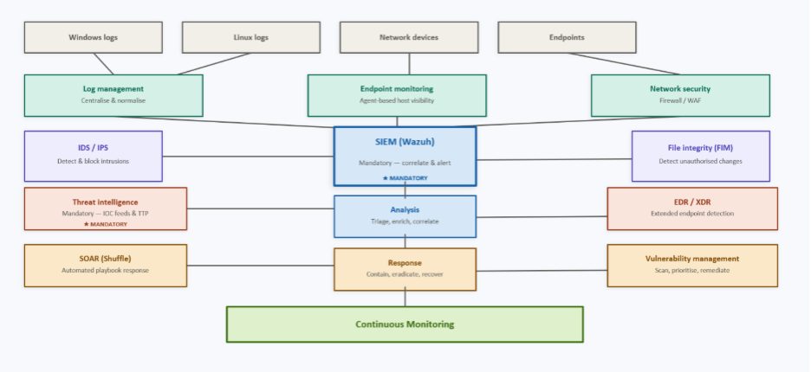
Figure 1: SOC architecture

This SOC architecture is a combination of eight components that span the entire security operations lifecycle. The two components required are the central correlation and alerting engine (SIEM - Wazuh) and the Threat Intelligence, that will provide external IOC feeds and TTP data from VirusTotal, AlienVault OTX, AbuseIPDB, etc.
Supporting components selected are: Log Management (centralizes and normalizes logs from Windows, Linux, and network devices); Endpoint Monitoring (offers agent-based visibility of hosts); Network Security (Firewall/WAF for perimeter security); IDS/IPS (network-level detection/blocking of intrusions); File Integrity Monitoring (flags unauthorized changes to files); EDR/XDR (extended endpoint detection and response); SOAR (Shuffle, for automated playbook execution); Vulnerability Management (continuous scanning and remediation prioritization).
The SOC workflow is a continuous cycle: Data Collection -> Detection -> Analysis -> Response -> Continuous Monitoring and returns findings back to enhance detection rules.

Five SOC Roles:
Role | Responsibilities
SOC Manager | Oversees Operations, staffing, reporting
L1 SOC Analyst | Monitors Alerts and performs initial triage
L2 SOC Analyst | Investigates escalated Incidents
Threat Hunter | Proactively searches for hidden threats
Threat Intelligence Analyst | Curates and operationalizes IOC/TTP feeds

Task 2:

This task talks about the three external threat intelligence sources chosen in details and structured analysis. The sources selected to support SOC operations are: VirusTotal, AbuseIPDB, and AlienVault OTX. For each source, the following will be explained in detail: purpose and overview of the platform, types of intelligence the platform provides, and how the selected source supports SOC operations, including detection, investigation, and response activities, which will include practical examples to demonstrate how the source is used.

1. VirusTotal

1.1 Purpose and Overview
VirusTotal is a free online threat intelligence platform, it is a multiscanner interface created by google. The primary objective of this platform is that it scans files,URLs using different antivirus engines, website security scanners, and blacklist databases to detect potential threats. It acts as a centralized platform that combines data from over 70 different security engines to deliver an overall evaluation on whether the given digital asset, whether a file or link, is malicious or not. By using this platform, it improves the probability of detecting various types of threats, including zero-day attacks and polymorphic malware that might be able to bypass traditional signature-based detection.

1.2 Types of Intelligence Provided
Type of Intelligence | Descriptions
IP Addresses | Reputation, geolocation, ASN, detected URLs, communicating samples.
Domains | WHOIS data, DNS records, subdomains, and related malware/phising indicators.
URLs | Malicious domains, phishing, or suspicious URLS that are assessed against blocklists and scanners.
File Hashes | MD5, SHA-1, and SHA-256 hashes analyzed against over 70 AV engines to determine maliciousness.
Malware Details | Behavior analysis report, sandbox execution results, and YARA rule.
TTPs | MITRE ATT&CK technique mappings in sandbox reports explain how known malware families’ behaviors react to specific tactics and techniques in the ATT&CK framework.

1.3 SOC Application

Threat Detection
When a file is created, Wazuh fires an alert containing a file hash (such as FIM), this hash gets auto-sent to VirusTotal s’ API to instantly determine whether that hash is flagged as malicious or not by any of its detection engines. This enriches the raw alert with actionable threat data, that enables faster triage.
Investigation
During any incident investigations, SOC analysts send suspicious domains, files, or IPs that have been encountered in logs to VirusTotal to claim detailed reports about the investigation submitted such as sandbox results, behavioral analysis, etc. This helps the analysts to further understand the full of a threat without the need for execution malware in a local sandbox environment.
Response
VirusTotal supports controlled decisions. In the case that the file hash has returned to be malicious and confirmed with a high detection ratio, the analysts can immediately escalate to isolation, hash-based blocking via EDR, or firewall rule updates to target specific malicious Ips and domains that have been identified in the report.
Practical Example
A SOC analyst receives a Wazuh alert indicating that a new executable file has been created on a Windows server, that was triggered by FIM (File Integrity Monitoring) rule. The alert sent contains the hash SHA-256. The first thing the analyst does is submit the hash to VirusTotal using API. VirusTotal then returns with 48/72 malicious, which means that 48 out of 72 antivirus engines flag the file as a known ransomware (e.g., Lynx, LockBit). The analyst also receives the associated IP addresses and domains from the VirusTotal report. Having this much evidence from the report and the intelligence, the analyst isolates the endpoint, blocks identified indicators at the firewall and escalates the incident to Tier 3 for full forensic analysis.

2. AbuseIPDB

2.1 Purpose and Overview
AbuseIPDB is a threat intelligence platform that is publicly accessible that is focused on IP address reputation. The main purpose of the platform is it acts as a central blacklist, where users are able to check report histories of any IP addresses to see if it has been associated with harmful actions. The way that this works is different users such as analysts, webmasters, and system administrators use this platform to report IP addresses that engage in abusive behavior, such as spamming, hacking, port scanning, brute force attacks, and other malicious activities.

2.2 Types of Intelligence Provided
Type of Intelligence | Description
Confidence Score | Abuse confidence score (0-100%) reflecting how likely an IP is to be abusive.
Total Report | The total number of abused report that have been filed against an IP by users.
ISP | The Internet Service Provider that is associated with the IP address
Abuse Categories | Attack types classified: port scan, web spam, DDoS, brute-force, hacking,phishing,etc
Geolocation | Information about the geographical location of a specific IP addressInt
Blocklists | Downloadable list of the most commonly reported IP addresses for proactive blocking

2.3 SOC Application

Detection
AbuseIPDB improves Wazuh alerts by adding IP reputation scores to events that involve source IP addresses. When Wazuh detects activity, such as failed login attempt, it can automaticcary asl AbuseIPDB to check whether the IP address has a record of malicious behavior or abusive activities. If the confidence score returns to be significantly high (for example, 80%+), this provides strong evidence of a potential threat activity and elevates the alert severity.
Investigation
During investigations, analysts can examine the full abuse report history of a suspicious IP they have on AbuseIPDB, in this way, they can look at the types of attacks that have been previously associated with this IP, how many different users reported it, and the timeframe that the activity occurred in. This context helps the analysts decide whether an alert represents a targeted attack by a known threat actor from what they’ve seen, or just a random automated scan.
Response
AbuseIPDB intelligence helps guide analysts to response actions. In the case that an IP address is confirmed to be malicious and has a high abuse confidence score, the SOC analysts can automatically act using Wazuh. For example, it can block the IP on the host’s firewall by running an active response script, or by adding the IP to a network-level blocklist via integration with a firewall or web application firewall (WAF).
Practical Example
A SOC analyst notices a Wazuh alert showing 200 failed SSH login attempts within the time period of five minutes targeting a Linux server, and it all comes from the same external IP address.
The first step that happens is that Wazuh automatically checks the IP address with AbuseIPDB to check the history of this IP, and it receives a 95% abuse confidence score, along with more than 1,500 reports from 100+ different users. The reports classify the activity as SSH brute-force attack and port scanning.
Based on the information received, Wazuh triggers an active response rule that will immediately block the IP address on the servers’ firewall by using iptables, which stops the attack in real-time.
Finally, the analysts document the incident and submit a new abuse report to AbuseIPDB to contribute and strengthen the shared threat intelligence database.

3.AlienVault OTX

3.1 Purpose and Overview

AlienVault OTX (Open Threat Exchange) is the world’s first open threat intelligence community which was developed by AT&T Cybersecurity. Its primary objective is to enable global sharing of threat intelligence through a collaborative model where threat researchers and security professionals, analysts, and organizations worldwide contribute over 19 million threat indicators daily known as Pulses. Each pulse represents a malware family or threat campaign and contains associated indicators or compromise (IOCs). OTX allows anyone in the security community to discuss, research, validate, and share the latest threat trends, data, and techniques, which help one another strengthen the cyber defenses and helps also raise awareness of emerging threats globally. OTX provides a free API and supports direct integration with Wazuh through threat feed ingestion, which makes it one of the most feature-rich and freely accessible threat intelligence sources available to SOC teams.

3.2 Types of intelligence Provided
Type of Intelligence | Description
IP Addresses | Ips that have been used as source/ destination for servers suspected of malicious activity.
CVE | Standards-based identification of common vulnerabilities and exposures that are linked to threat pulses
Domain | Domain names that are suspected of hosting or engaging in malicious activity, which may also include a series of hostnames.
File Hashes | MD5, SHA256, SHA1. Hashes used to identify whether a file is malicious or not, it is often used to identify malwares such as trojans, viruses, ransomware, etc.
Mutex | Mutual Exclusion Object. A mechanism used by malware to detect whether a system has already been infected.

3.3 SOC Application
Detection
Wazuh integrates with AlienVault OTX to make it possible for the system to compare the telemetry information with threat intelligence feeds, allowing user to detect potential threats based on the latest threat intelligence data. Whenever a Wazuh alert includes and IP address, domain name, or file hash, it is compared against OTX IOCs, flagging any matches as malicious.
Investigation
If any IOC is discovered for a particular domain or indicator, the alert generated contains information that can help further analyze the IOCs found, giving the analyst additional threat context, such as the associated pulse, threat actor, and related indicators.
Response
A Wazuh alert triggered by an OTX IOC will result in the activation of an active response script, enabling automation for actions like blocking a malicious IP address or isolating an affected host.
Practical Example
A SOC analyst receives an alert through Wazuh regarding a Windows endpoint where Sysmon Event ID 22 triggers on the agent, meaning that the endpoint performed a DNS query to an unfamiliar domain. Wazuh identifies the queried domain as one that has never been seen before within the organization and triggers an alert, which automatically triggers an active response script on the agent to perform an API call to AlienVaultOTX with the queried hostname as a parameter. OTX then confirms the domain as a match and identifies it as an IOC in an OTX pulse. The alert generated contains relevant information about this malicious IOC, including its associated threat campaign, IP addresses, and the pulse that flagged it. With all this information, the analyst can immediately find out which endpoint connected to this malicious domain, review related IOCs from the same pulse to check for further exposure across the network, and take containment actions such as blocking the domain at the firewall level.

Part B

Task 1:

Introduction
The purpose of this task was to deploy centralized SIEM via Wazuh. To achieve this, various agents were integrated into several systems including Windows Server 2022, Bhodi Linux, and snort. Using these machines, the host, server, and network monitoring were provided. Agents were deployed and tested in the Wazuh dashboard to ensure they were communicating with the Wazuh manager. After integration, attacks were simulated from Kali Linux, such as brute force, port scanning, and ICMP attacks. This resulted in events that were logged and monitored in Wazuh, demonstrating the capability to aggregate logs and identify threats. This report's screenshots demonstrate the deployment of agents, log collection, and detection of attacks, meeting the criteria for Part B Task 1.

- Wazuh Deployment
Wazuh was deployed using the OVA appliance. The OVA stores the Wazuh Manager. Wazuh Indexer, and Wazuh Dashboard into a single machine ensuring all components were configured and compatible with the version being used.
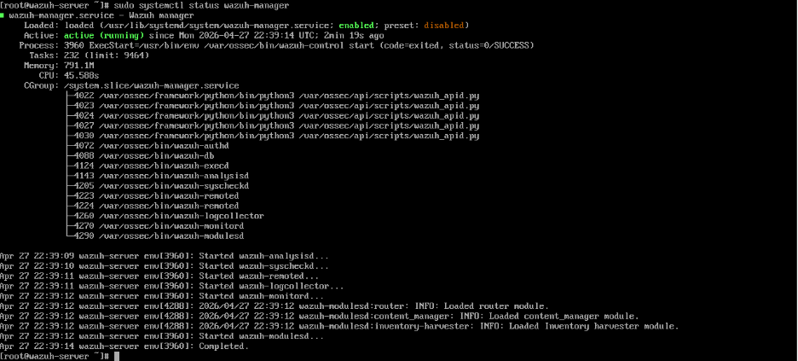 Figure 2
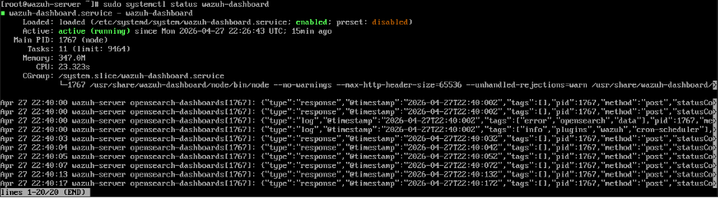Figure 3
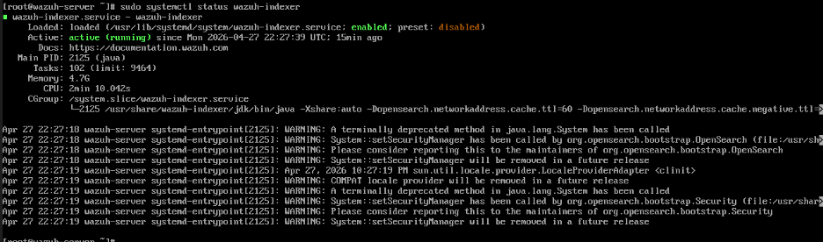
Figure 4

Figures 2,3,and 4 verify that the Service Status is active and running.

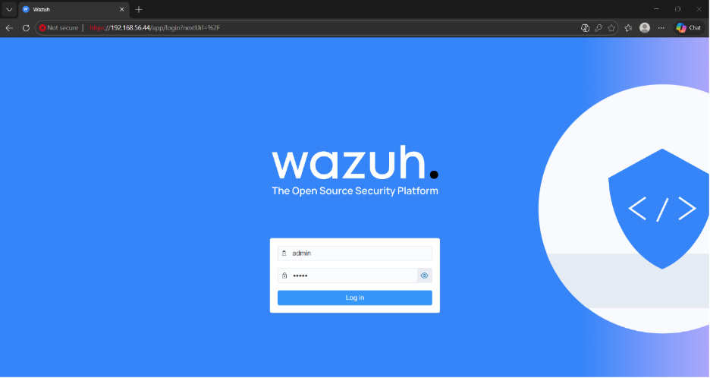
Figure 5: shows that the Wazuh Dashboard is running and accessed via the HTTPS web interface.

- Agent and Log Source Integration
During this process, T=three log sources were integrated into the Wazuh Manager: Windows Server (2022), BodhiLinux, and Snort IDS running on BodhiLinux via syslog. This section documents this process.
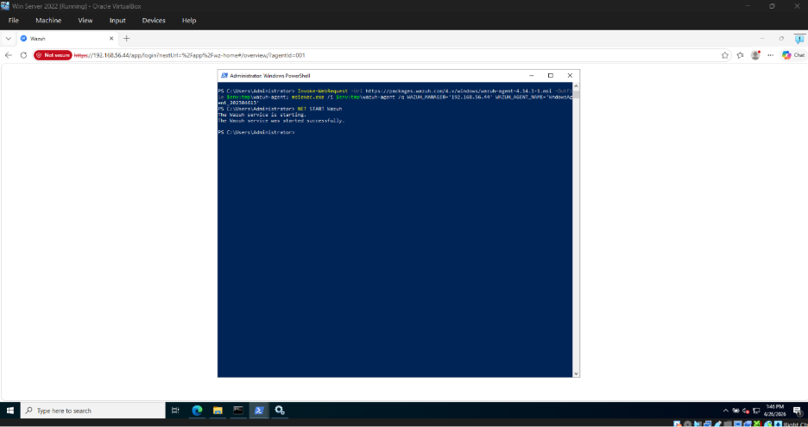 Figure 6: shows the installation of the Agent on Windows Server 2022
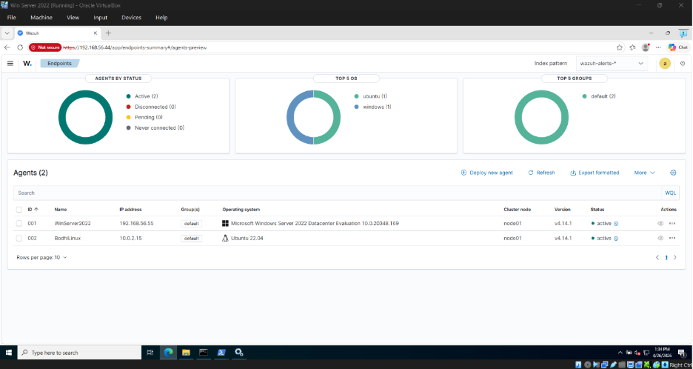Figure 7: the installed agent on Windows Server is shown in Wazuh dashboard
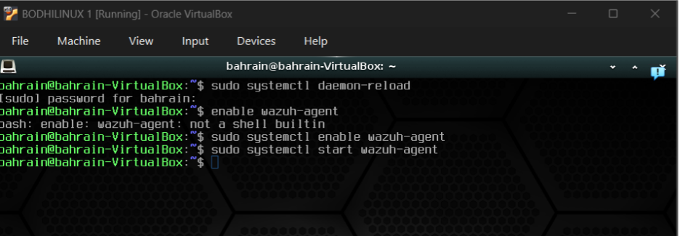Figure 8: Shows that the wazuh agent is enabled and started in Bodhi Linux using systemctl.

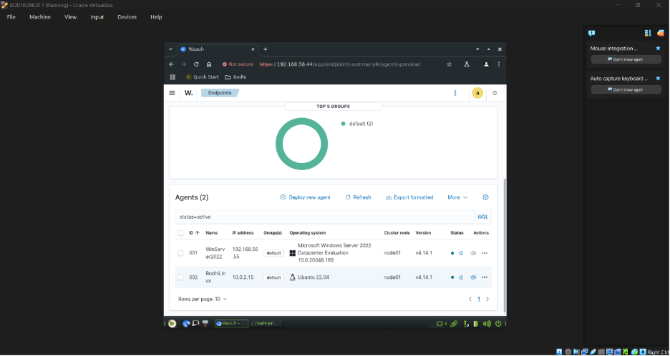Figure 9: verifies that the agent is active and running.

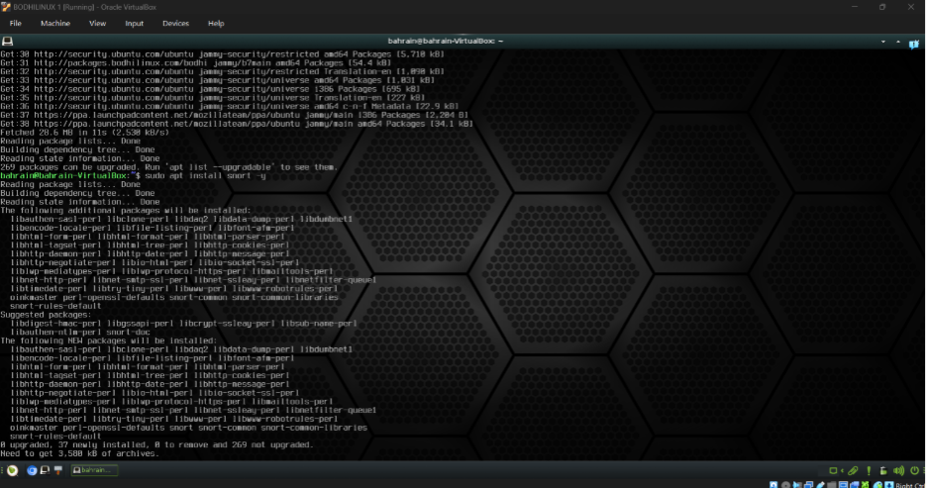Figure 10: shows that snort is installed on BodhiLinux via apt package manager.

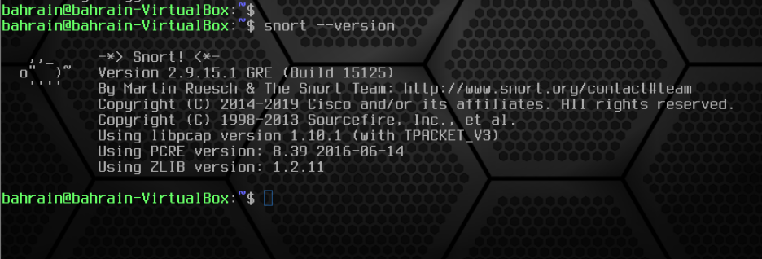Figure 10: confirms that snort has been installed on BodhiLinux.

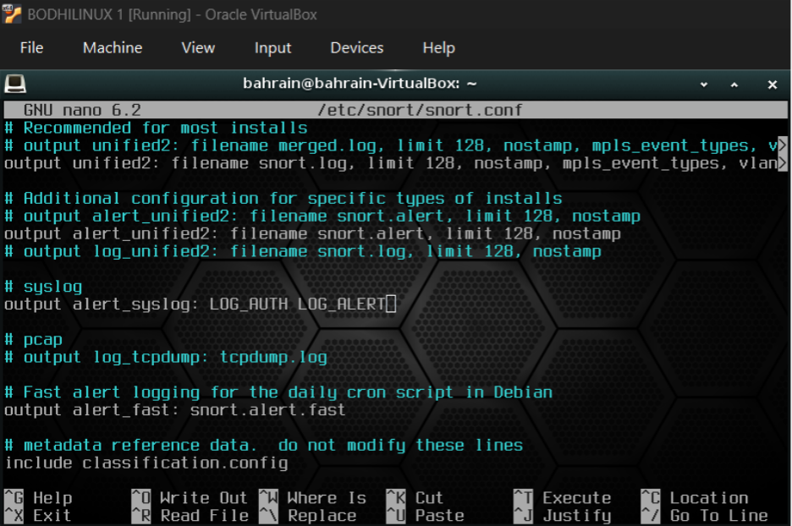Figure 11: Snort output plugin has been configured.
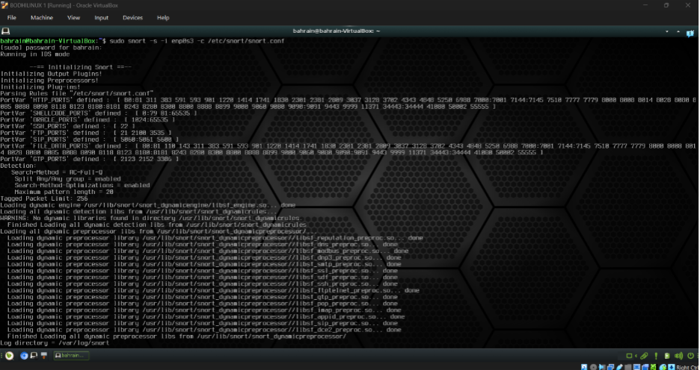Figure 12: Shows Snort initializing IDS mode on Bodhi Linux.

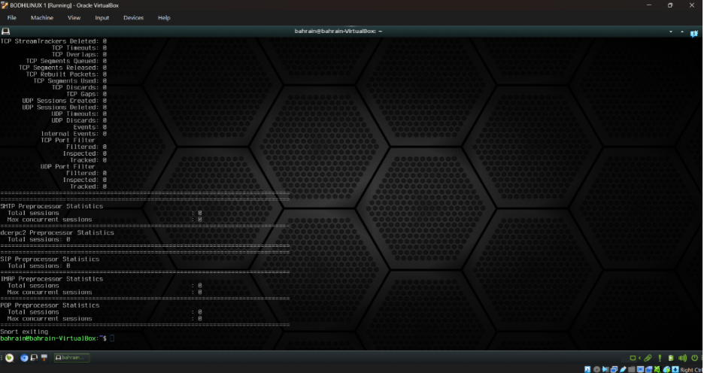Figure 13: Confirms a successful IDS session.

- Log Collection and Event Verification
This section ensures that the agents and syslog integration are running correctly as all logs from all resources were successfully received and stored by Wazuh.
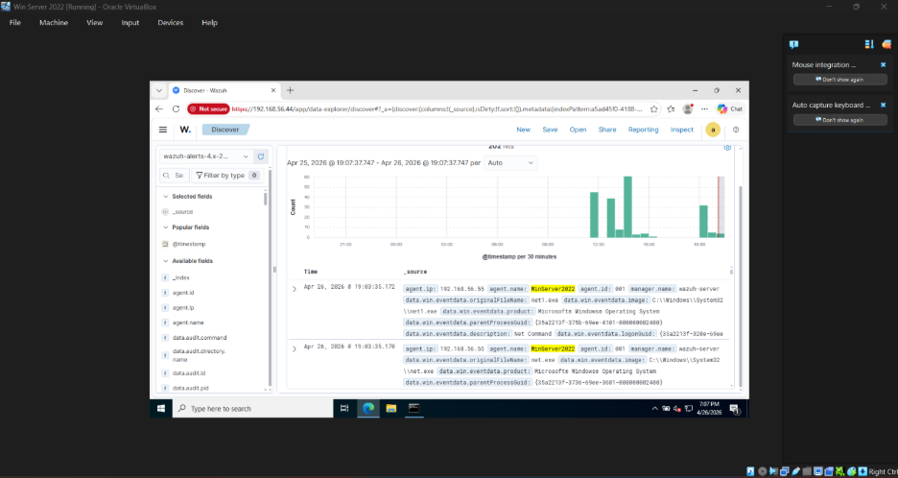Figure 14: shows the Windows Server Event Logs in Wazuh Discover.
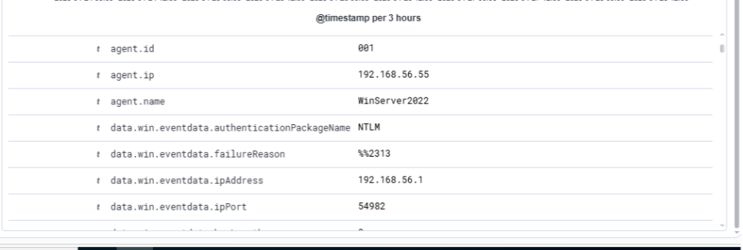 Figure 15: Shows a detailed log from event ID 4625
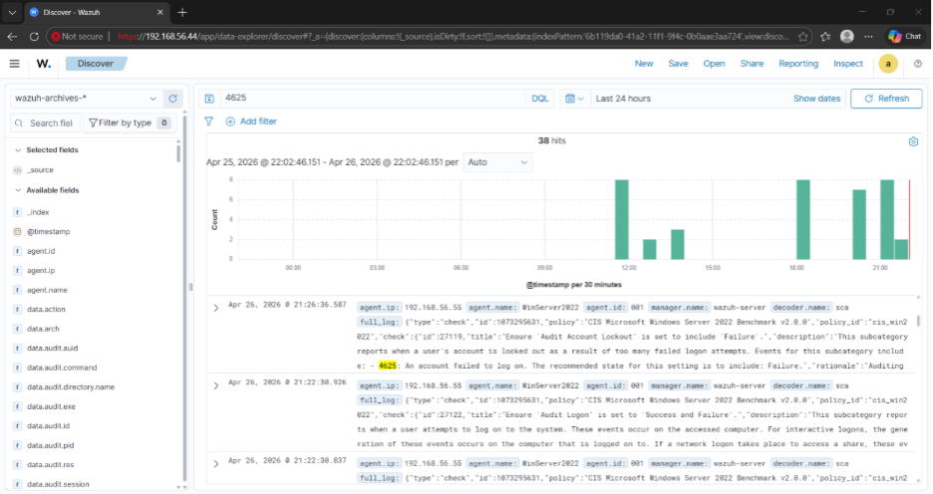Figure 16: Shows 38 hits for Windows Event 4625.

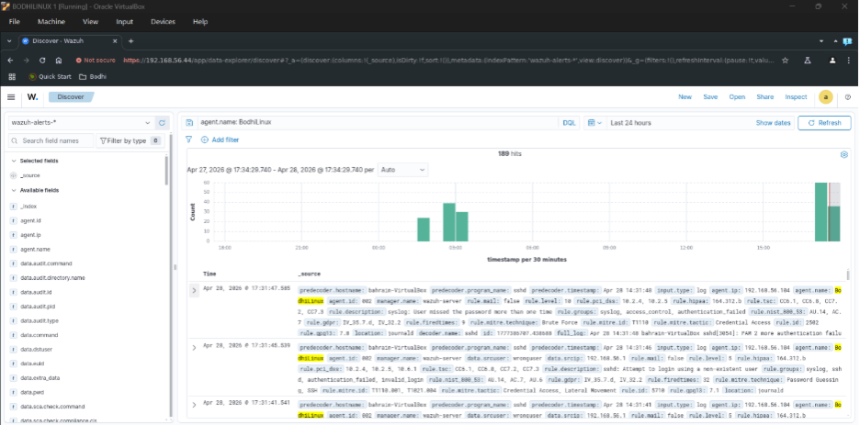Figure 17: Shows BodhiLinux agent events in Wazuh discover with 93 hits.

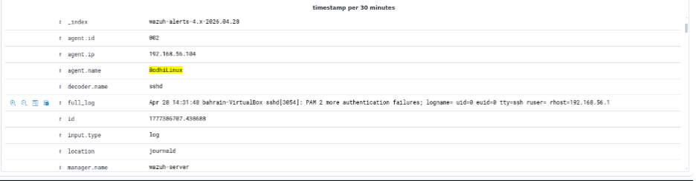Figure 18: Shows expanded Bodhi Linux SSH authentication failure event detail.

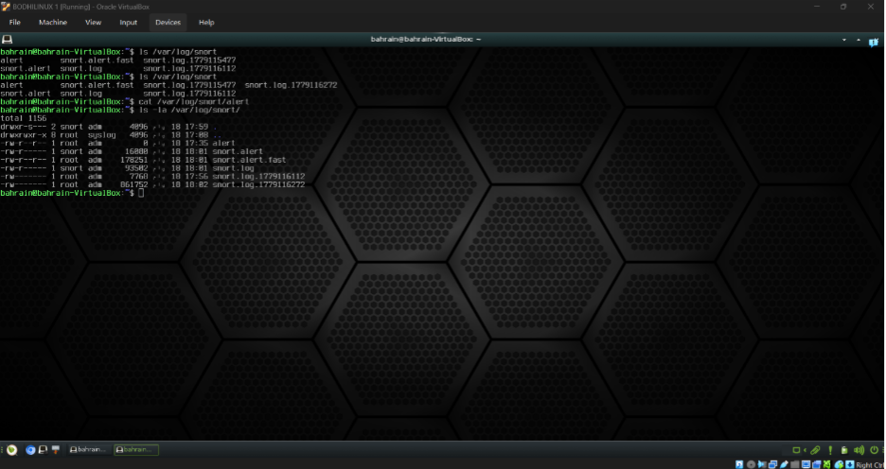Figure 19: Shows the snort log directory on Bodhi Linux confirming alert and packet capture files.

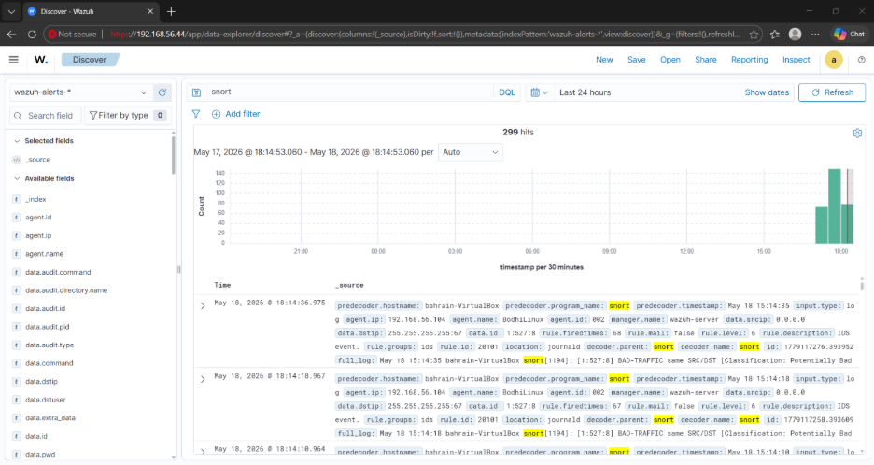Figure 20: Shows Snort IDS alerts on wazuh discover with 299 hits.

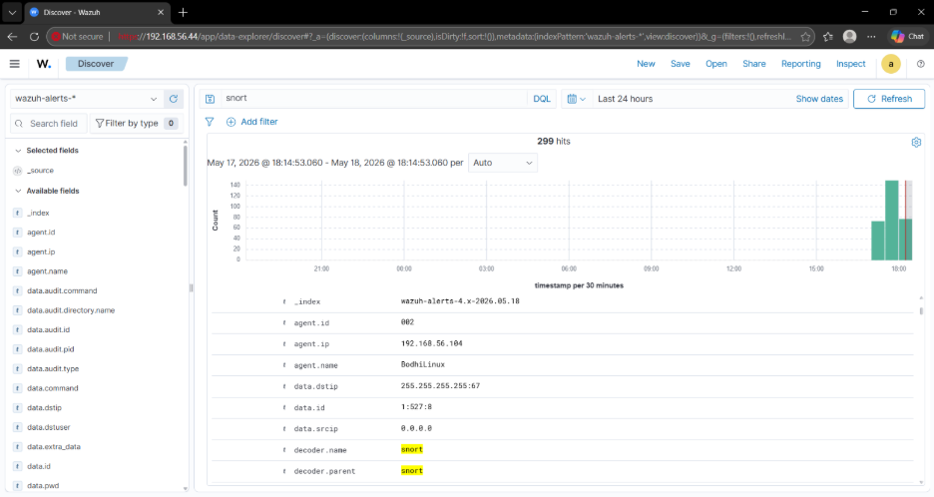Figure 21: Shows a detailed snort IDS alert event confirming successful login into Wazuh.

- Event Generation
Using Kali Linux, security events were generated against all three integrated systems to validate that Wazuh could detect and log a real attack activity such as ICMP ping sweeps, SSH brute force attempts, SMB credential attacks, and Nmap port scans.

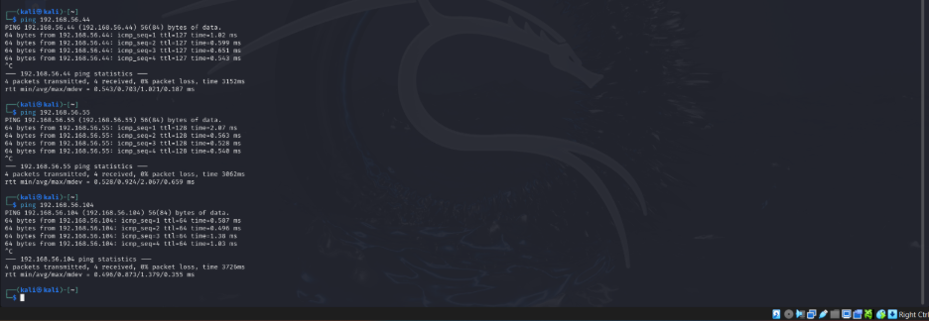Figure 22: Kali Linux pinging all target systems confirming full network reachability.

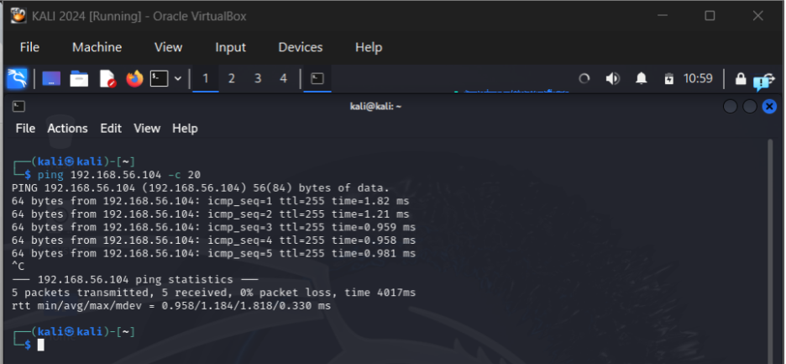Figure 23: Shows Kali flooding ICMP packets to BodhiLinux triggering Snort IDS alerts.

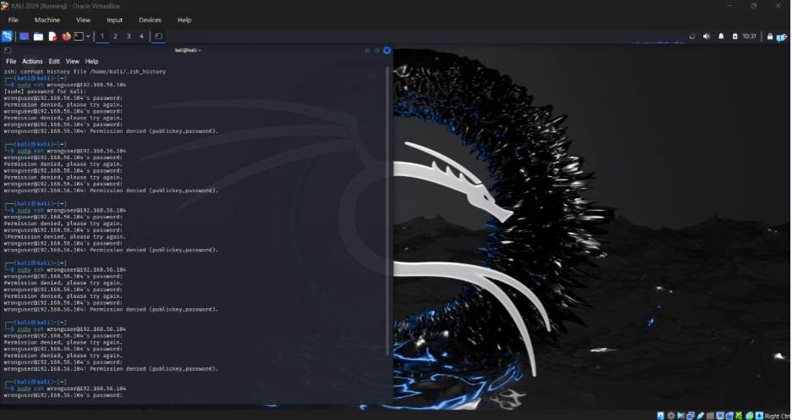Figure 24: Shows repeated SSH login attempts against Bodhi Linux.

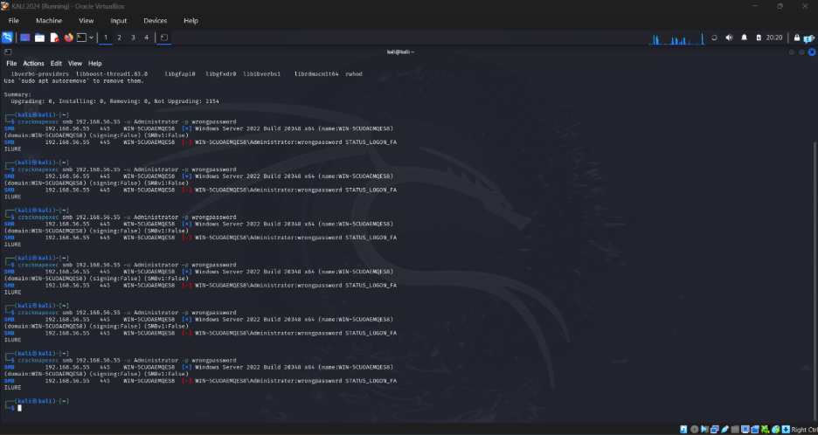Figure 25: Shows failed SMB attempt against Windows server.

Task 2 - XDR Detection and Automated Response

Introduction
The current assignment involves the implementation of Extended Detection and Response (XDR) via Wazuh. There were three different cyber attacks that were performed and identified: SMB brute force attack, malware detection with VirusTotal and EICAR, and suspicious PowerShell command execution via Sysmon. Detection for each one was set up, events were identified, and the response was implemented successfully and proved by evidence.
Implementation Summary
Attack | Detection Rule | Logs / Event IDs | Response Action | Result
Attack 1: SMB Brute Force. | Custom rule Wazuh rule 100100 derived from failed login rule 60122. | Event ID 4625 for Windows Security ; Source IP is 192.168.56.105, Target User Administrator. | Block Windows Firewall inbound for Kali IP for ICMP/SMB | Resultant: Attacker traffic blocked; Ping responded to 100% packet loss on SMB port 445.
Attack 2: Malware / EICAR with VirusTotal | Rule FIM 554, Rule VirusTotal 87105, Result rule Active Response 100092, Deletion rule 553 | FIM File Added rule 554; VirusTotal Malicious Detection rule 87105; Active Response rule 100092; File Deleted rule 553 | remove-threat.exe Active Response removed the detected file | Successful: Test-Path returned False for eicar.txt
Attack 3: Suspicious PowerShell | Wazuh custom rule 100900 for Sysmon event id 1 with PowerShell -nop parameter | Sysmon event id 1 ; Image and command line fields of powershell | Block from Windows firewall outbound connection to powershell.exe | Successful : Test-NetConnection reported TcpTestSucceeded

Document Structure

The following attacks consist of all three completed attack packages. The attack package contains information on threat simulation, rule set up, Wazuh dashboard response evidence, logs/event ID numbers, response set up, and evidence of validation to follow the Task 2 rubric.

Attack 1 Evidence Package: SMB Brute Force Detection and IP Blocking
Objectives: In this part, an example of an attack through XDR will be presented in Wazuh. A brute-force attack will be created using Kali Linux towards Windows Server 2022 through SMB authentications. The detection of repeated failed logins is made through a rule on Wazuh, while the blocking is done through the Windows Firewall.
Attack 1 Rubric Mapping
Rubric Requirement | Evidence in This Section | Key Screenshot(s) | Status
Threat Simulation & Detection. | SMB login failures were created by Kali and Wazuh created a custom event with ID 100100. | Figures 32-33 | Successful
Detection Rule Configuration | The Wazuh rule with ID 100100 was set up on local_rules.xml. | Figure 30 | Successful
Logs / Event IDs | Windows Security Log event ID 4625, source 192.168.56.105, and targeted username Administrator. | Figures 34-36 | Successful
Response Configuration | Windows firewall inbound rules filtered traffic from Kali to Windows SMB port TCP/445 and ICMP. | Figure 37 | Successful
Result Validation | Kali ping resulted in 100% packet loss; Nmap reported TCP/445 filtered. | Figures 38-39 | Successful

Environment and Agent Identification
Purpose: The name of the Windows Wazuh agent has been changed to incorporate the student ID such that the Wazuh dashboard proof will belong to this implementation. The old disconnected agent should be disregarded since the new one is registered.
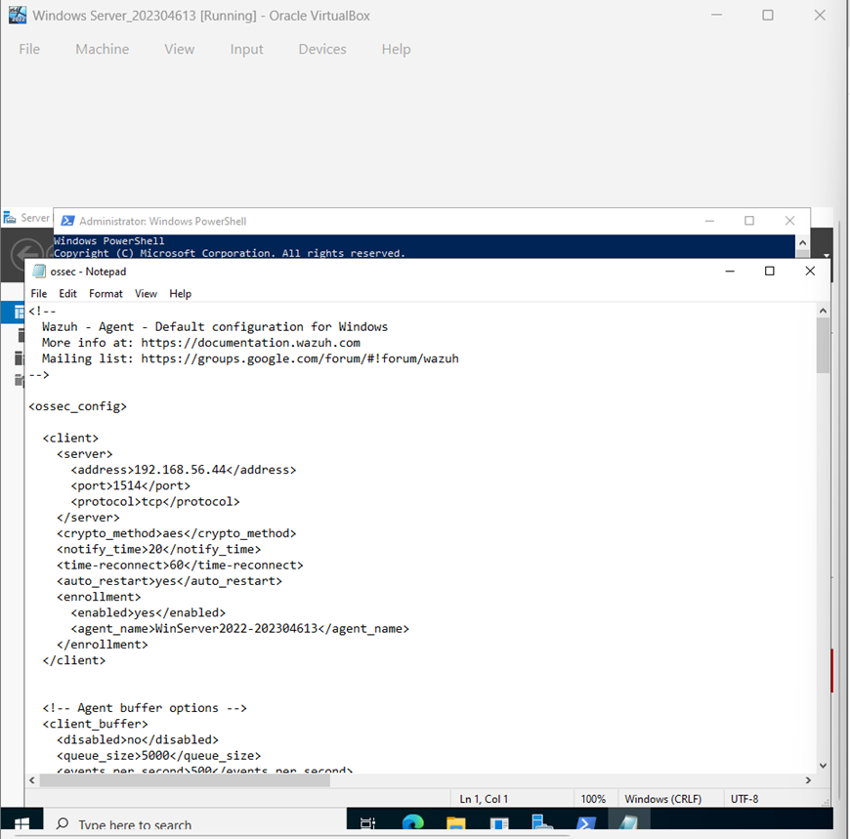
Figure 26: Windows Wazuh agent configuration showing agent_name WinServer2022-202304613.
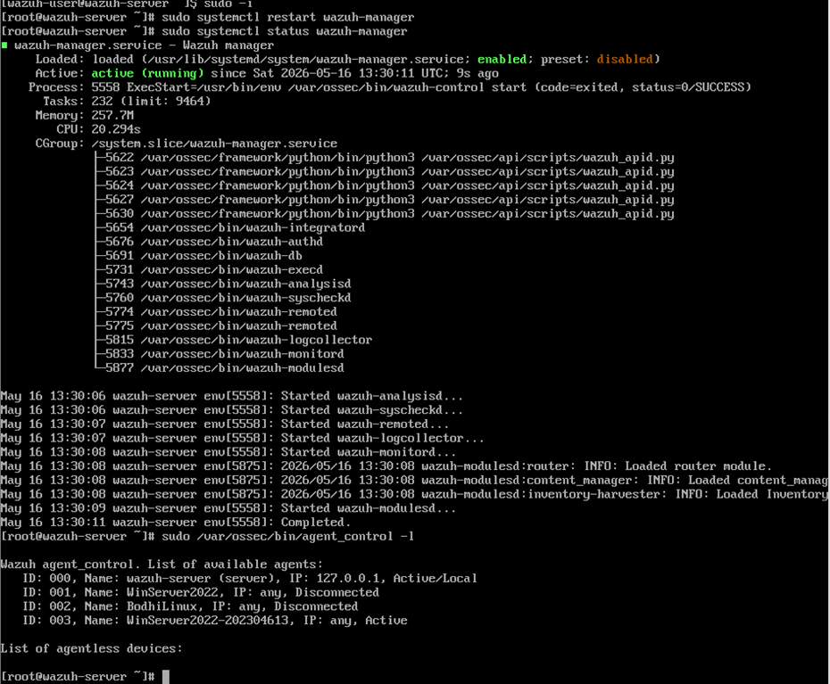
Figure 27: Wazuh server agent list showing WinServer2022-202304613 as an active agent.
IP Address Verification
Windows Server acted as the target machine, while Kali Linux was the machine used to carry out the attack. The connection between the two systems was established prior to performing the brute force attack.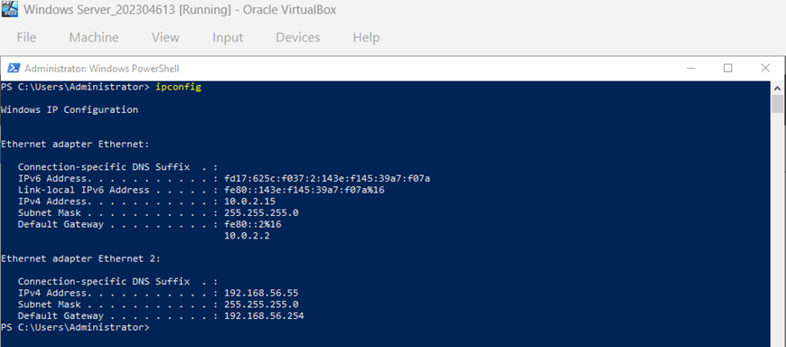
Figure 28: Windows Server target IP address 192.168.56.55.
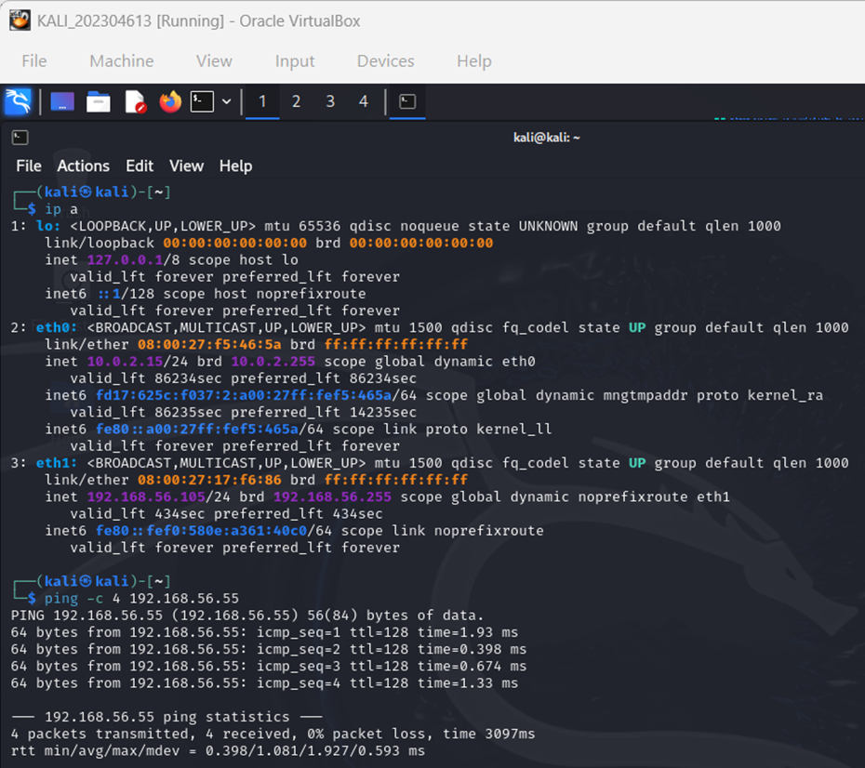
Figure 29: Kali Linux IP address and successful connectivity test to the Windows Server before the attack.

Detection Rule Configuration Evidence
Rule used: The custom Wazuh rule with the ID 100100 was customized to detect multiple occurrences of Windows failed logon attempts. The alert message is ("Possible SMB Brute Force Attack Detected"), while the alert level is 10.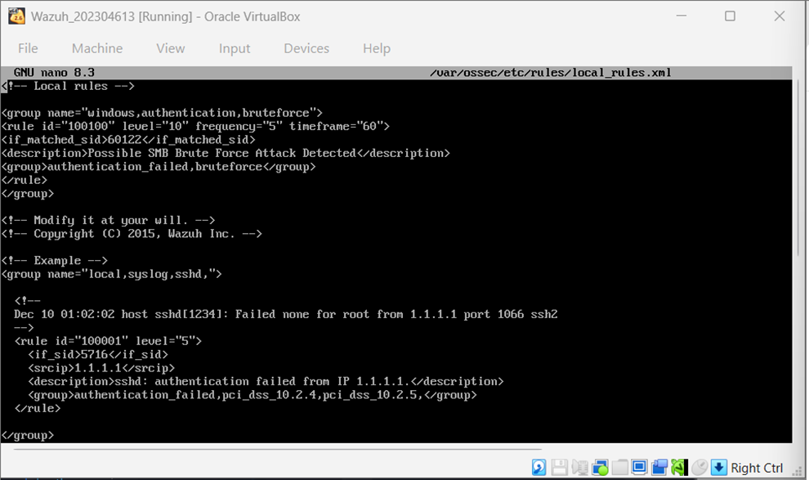Figure 30: Custom Wazuh rule 100100 configured in local_rules.xml for SMB brute force detection.
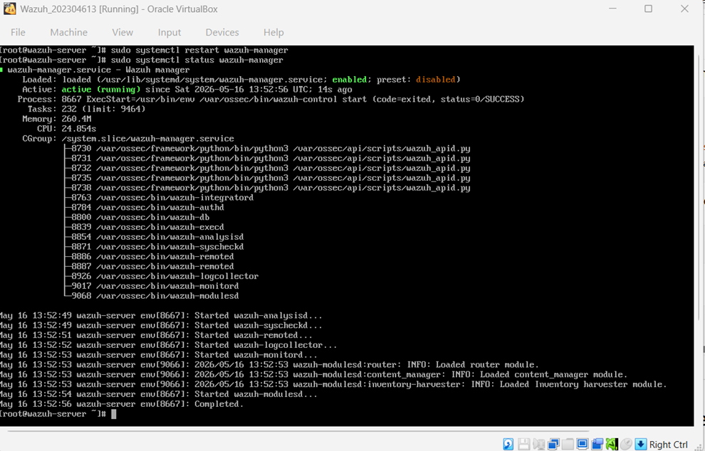Figure 31: Wazuh manager running successfully after rule configuration.
Threat Simulation Evidence
Tool for attack: CrackMapExec from Kali Linux was used to cause multiple instances of failed SMB authentications against the Windows Server. The image below confirms that STATUS_LOGON_FAILURE appeared in the output due to the attack.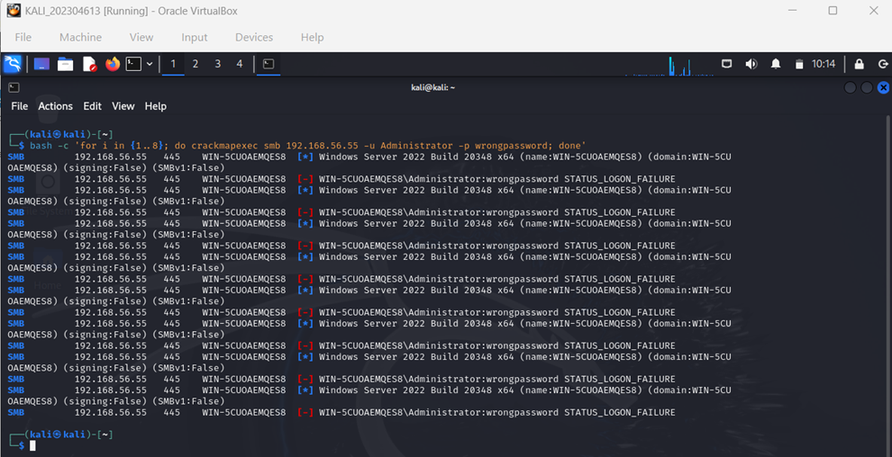Figure 32: Kali Linux generating repeated SMB failed login attempts using CrackMapExec.
Wazuh Dashboard Response Evidence
Doctor feedback provided: This section covers the Wazuh dashboard output for Attack 1. Wazuh has indeed found evidence of SMB brute-force attack and created the custom rule ID 100100 for the new name of the agent WinServer2022-202304613.
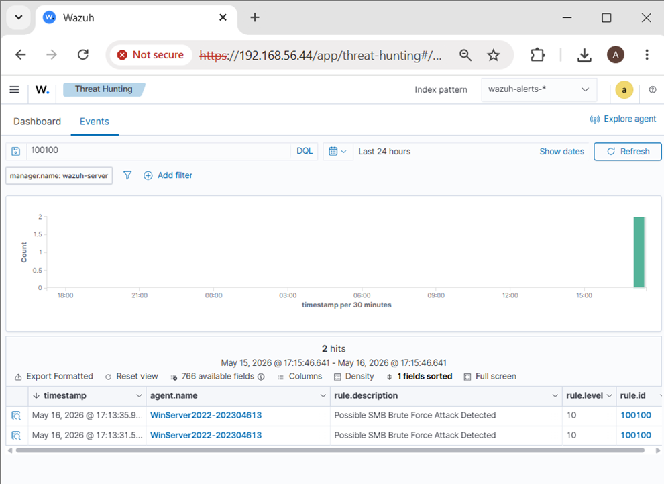Figure 33: Wazuh dashboard response showing SMB brute force detection with rule ID 100100 and agent WinServer2022-202304613.

Logs and Event ID Identification
The Wazuh document contains the details that contain the relevant Windows failed logon details. The fields confirm the source of the attack, target accounts, and Windows Security event id.
Field | Value / Evidence
Custom rule ID | 100100
Alert description | Possible SMB Brute Force Attack Detected
Agent name | WinServer2022-202304613
Target IP address | 192.168.56.55
Source / attacker IP address | 192.168.56.105
Target user | Administrator
Relevant Windows event ID | 4625 - failed logon
Response action | Block Kali IP using Windows Firewall

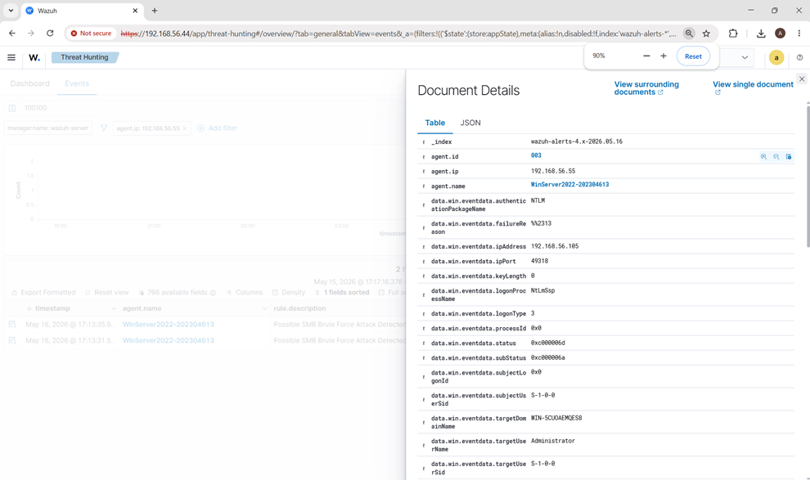
Figure 34: Wazuh document details showing the attacker IP address 192.168.56.105 and target user Administrator.

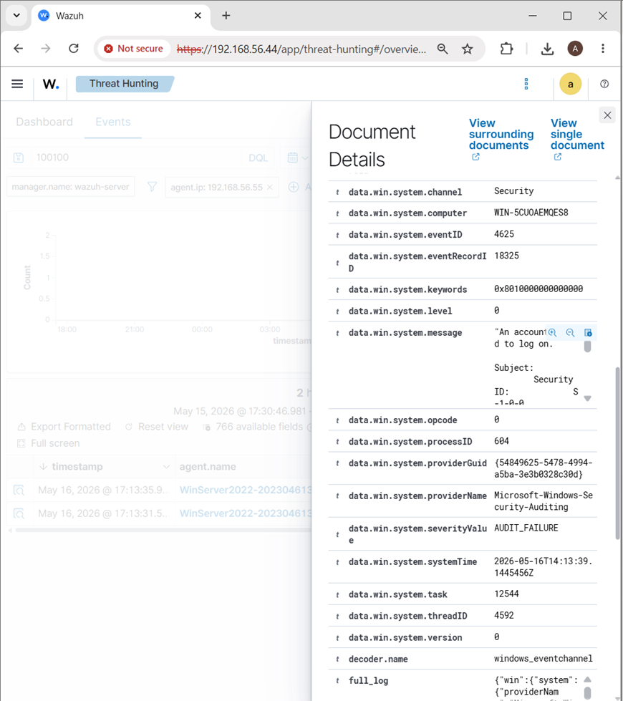
Figure 35: Wazuh document details showing Windows Security Event ID 4625 for failed logon activity.

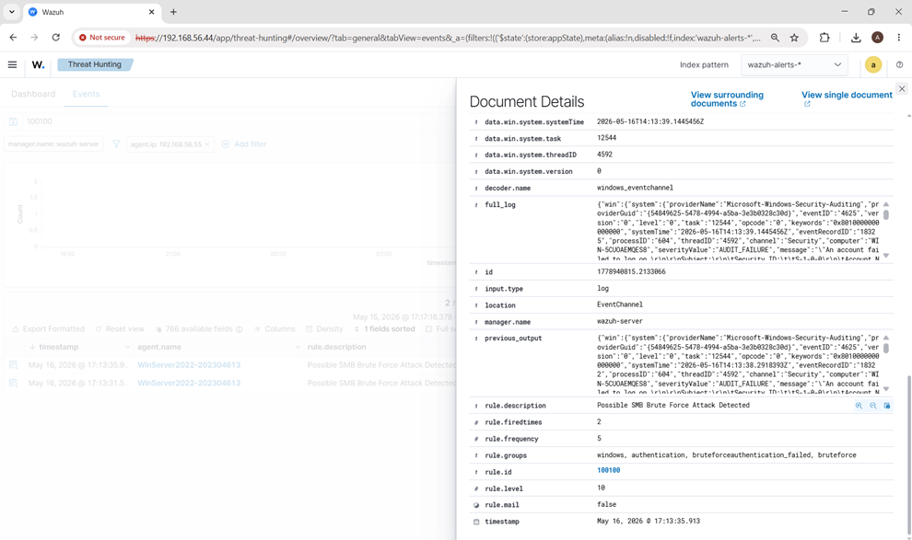
Figure 36: Wazuh document details showing custom rule ID 100100, alert level 10, and the brute force alert description.

Response Configuration Evidence
Response action: Once the alert was confirmed in Wazuh, firewall rules were set up for blocking the attacker IP address 192.168.56.105 on both SMB and ICMP ports. The above action is an example of containing the attack machine.

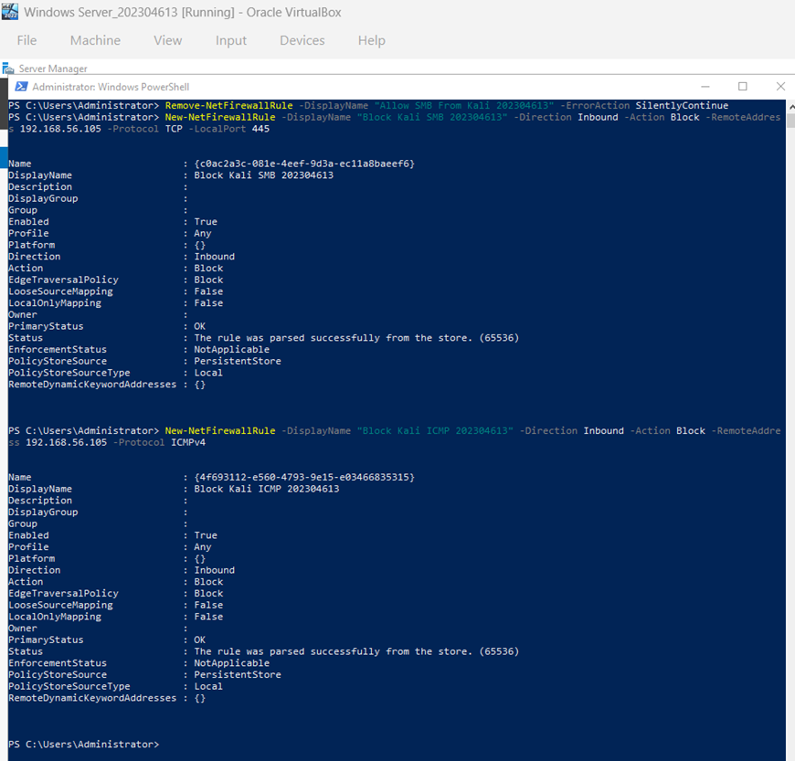
Figure 37: Windows Firewall response rules configured to block Kali IP 192.168.56.105 for SMB and ICMP traffic.

Result Validation Evidence
The response was authenticated using Kali Linux. The ICMP traffic resulted in 100% packet loss, while Nmap showed the SMB port 445 to be filtered post-firewall block.
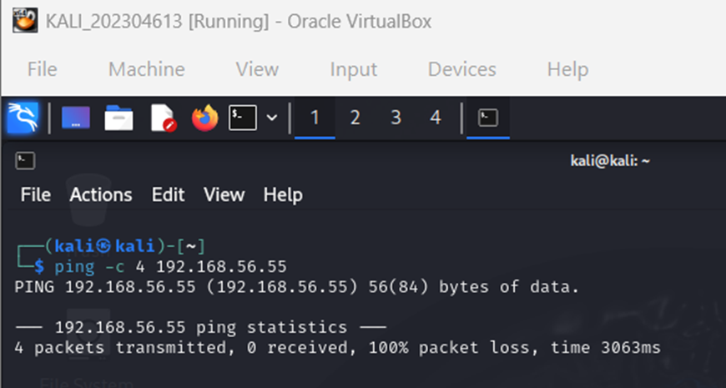
Figure 38: Kali validation showing 100% packet loss after the firewall block response.

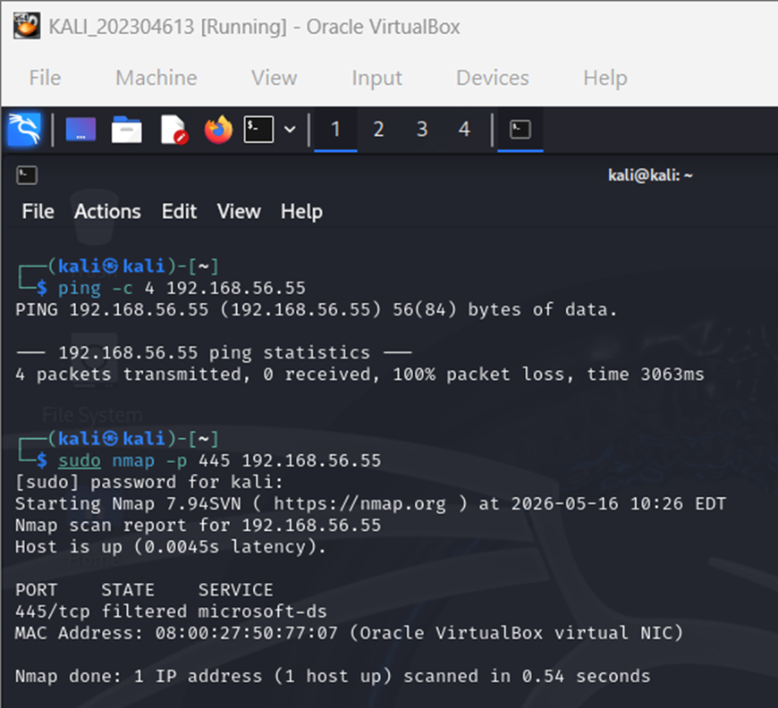
Figure 39: Nmap validation showing SMB port 445 filtered after the firewall response was applied.

Attack 1 Result
Result: Successful. Kali Linux made repeated failed attempts at authenticating via SMB with Windows Server 2022. The attempt was detected by Wazuh based on customized rule ID 100100, where the alert was shown on the dashboard for the renamed agent named WinServer2022-202304613. The document provided the confirmed Windows Security Event ID 4625, the attacking IP 192.168.56.105, and the attacked user Administrator. The response was implemented via Windows Firewall rule blocking access to SMB and ICMP ports from Kali. The response was confirmed successful due to 100% packet loss via Kali ping and TCP/445 filtered by Nmap.
Attack 1 Deliverable Checklist
• Screenshot demonstrating attack detection on the Wazuh dashboard: done.
• Screenshot/config demonstrating rule configuration: done, utilizing local_rules.xml file and rule ID 100100.
• Relevant logs/events IDs: done, utilizing Windows Security Event ID 4625 and document detail information.
• Screenshot/config demonstrating rule response configuration: done, utilizing Windows Firewall blocking rules.
• Successful result validation: completed using ping 100% packet loss and Nmap TCP/445 filtered evidence.

Attack 2: Malware Activity Detection and Automated Response (EICAR + VirusTotal)
Attack Scenario | Malware Activity using the EICAR test file
Endpoint / Agent | Windows Server 2022 - WinServer2022-202304613
Detection Tools | Wazuh File Integrity Monitoring (FIM), VirusTotal integration
Response Action | Wazuh Active Response executed remove-threat.exe and removed eicar.txt

1. Objective
This attack demonstrates Extended Detection and Response (XDR) using Wazuh. A safe EICAR test file was downloaded to the monitored Windows Downloads directory to simulate malware activity. Wazuh detected the new file through File Integrity Monitoring, enriched the alert with VirusTotal, and executed an active response to remove the file.
2. Rubric Mapping for Attack 2
Requirement | Evidence Provided | Rule / Event IDs | Status
Threat Simulation & Detection | EICAR file downloaded into the monitored Downloads directory; Wazuh FIM detected file creation. | 554, 87105 | Successful
Detection Rule Configuration | Windows FIM directory monitoring, VirusTotal integration, and custom Active Response result rule configured. | 554, 87105, 100092 | Successful
Logs / Event IDs | Wazuh dashboard and Document Details show file creation, VirusTotal malicious verdict, Active Response execution, and deletion. | 554, 87105, 100092, 553 | Successful
Response Configuration | remove-threat.exe configured as a Wazuh Active Response command triggered by VirusTotal rule 87105. | 87105 -> 100092 | Successful
Result Validation | Dashboard shows response execution and file deletion; PowerShell Test-Path returned False. | 100092, 553 | Successful

3. Configuration Evidence
The following screenshots provide rule and response configuration evidence. They are included as images to meet the feedback requirement that the configuration/command pieces must appear as screenshots, not only as plain text.
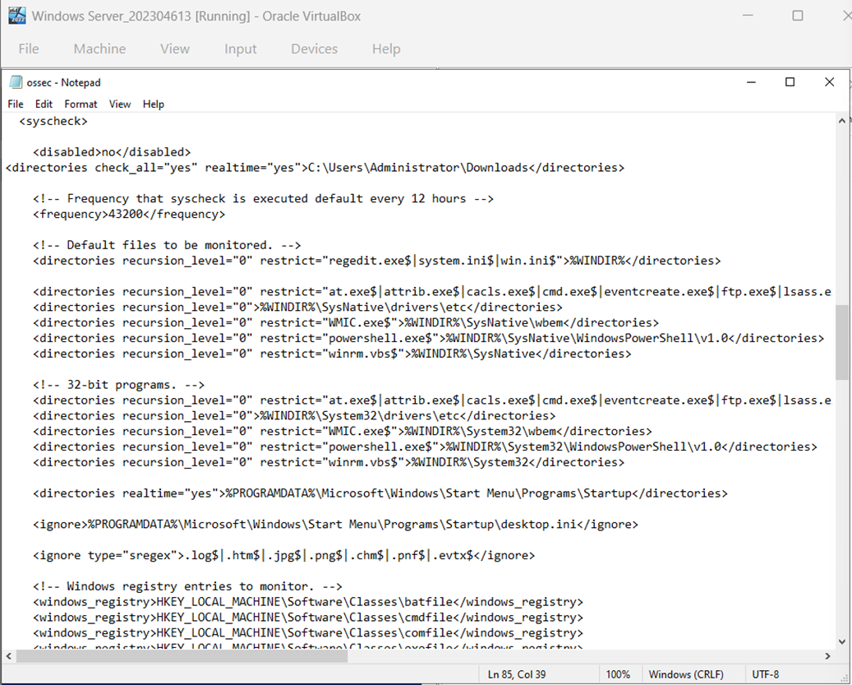Figure 40: Windows Wazuh agent FIM configuration monitoring C:\Users\Administrator\Downloads in real time.

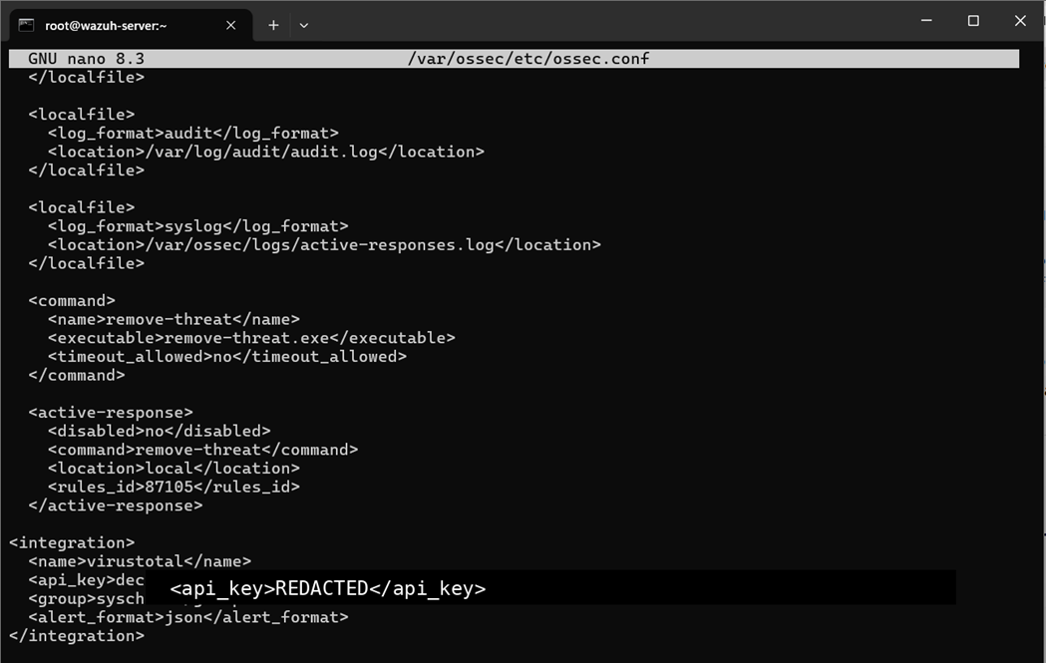Figure 41: Wazuh manager configuration showing VirusTotal integration, remove-threat command, and Active Response triggered by rule ID 87105. The API key is hidden.

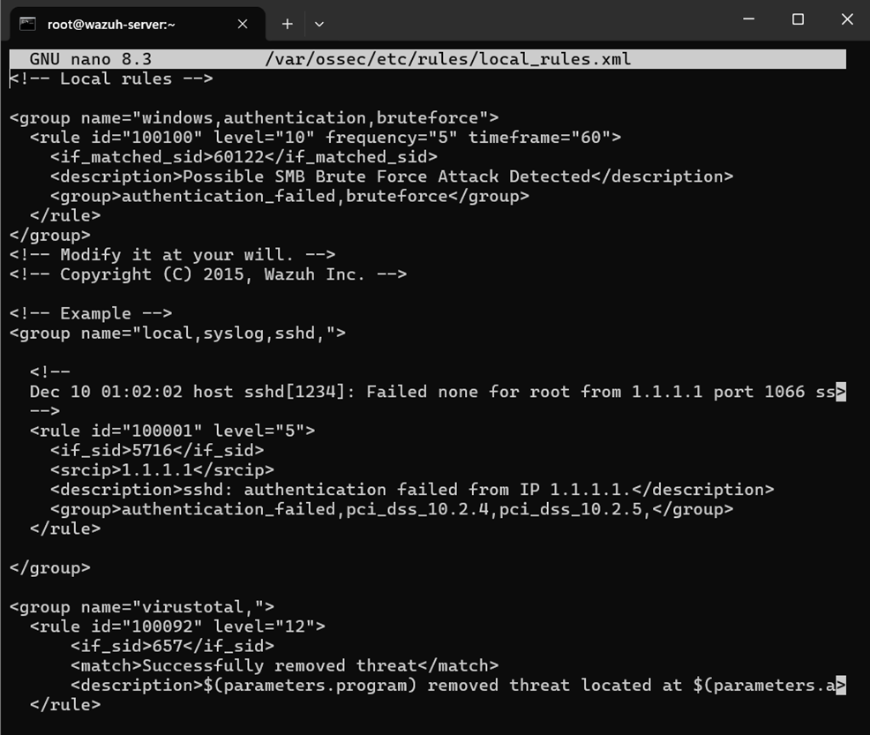Figure 42: local_rules.xml showing custom rule ID 100092 for a successful Active Response threat removal event.

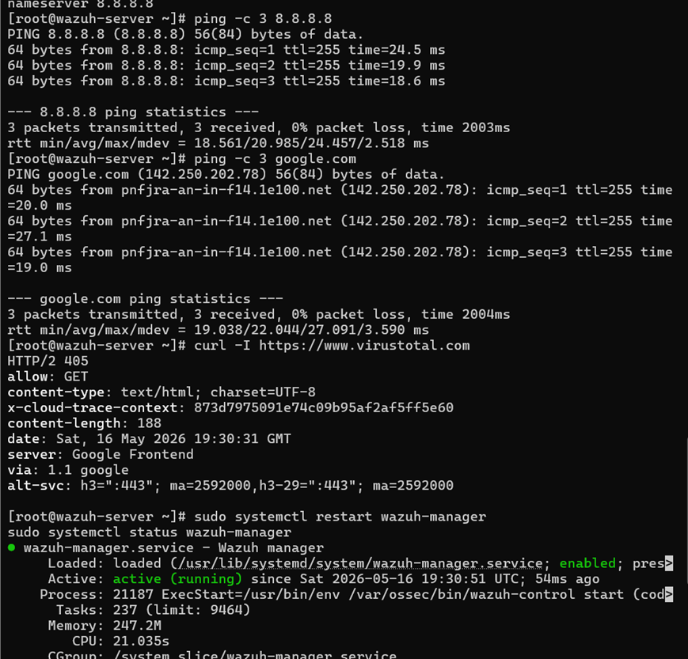
Figure 43: Wazuh server internet connectivity and Wazuh manager active/running status after the VirusTotal connectivity issue was fixed.

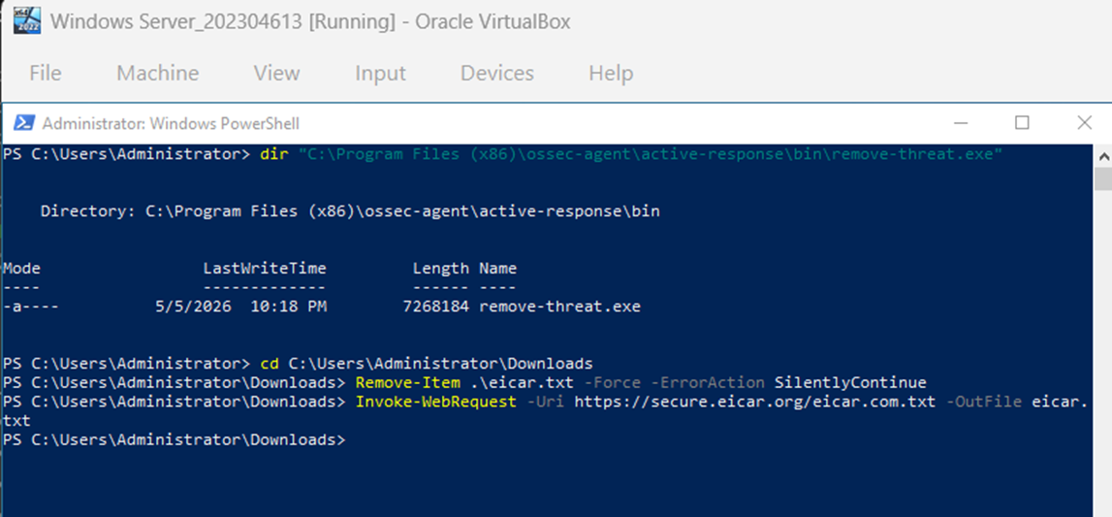Figure 44: Windows PowerShell evidence showing remove-threat.exe exists and the EICAR test file was downloaded into the monitored Downloads directory.

4. Threat Simulation and Detection Evidence
The EICAR file was used as a safe malware test file. After it was placed in the monitored directory, Wazuh generated a file creation alert and VirusTotal identified the file as malicious.
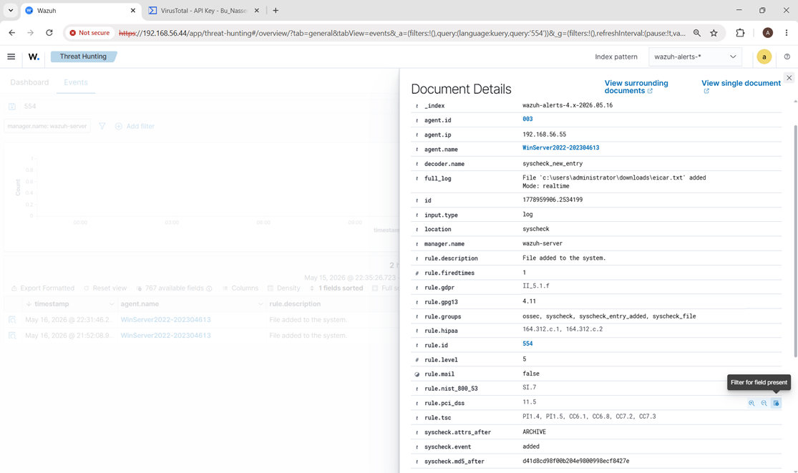Figure 45: Document Details for rule ID 554 showing that eicar.txt was added to the monitored Downloads directory.
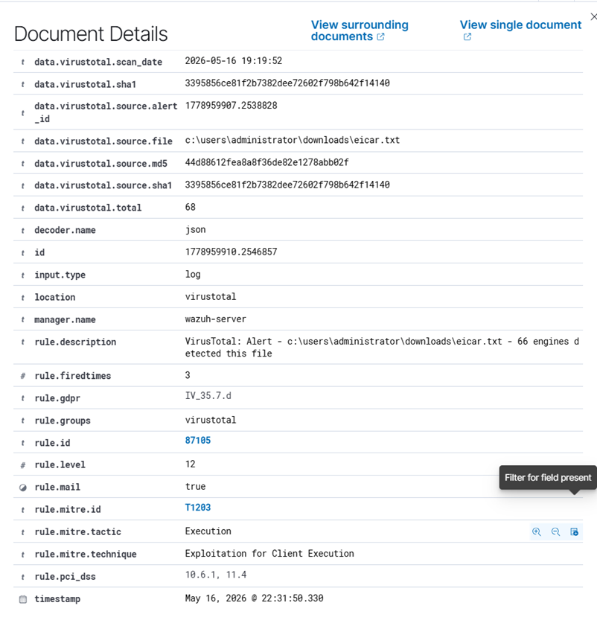
Figure 46: VirusTotal Document Details showing the EICAR file was found and marked malicious, with 66 positive detections.

Figure 47: VirusTotal alert details showing rule ID 87105, severity level 12, the eicar.txt file path, and MITRE mapping.

5. Wazuh Dashboard Response Evidence
The doctor feedback required dashboard response evidence for each attack. Figure 48 provides the main Attack 2 dashboard response, showing the full chain from file creation to malware detection, automated removal, and file deletion under the renamed agent WinServer2022-202304613.
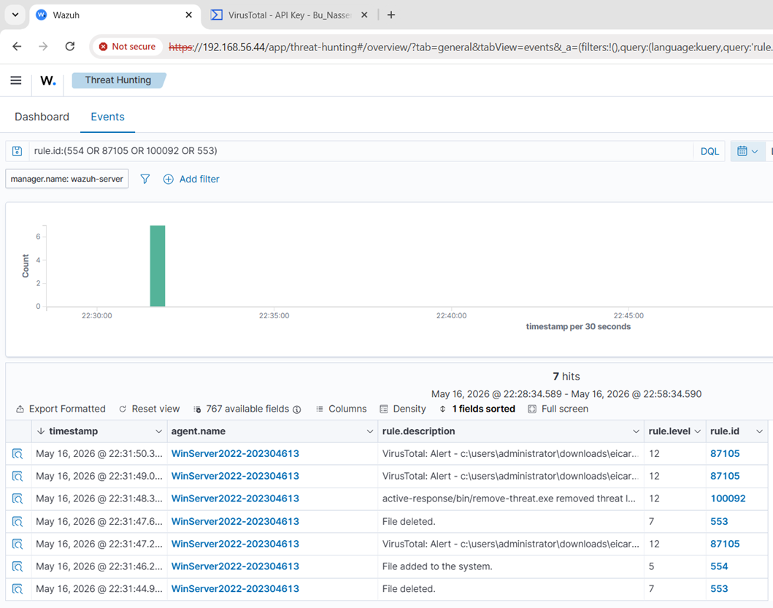Figure 48: Wazuh dashboard response showing the full Attack 2 chain: 554 file added, 87105 VirusTotal alert, 100092 Active Response executed, and 553 file deleted.
6. Response Execution and Validation
The response action was configured through Wazuh Active Response. When VirusTotal rule 87105 was triggered, Wazuh executed remove-threat.exe on the Windows endpoint. The Wazuh dashboard generated rule ID 100092 to confirm that the file was removed, and rule ID 553 confirmed the file deletion event.
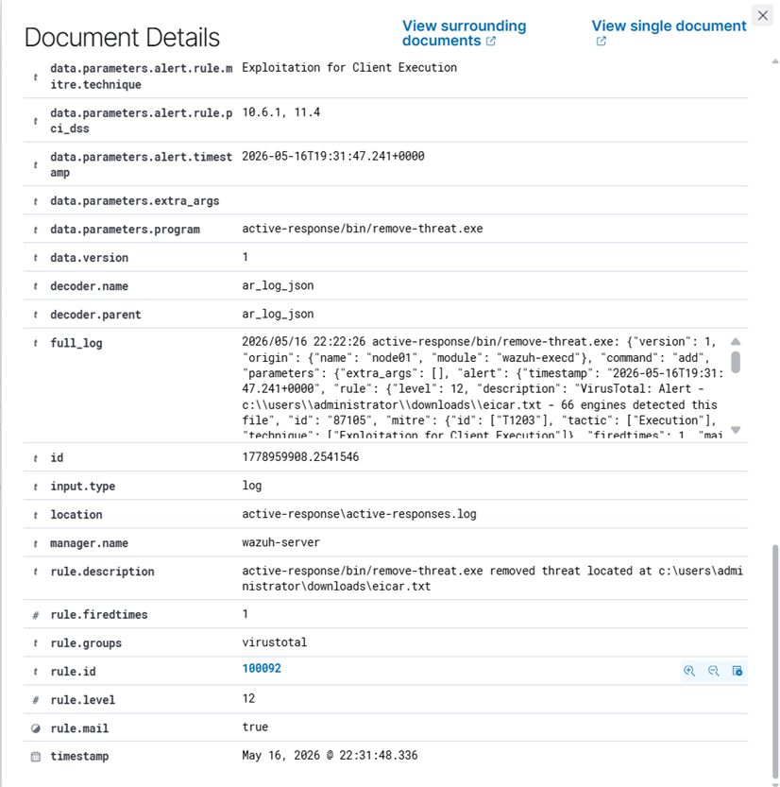
Figure 49: Document Details for rule ID 100092 showing Active Response remove-threat.exe successfully removed eicar.txt.

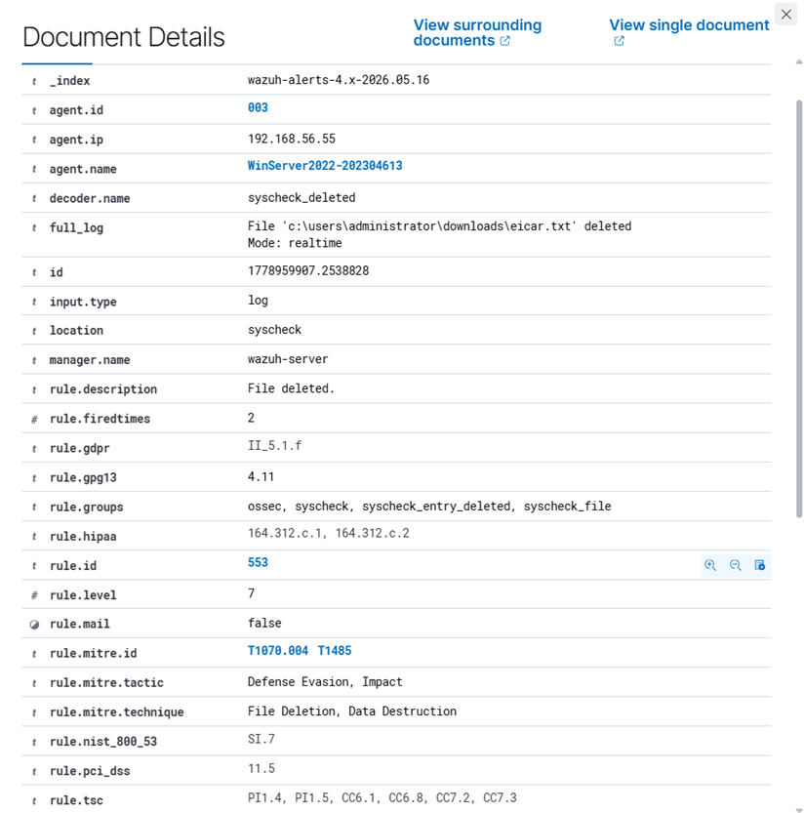
Figure 50: Document Details for rule ID 553 showing that eicar.txt was deleted from the monitored directory.

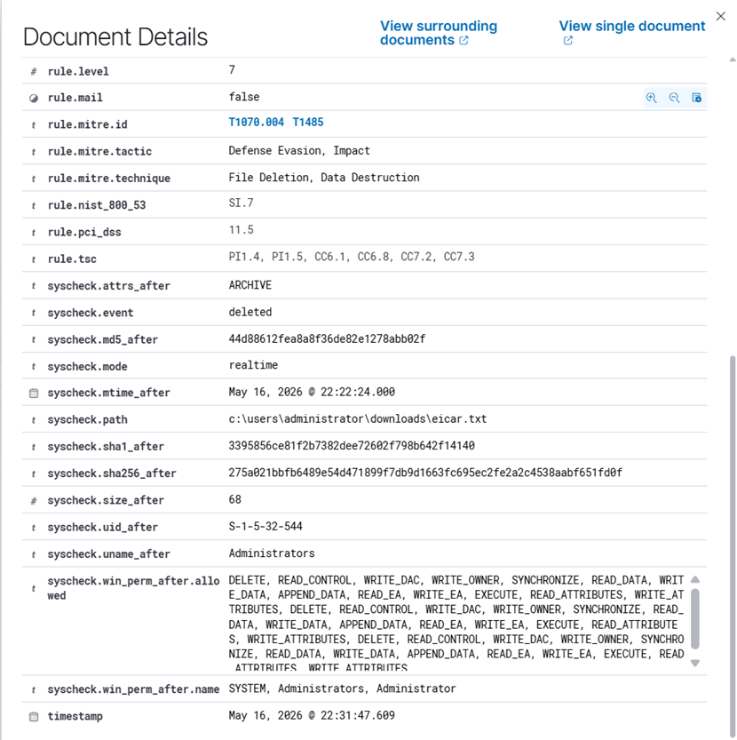
Figure 51: Additional rule 553 details showing the deleted file path, hashes, syscheck event status, and deletion metadata.

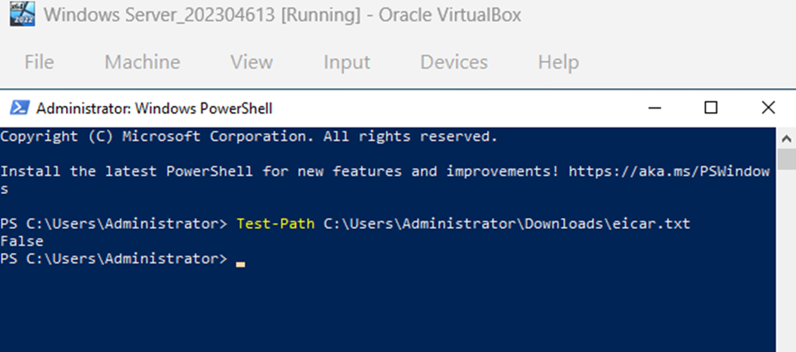
Figure 52: PowerShell validation showing Test-Path returned False, confirming eicar.txt no longer exists on the endpoint.

7. Logs and Event IDs Identified
Rule ID | Source / Module | Meaning | Evidence
554 | syscheck | File added to the system: eicar.txt was created in the monitored Downloads folder. | Figures 45 and 48
87105 | virustotal | VirusTotal detected eicar.txt as malicious with 66 positive detections. | Figures 46, 47 and 48
100092 | active-response log | remove-threat.exe successfully removed the detected threat. | Figures 48 and 49
553 | syscheck | File deleted: eicar.txt was removed from the endpoint. | Figures 48, 50 and 51

8. Attack 2 Result
Attack 2 was successful. The EICAR test file was downloaded into the monitored Downloads directory on Windows Server 2022. Wazuh File Integrity Monitoring detected the file creation using rule ID 554. The alert was enriched by VirusTotal, which identified the file as malicious and generated rule ID 87105. Wazuh Active Response executed remove-threat.exe and generated rule ID 100092, confirming that the threat was removed. Wazuh also generated rule ID 553 confirming that the file was deleted. Finally, the response was validated using PowerShell, where Test-Path returned False, confirming that eicar.txt was removed from the endpoint.
9. Deliverables Checklist - Attack 2
Deliverable | Evidence in this document | Status
Threat Detection Evidence | Wazuh dashboard and Document Details for rules 554 and 87105 | Complete
Rule Configuration Evidence | FIM configuration, VirusTotal integration, Active Response block, and custom rule 100092 | Complete
Logs / Event IDs | 554, 87105, 100092 and 553 identified and explained | Complete
Response Configuration Evidence | remove-threat command and Active Response triggering on rule 87105 | Complete
Result Validation | Dashboard rule 100092, rule 553, and PowerShell Test-Path False | Complete

Attack 3: Suspicious PowerShell Activity Detection and Response
1. Attack Overview
Scenario: Suspicious PowerShell execution was simulated on Windows Server 2022 using the -nop parameter. This parameter is commonly associated with suspicious or evasive PowerShell activity because it can prevent profile scripts from loading and is often seen in process creation telemetry during malicious script execution attempts.
Goal: Detect the suspicious PowerShell command using Wazuh and Sysmon, then apply a response action that blocks outbound web traffic from powershell.exe. The response is validated by confirming that PowerShell can no longer establish a TCP connection to example.com on port 80.
2. Environment and Tools Used
Component | Used For
Windows Server 2022 agent | Endpoint where the suspicious PowerShell command was executed.
Agent name | WinServer2022-202304613, showing the required student ID in Wazuh evidence.
Sysmon64 | Collected Windows process creation telemetry.
Wazuh agent | Forwarded Sysmon Operational logs to the Wazuh manager.
Wazuh manager and dashboard | Detected rule 100900 and displayed dashboard/document details evidence.
Windows Firewall | Response action used to block outbound network traffic from powershell.exe.

3. Rubric and Requirement Mapping
Task 2 Requirement | Attack 3 Evidence Provided | Status
Generate the attack | PowerShell command executed with -nop and web request to example.com. | Met
Configure detection rule | Custom Wazuh rule ID 100900 detects powershell.exe command lines containing -nop. | Met
Verify detection using logs/events | Wazuh dashboard and Document Details show rule 100900, Sysmon Event ID 1, PowerShell image, and command line. | Met
Configure response action | Windows Firewall rule blocks outbound traffic from powershell.exe. | Met
Confirm response successfully executed | Test-NetConnection shows TcpTestSucceeded: False after the block rule. | Met
Doctor feedback: dashboard response | Dashboard Events and Document Details are included for the attack. | Met

4. Log Source and Collection Configuration
Sysmon was confirmed as running on the Windows Server endpoint, and the Wazuh agent was configured to collect the Microsoft-Windows-Sysmon/Operational event channel. This provides the process creation telemetry needed for suspicious PowerShell detection.

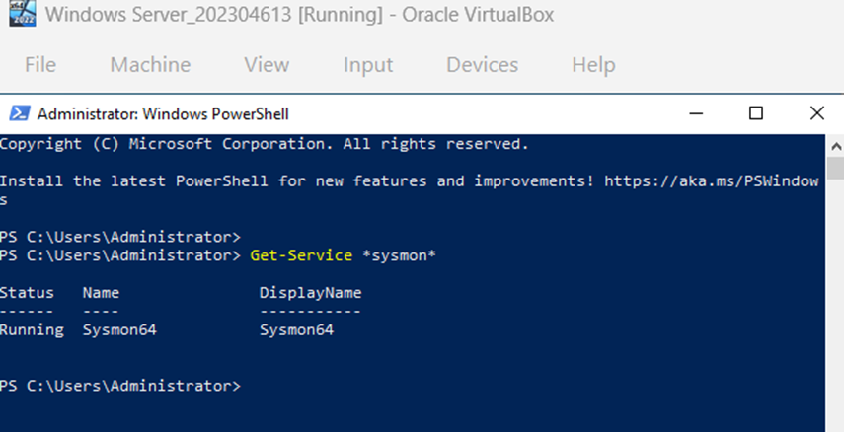
Figure 53: Sysmon64 service running on Windows Server 2022.

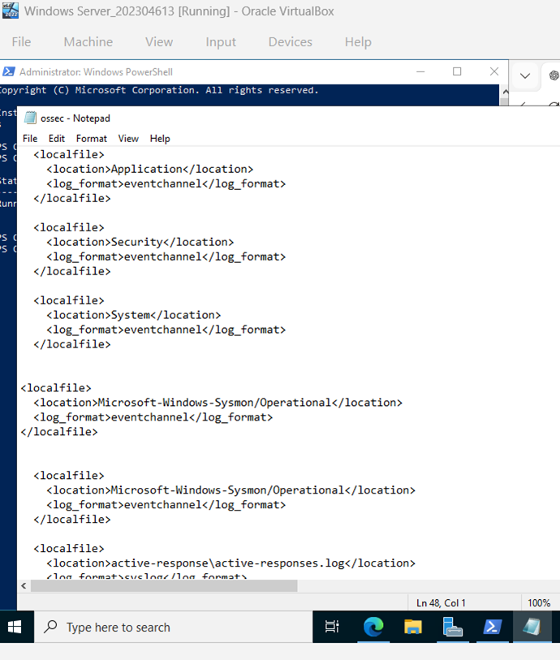
Figure 54: Wazuh agent configuration collecting Microsoft-Windows-Sysmon/Operational logs.

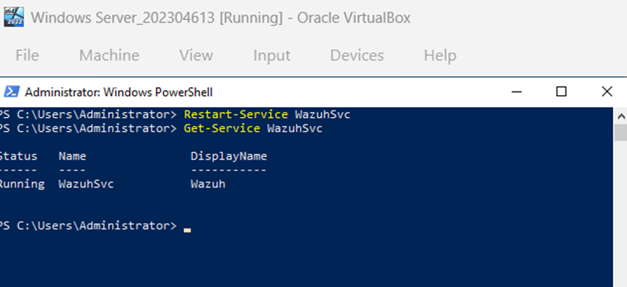
Figure 55: Wazuh agent service restarted and running after the Sysmon log collection configuration.

5. Detection Rule Configuration Evidence
A custom Wazuh rule was configured to detect PowerShell process creation where the command line contains the -nop parameter. The rule is associated with Sysmon Event ID 1 process creation telemetry and generates rule ID 100900 at level 12.
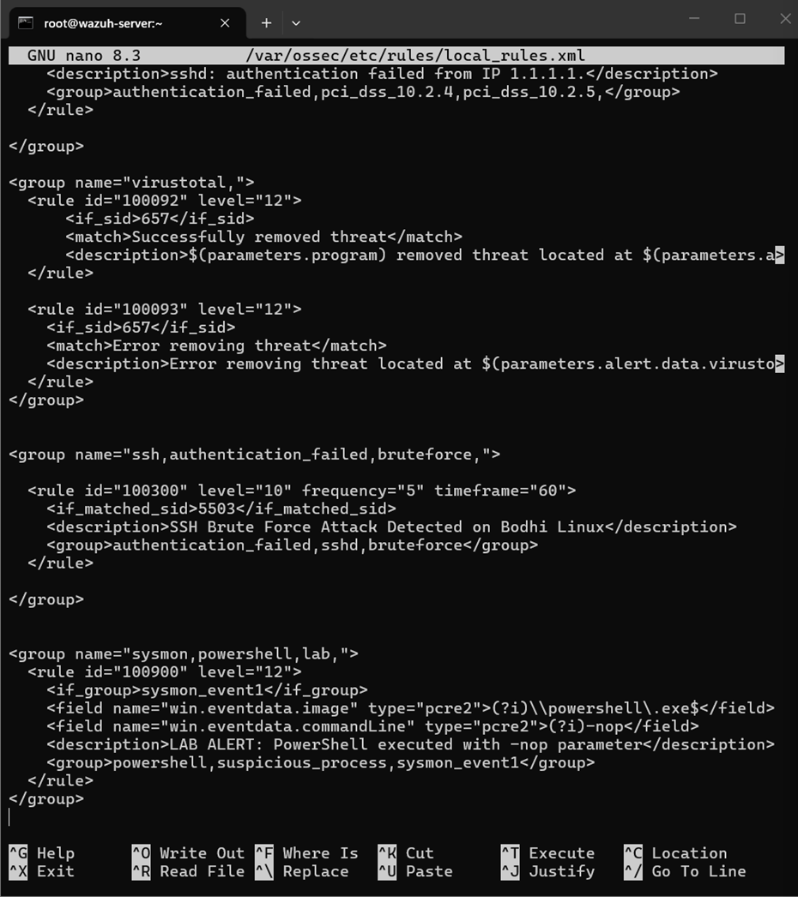
Figure 56: Custom Wazuh rule 100900 configured in local_rules.xml to detect PowerShell -nop execution.

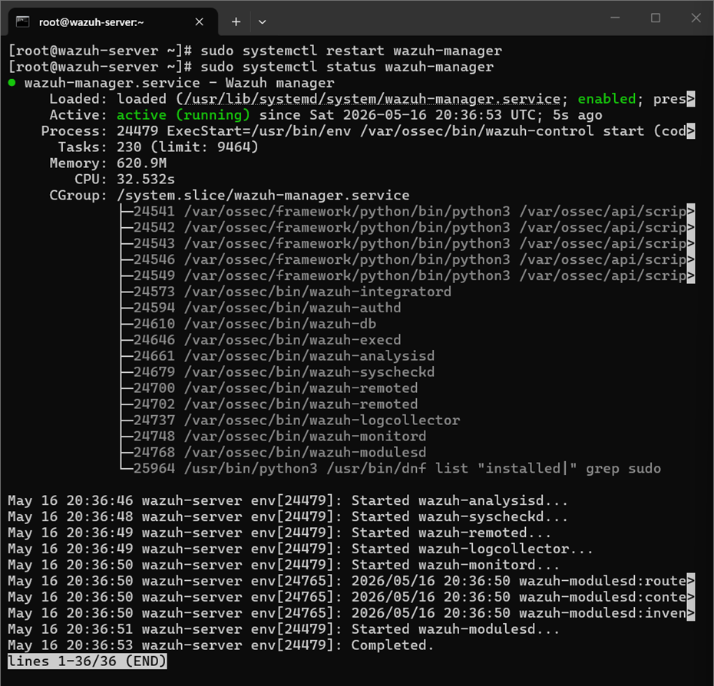
Figure 57: Wazuh manager restarted successfully and running after the custom rule configuration.

6. Attack Simulation Evidence
The suspicious activity was generated by running a PowerShell command with the -nop parameter and a web request. This creates a Sysmon process creation event that Wazuh can evaluate against the custom detection rule.
powershell -nop -W hidden -c "iwr http://example.com"
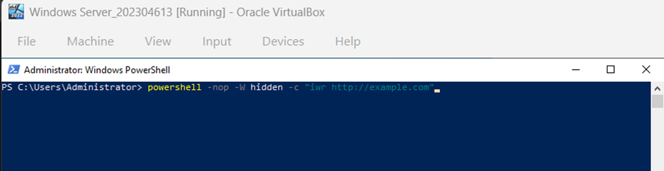
Figure 58: Suspicious PowerShell command executed with the -nop parameter.

7. Wazuh Dashboard Response Evidence
The Wazuh dashboard detected the suspicious PowerShell activity using custom rule ID 100900. The alert appears under the renamed Windows agent WinServer2022-202304613, satisfying the requirement to show the student ID in the agent name.
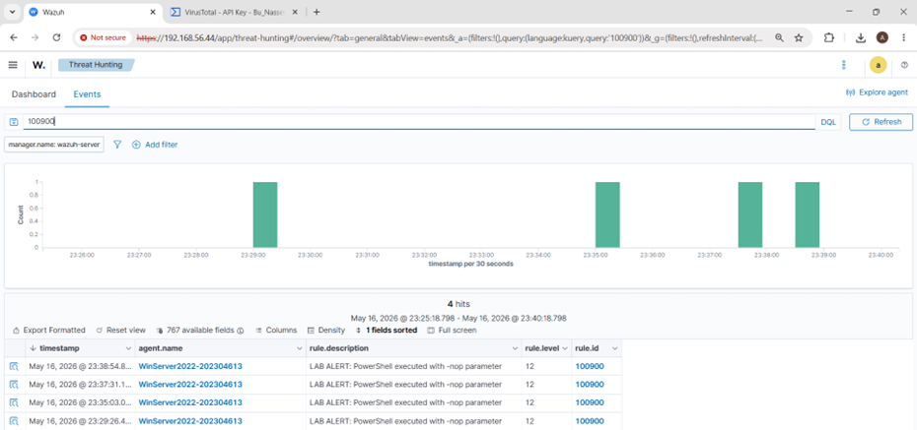
Figure 59: Wazuh dashboard response showing rule ID 100900 for suspicious PowerShell execution.

8. Logs and Event ID Evidence
Document Details confirmed that the alert came from the Sysmon Operational channel. The important log identifiers are Sysmon Event ID 1, the PowerShell executable path, the user context, and the command line containing the -nop parameter.
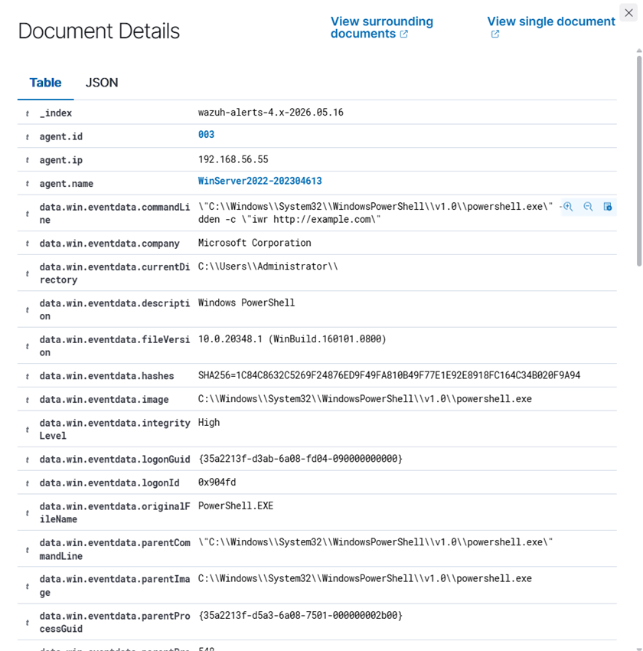
Figure 59: Document Details showing the PowerShell command line and powershell.exe image path.

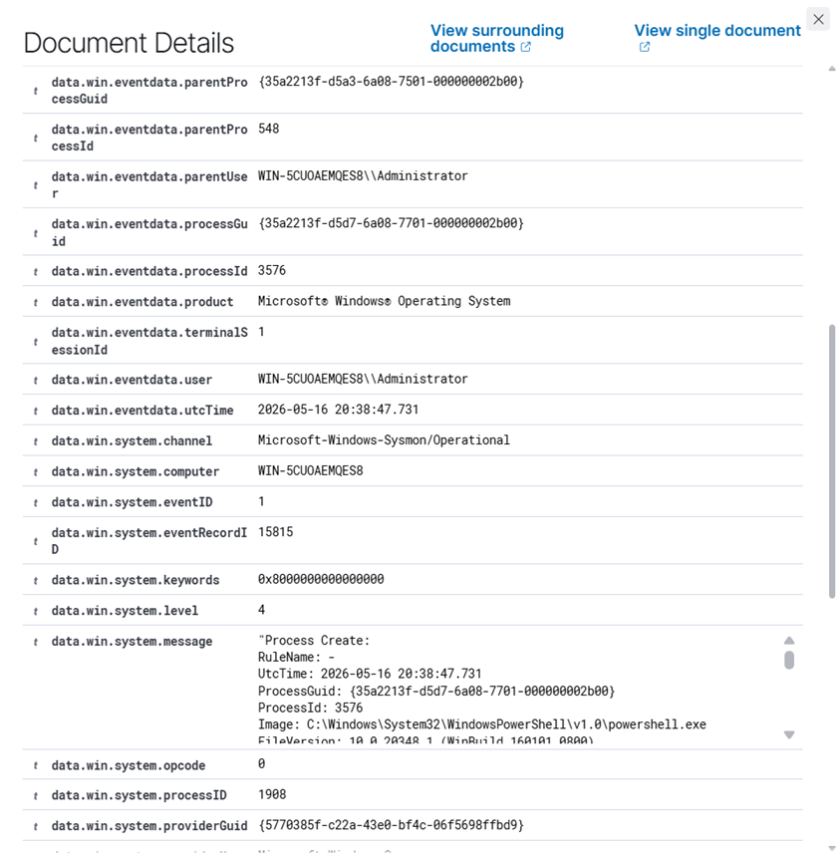
Figure 60: Document Details showing Microsoft-Windows-Sysmon/Operational and Sysmon Event ID 1.
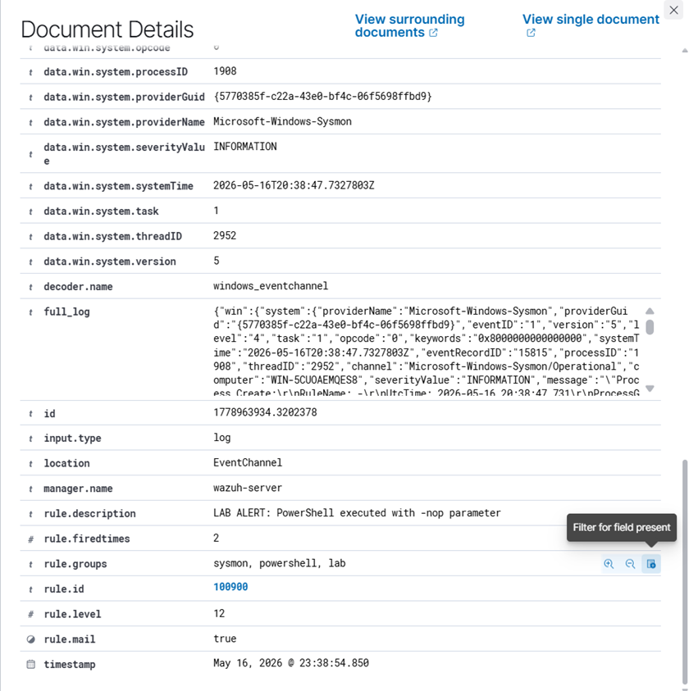
Figure 61: Document Details showing rule ID 100900 and the alert description.

Field | Value / Meaning
Agent name | WinServer2022-202304613
Log channel | Microsoft-Windows-Sysmon/Operational
Event ID | 1 - Process Create
Custom rule ID | 100900
Rule level | 12
Rule description | LAB ALERT: PowerShell executed with -nop parameter
Detected process | C:\Windows\System32\WindowsPowerShell\v1.0\powershell.exe
Suspicious indicator | Command line contains -nop

9. Response Configuration Evidence
The response action configured for this attack was a Windows Firewall outbound block rule for powershell.exe. This response prevents PowerShell from making outbound web connections after suspicious PowerShell activity is detected.
New-NetFirewallRule -DisplayName "Block PowerShell Outbound 202304613" -Direction Outbound -Program "$env:SystemRoot\System32\WindowsPowerShell\v1.0\powershell.exe" -Action Block
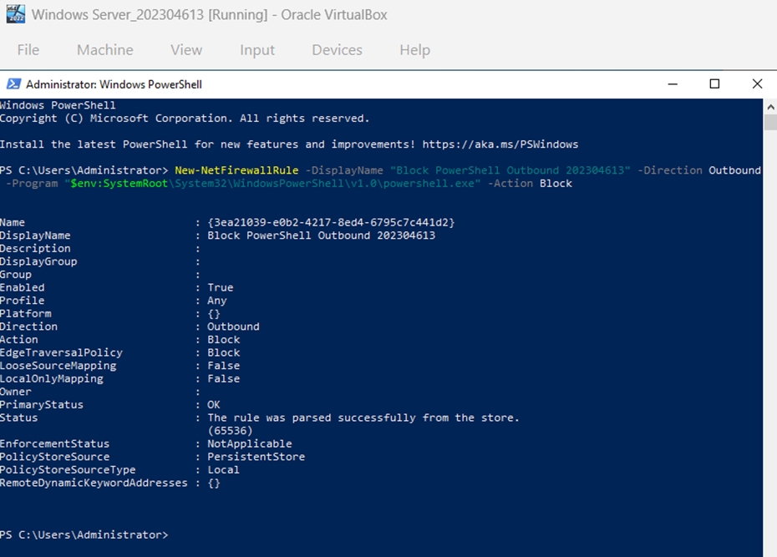
Figure 62: Windows Firewall response rule configured to block outbound traffic from powershell.exe.

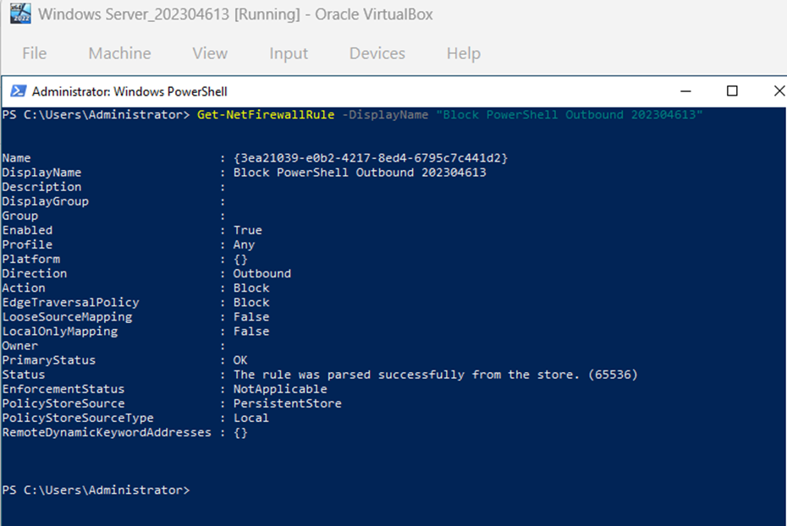
Figure 63: Firewall rule verification showing the PowerShell outbound block rule is enabled and active.

10. Result Validation Evidence
The response was validated by testing outbound TCP connectivity from PowerShell to example.com on port 80. The result shows that ICMP/ping can still succeed, but TCP port 80 fails. This is expected because the response rule specifically blocks PowerShell outbound web traffic, not all network traffic.
Test-NetConnection example.com -Port 80
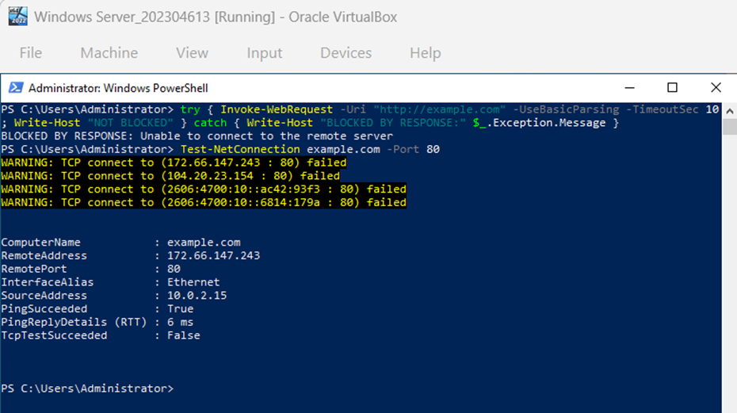
Figure 64: Response validation showing TcpTestSucceeded: False after the PowerShell outbound block was applied.

11. Attack 3 Result
Attack 3 was successful. Suspicious PowerShell activity was generated using a command that included the -nop parameter. Sysmon recorded the process creation event, and Wazuh detected it using custom rule ID 100900. The Wazuh dashboard showed the alert under the renamed agent WinServer2022-202304613, and Document Details confirmed Sysmon Event ID 1, powershell.exe, and the command line. The response action was implemented by creating a Windows Firewall outbound block rule for powershell.exe. The response was validated using Test-NetConnection, which returned TcpTestSucceeded: False, proving that PowerShell outbound web traffic was blocked.
12. Attack 3 Deliverables Summary
Deliverable | Evidence Included
Threat Detection Evidence | Wazuh dashboard screenshot showing rule ID 100900 and the suspicious PowerShell alert.
Rule Configuration Evidence | local_rules.xml screenshot showing custom rule 100900.
Logs / Event IDs | Document Details screenshots showing Sysmon Operational channel and Event ID 1.
Response Configuration Evidence | Windows Firewall rule screenshots blocking outbound traffic from powershell.exe.
Result | Test-NetConnection screenshot showing TcpTestSucceeded: False.

Task 2 Requirement Mapping
Project Requirement | Evidence Provided in This Document
Simulate and detect any three cyber threats | Three attacks were implemented: SMB brute force, malware/EICAR with VirusTotal, and suspicious PowerShell execution.
Configure a detection rule for each attack | Rule 100100 was configured for SMB brute force, VirusTotal/FIM rules 554 and 87105 with response rule 100092 were used for malware detection and removal, and rule 100900 was configured for suspicious PowerShell detection.
Verify detection using logs/events | Event ID 4625 was identified for failed logon, rule IDs 554/87105/100092/553 were identified for the malware detection chain, and Sysmon Event ID 1 was identified for PowerShell process creation.
Configure an appropriate response action | A Windows Firewall block was used for the brute force attacker IP, remove-threat.exe was used for malware removal, and a Windows Firewall outbound block was used for powershell.exe.
Confirm response successfully executed | Ping/Nmap validation confirmed Attack 1 containment, Test-Path False confirmed Attack 2 removal, and TcpTestSucceeded False confirmed Attack 3 PowerShell outbound block.

Overall Task 2 Result
Successful. The three selected attacks meet the XDR Detection and Automated Response requirements. The final evidence includes attack generation, detection rule configuration, Wazuh dashboard response evidence, event/log identification, response configuration, and response validation for each attack.

Task 3 - SOAR Automation Using Shuffle

Introduction
The project demonstrates the SOAR process through integration of Wazuh with Shuffle. The chosen scenario involves SSH brute force attacks on the Bodhi Linux machine. Wazuh monitors multiple failed login attempts via a custom rule that raises an alert, which is then sent to Shuffle via webhooks, and Shuffle notifies the SOC analyst via an automated email message.
Implementation Summary
Item | Implementation Evidence
Selected attack scenario | SSH brute force attack generated from Kali Linux against Bodhi Linux using Medusa.
Wazuh detection rule | Custom Wazuh rule ID 100300 detects repeated SSH authentication failures.
Shuffle integration | Wazuh forwards JSON alerts to the Shuffle webhook using the ossec.conf integration block.
Playbook design | The workflow uses Wazuh Alert Trigger -> Wazuh logs -> Email notification.
Automated response / notification | Shuffle sends an automated email notification containing the SSH brute force alert details.
Verification result | Workflow execution finished successfully, the alert details were received by Shuffle, and the email arrived in the inbox.

Task 3 Requirement Mapping
Requirement | Evidence Provided | Key Figure(s) | Status
Wazuh Rule Configuration | Custom rule 100300 configured and alert generated in Wazuh. | Figures 65, 67, 68 | Complete
Shuffle Integration | Webhook trigger and Wazuh ossec.conf integration configured to forward JSON alerts. | Figures 69, 70 | Complete
Playbook Design | Workflow created with Wazuh alert trigger, log processing, and email action. | Figures 71, 72 | Complete
Automated Response / Notification | Email notification sent automatically after the Wazuh alert triggered Shuffle. | Figures 75, 76 | Complete
Output / Verification | Execution history and received alert details confirm successful playbook run. | Figures 73, 74 and 76 | Complete

Evidence Package
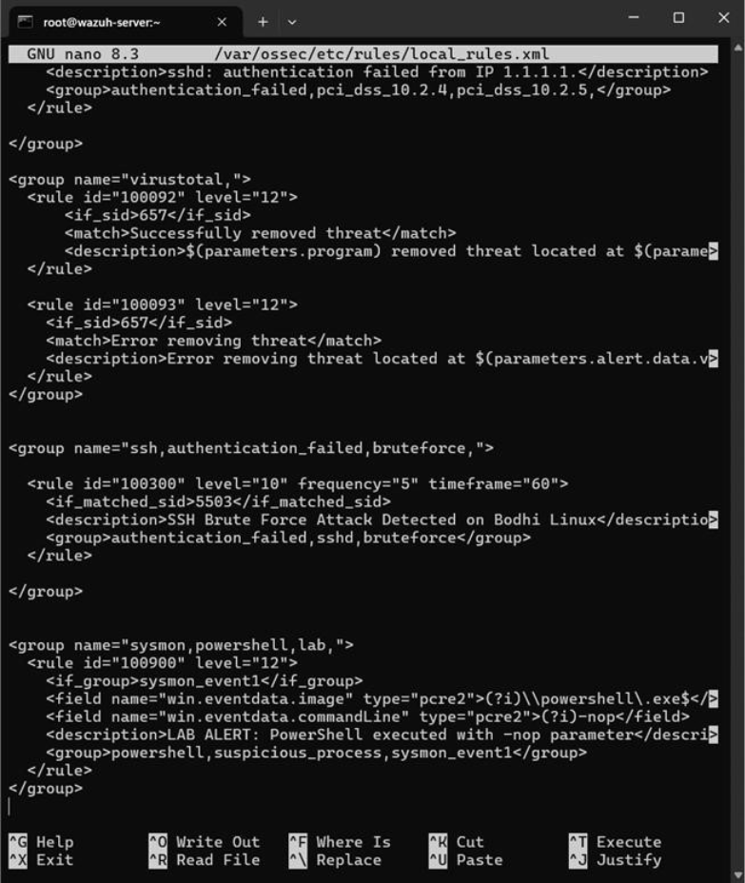Figure 65: Custom Wazuh rule 100300 configured in local_rules.xml to detect repeated SSH authentication failures on Bodhi Linux.

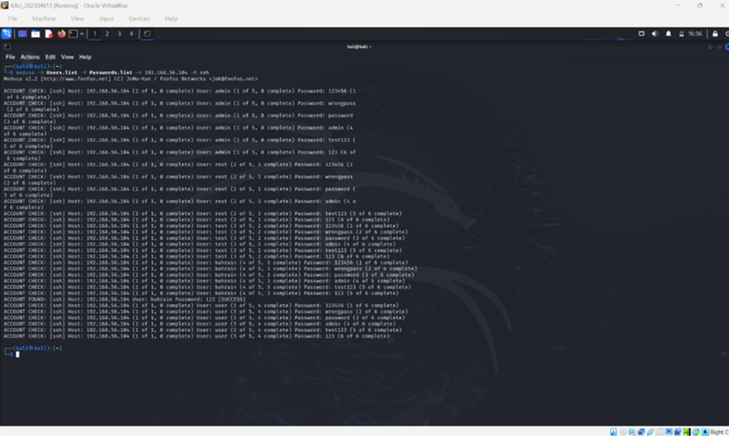Figure 66: Kali Linux running Medusa to generate SSH brute force authentication attempts against the Bodhi Linux target.

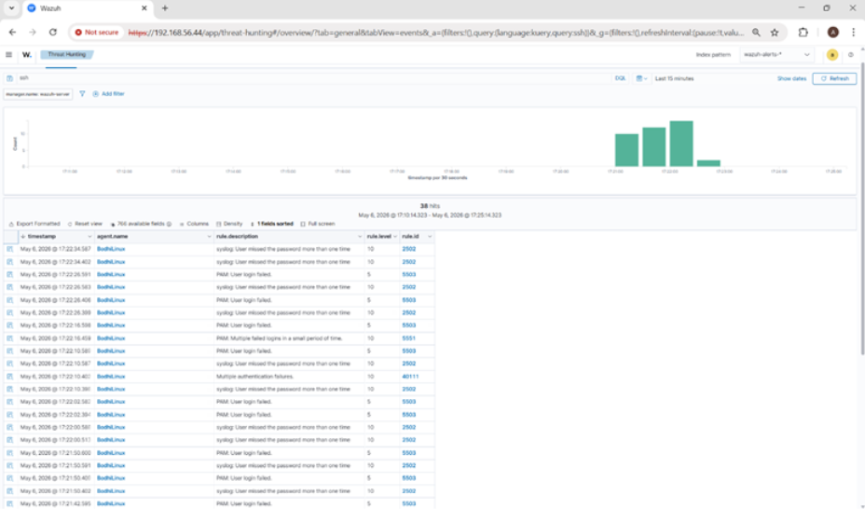
Figure 67: Wazuh dashboard showing the SSH brute force alert generated by custom rule ID 100300.

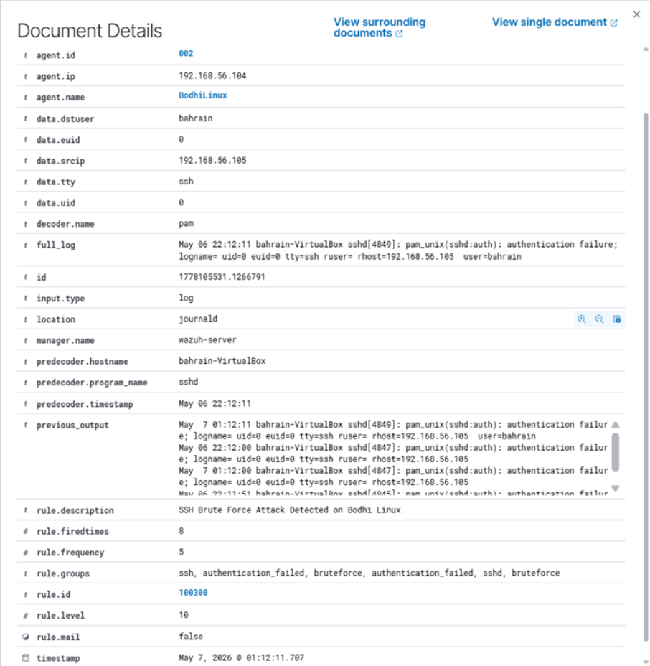Figure 68: Wazuh alert document details showing the SSH brute force alert fields, including BodhiLinux agent information, source IP 192.168.56.105, rule ID 100300, frequency, fired times, and severity level.

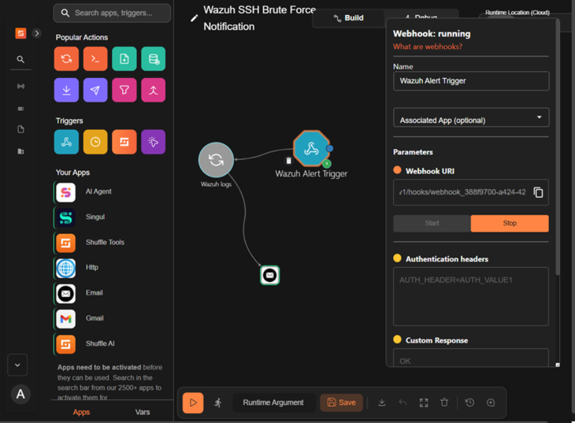Figure 69: Shuffle webhook trigger running and ready to receive alerts from Wazuh.

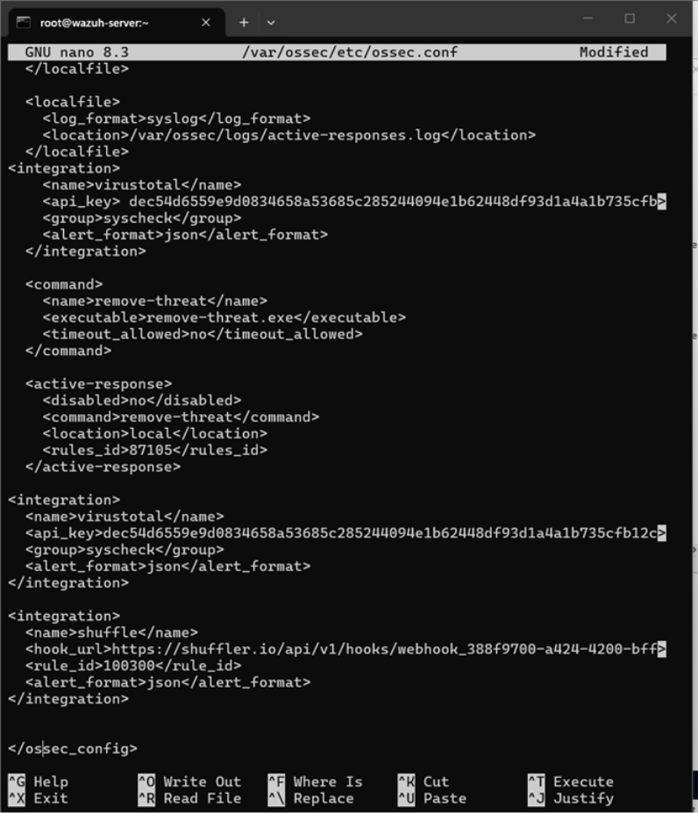Figure 70: Wazuh ossec.conf integration configuration forwarding JSON alerts from Wazuh to the Shuffle webhook.

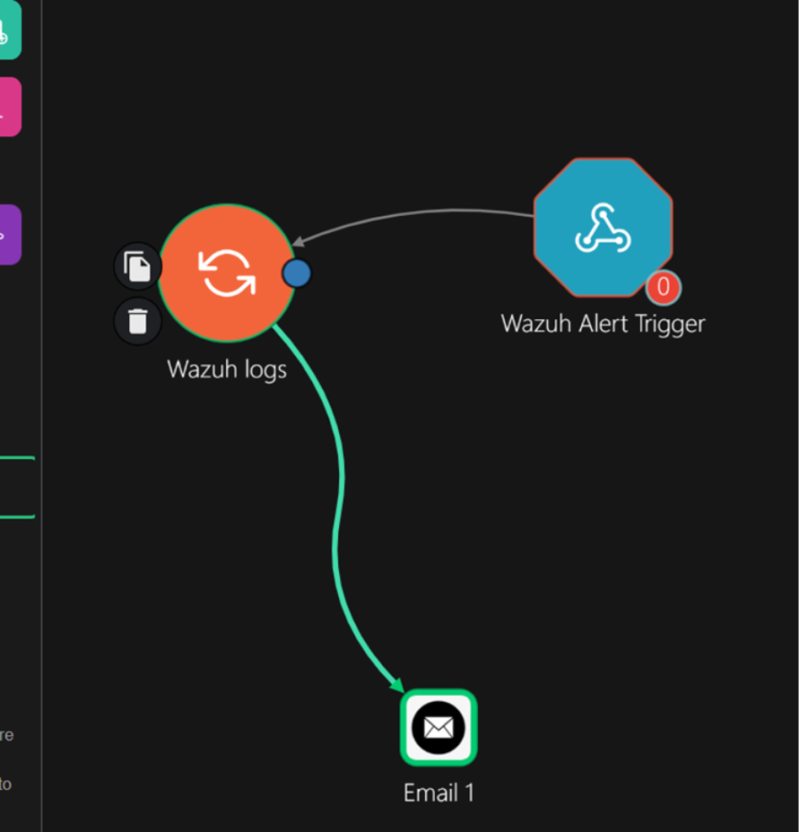Figure 71: Complete Shuffle SOAR playbook configured as Wazuh Alert Trigger → Wazuh logs → Email 1.

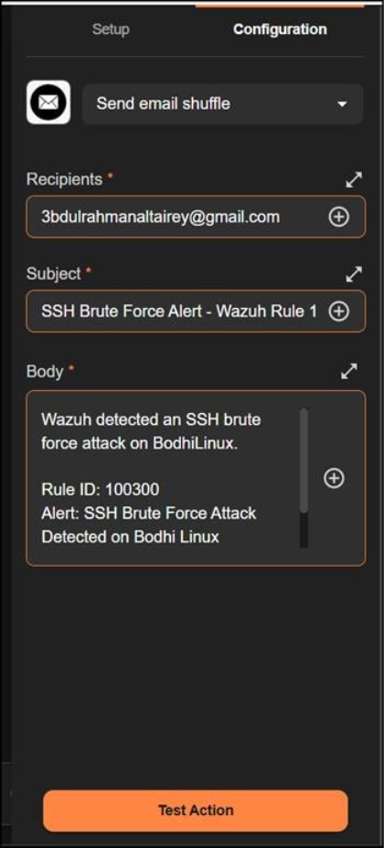
Figure 72: Shuffle Email action configuration showing the recipient, alert subject, and notification body for rule ID 100300.

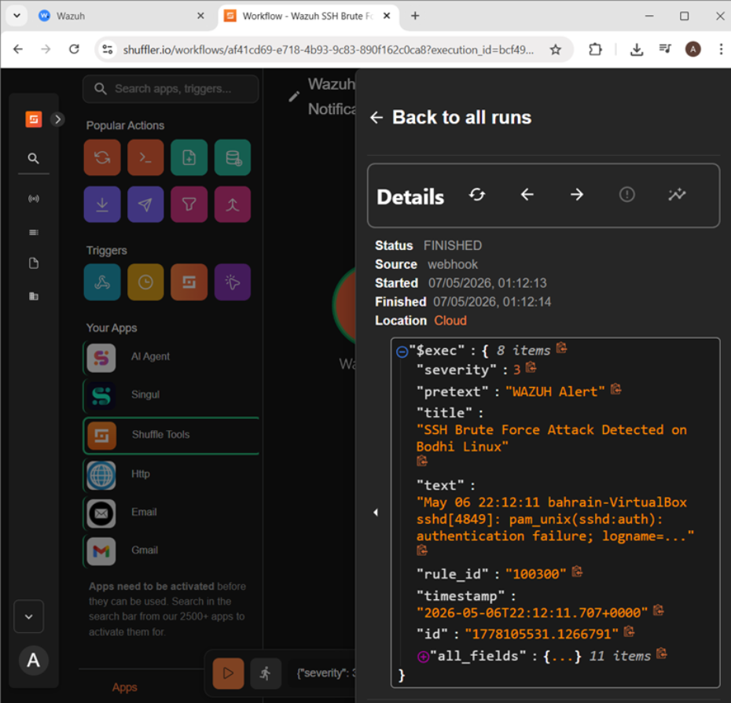Figure 73: Shuffle execution history showing a finished workflow run after the Wazuh alert triggered the playbook.

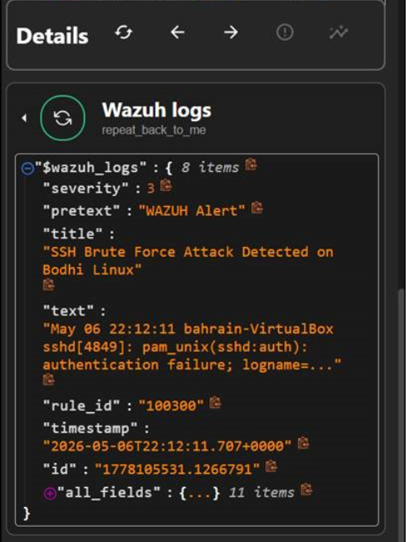
Figure 74: Shuffle Wazuh logs action showing the received SSH brute force alert details and rule ID 100300.

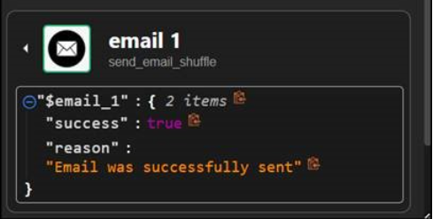
Figure 75: Shuffle Email action result showing that the automated SOC notification email was successfully sent.

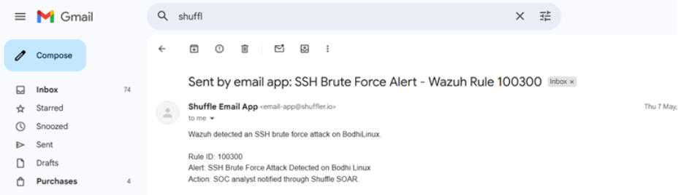Figure 76: Email inbox showing the automated SSH brute force alert received from Shuffle.

Task 3 Result

Result: Success. The SSH brute-force attack detection was made possible via Wazuh with the help of a custom rule having ID 100300. It triggered the playbook on Shuffle through the Wazuh webhook integration, the execution of which was successful, as well as the sending of an e-mail notification as required in this case study.
Task 3 Deliverables Checklist
• Wazuh rules configuration proof: accomplished with custom rule ID 100300.
• Threat detection proof: accomplished with Wazuh dashboard and alert document information.
• Shuffle integration proof: accomplished with webhook trigger and ossec.conf integration screen capture.
• Playbook design proof: accomplished with the whole Shuffle process flow and Email action configuration.
• Automated notification proof: accomplished with Shuffle Email output and email inbox screen capture.

Task 4: Threat Intelligence Integration into Wazuh
Objective
The objective of this task was to integrate the external threat intelligence sources that have been chosen in Part A into Wazuh. This integration helps enrich security monitoring by enabling Wazuh to ingest and utilize threat intelligence data and improves detection and analysis of security events all over the monitored infrastructure.
The three external threat intelligence sources that have been chosen and used are: VirusTotal, AbuseIPDB, AlienVaultOTX.

Source 1: VirusTotal
Integration Method: Built-in API Integration
VirusTotal was integrated into Wazuh, using its built-in nativa integration module, this module was combined with File Integrity Monitoring (FIM) capability. This integration working by monitoring a specific directory on the Windows Server endpoint. When FIM detects a new file or a file that has been modified, it automatically sends the cryptographic hashes over to VirusTotal API right away. The API then scans the hash against 70 antivirus engines and comes back with a threat verdict. If the file is to be identified as malicious, Wazuh generated a high-severity alert and triggers an automated active response which removes the threat from the endpoint.

Configuration
The first step was to configure FIM on the Windows Server agent. The Wazuh agent configuration file (ossec.conf) was edited to enable real-time monitoring of the Downloads directory. This ensures any file that has been placed or modified in that directory to be immediately detected and its hashes sent to VirusTotal.

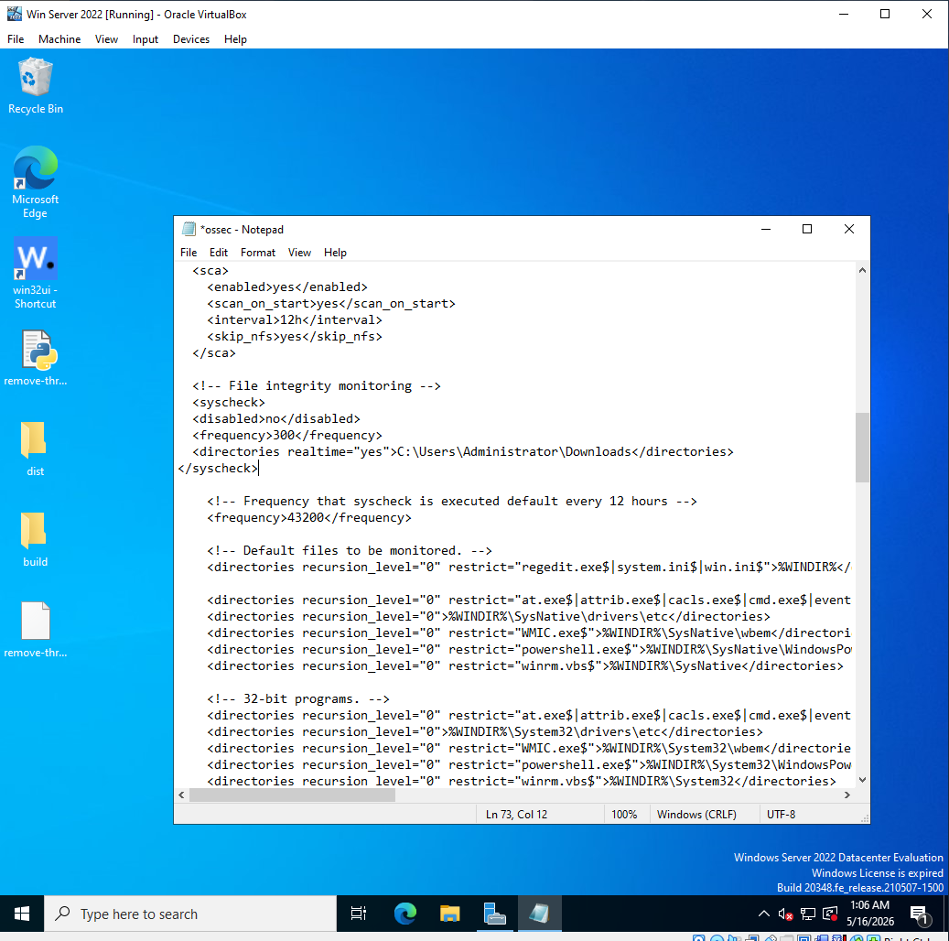Figure 77: ossec.conf file in Windows showing the syscheck block enabled with real-time monitoring for the Downloads directory.

Python was then installed on Windows in order to support the action of automated threat removal capability which will be used later, and PyInstaller was then used to convert an active response Python script into a Windows executable. The script that was converted reads the VirusTotal alert data that come from Wazuh, extracts malicious file path, and makes sure to securely delete the file immediately from the endpoint.
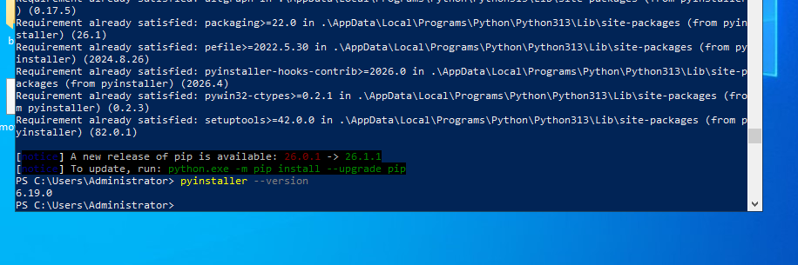Figure 78: PowerShell showing Python version installed and confirming PyInstaller version.
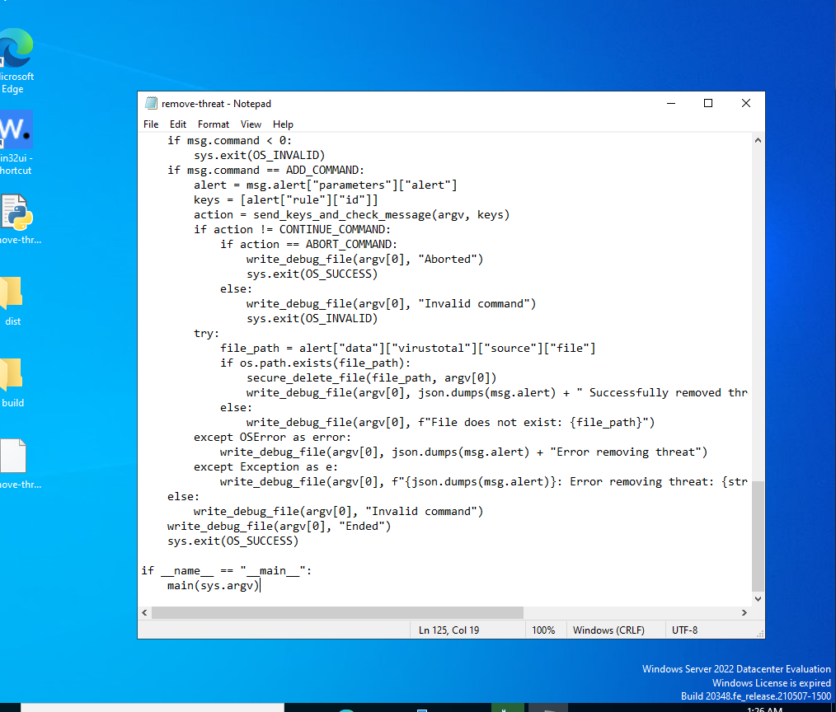Figure 79: The remove-threat.py active response script open in Notepad on Windows.

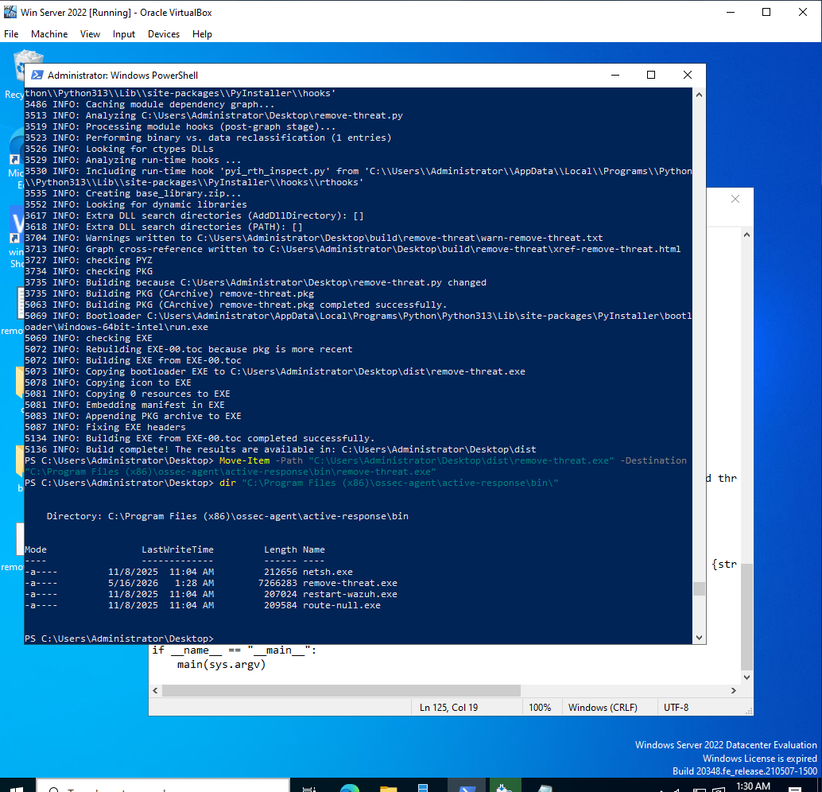Figure 80: Windows PowerShell showing remove-threat.exe placed in the active-response\bin\ directory.
On the Wazuh Manager, the VirusTotal integration block was added to the main configuration file. The integration uses the syscheck group trigger, which means it fires whenever any FIM rule has been activated. The VirusTotal API key was taken from the VirusTotal website and was then pasted and configured in the integration block. The active response blocks were also included into the script, in order to instruct Wazuh on executing the remove-threat.exe script whenever rule 87105 fires.

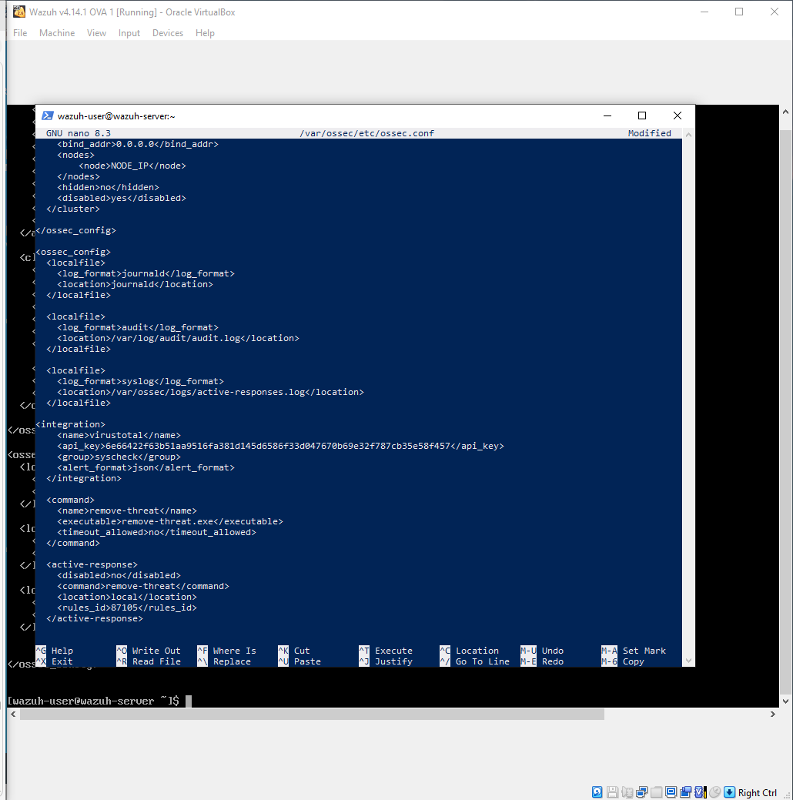Figure 81: Wazuh Manager ossec.conf showing the VirusTotal integration block and active response configuration.

In a new file called local_rules.xml, custom local rules were created and added to generate alerts that confirm when the active response script successfully removed the threat.

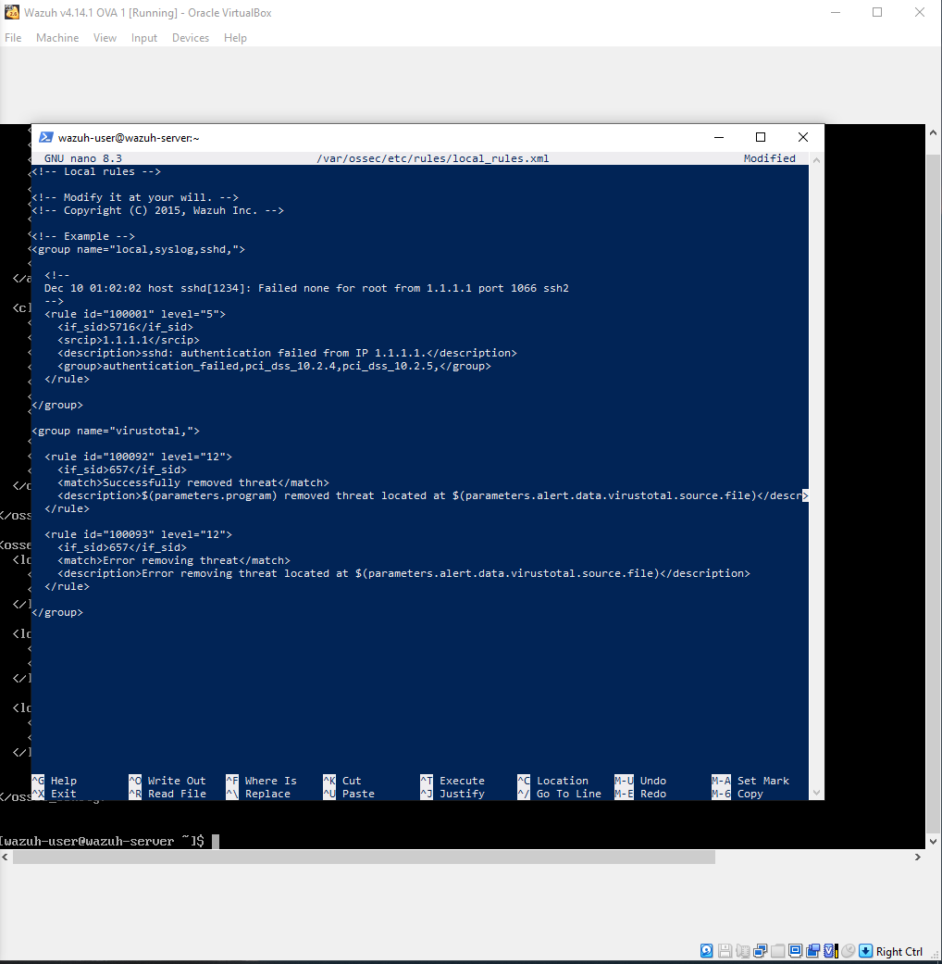Figure 82: The local_rules.xml file showing custom rules 100092 and 100093 configured to alert on active response execution results.

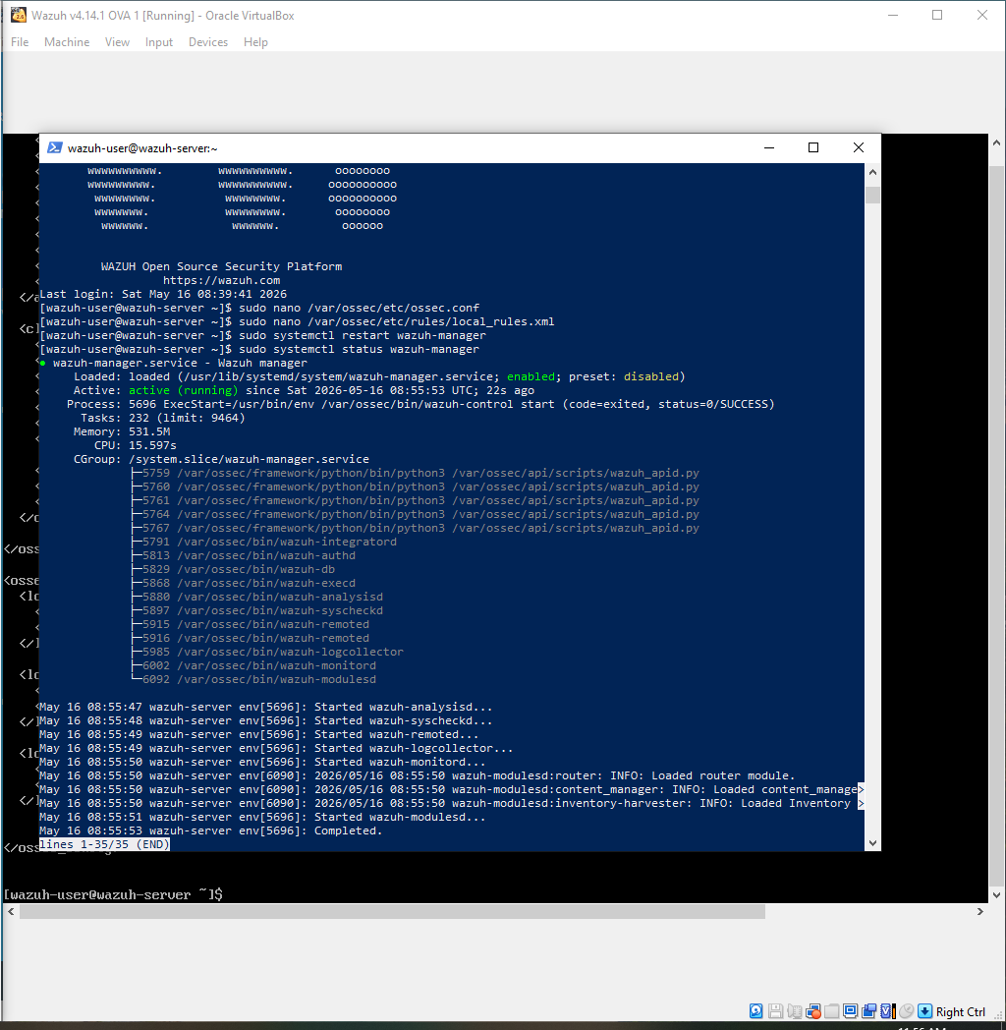Figure 83: Terminal showing the Wazuh Manager service active and running after configuration changes were applied.

Verification of Integration
To verify whether the integration works, Windows Defender real-time protection was temporarily disabled and the EICAR antivirus test file was downloaded to the monitored Downloads folder on Windows. The EICAR antivirus test file is a globally recognized harmless test file used to validate threat detection systems. Wazuh's FIM module detected the file, and sent its hash to VirusTotal, then received a positive malicious verdict, which made the active response script triggered and immediately and automatically delete the file. It generated a complete alert chain in the Wazuh Dashboard.

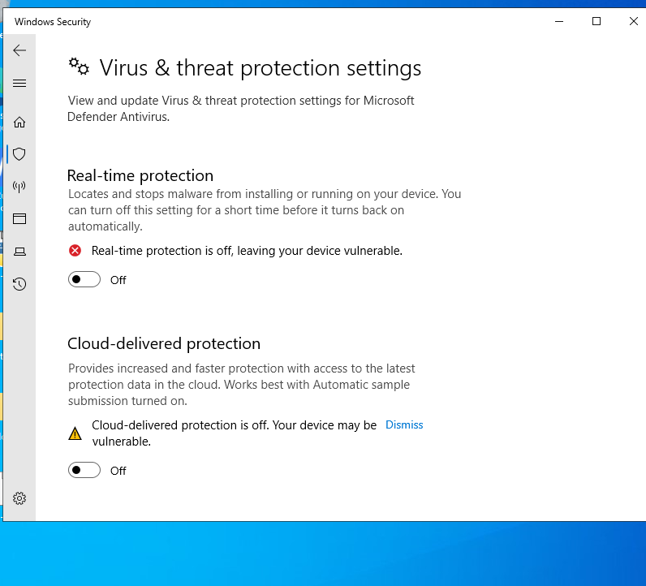Figure 84: Windows Security showing Real-time protection turned Off.

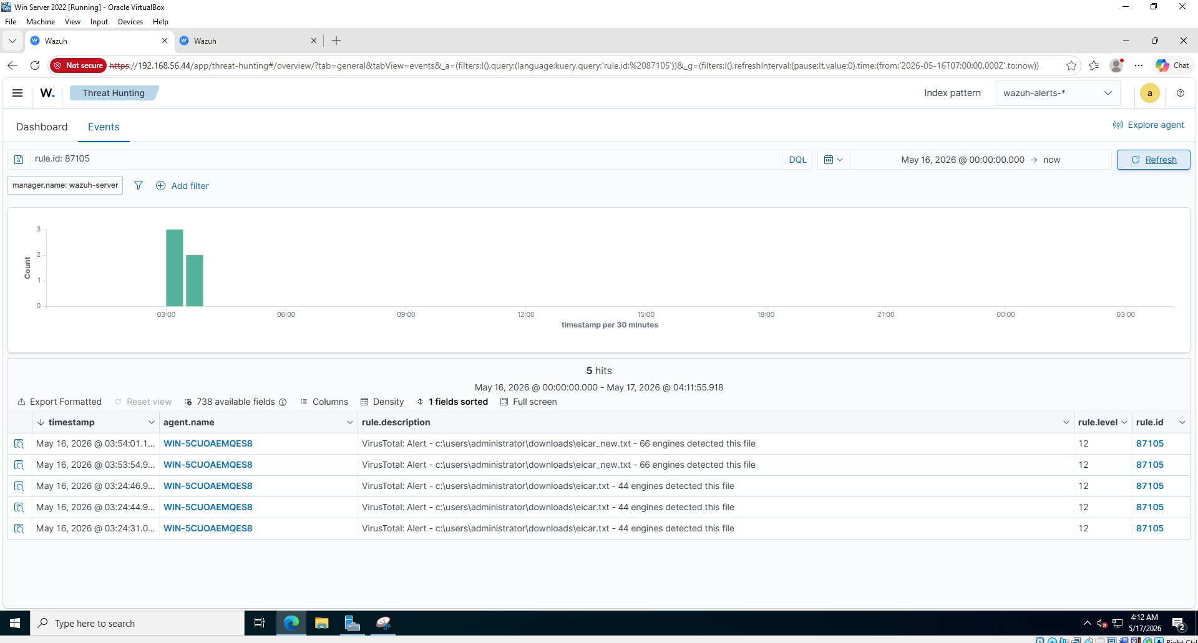Figure 85: Wazuh Threat Hunting Events filtered by rule.id 87105, showing 5 VirusTotal alerts from WIN-5CUOAEMQES8 — 66 engines detected eicar_new.txt and 44 engines detected eicar.txt.

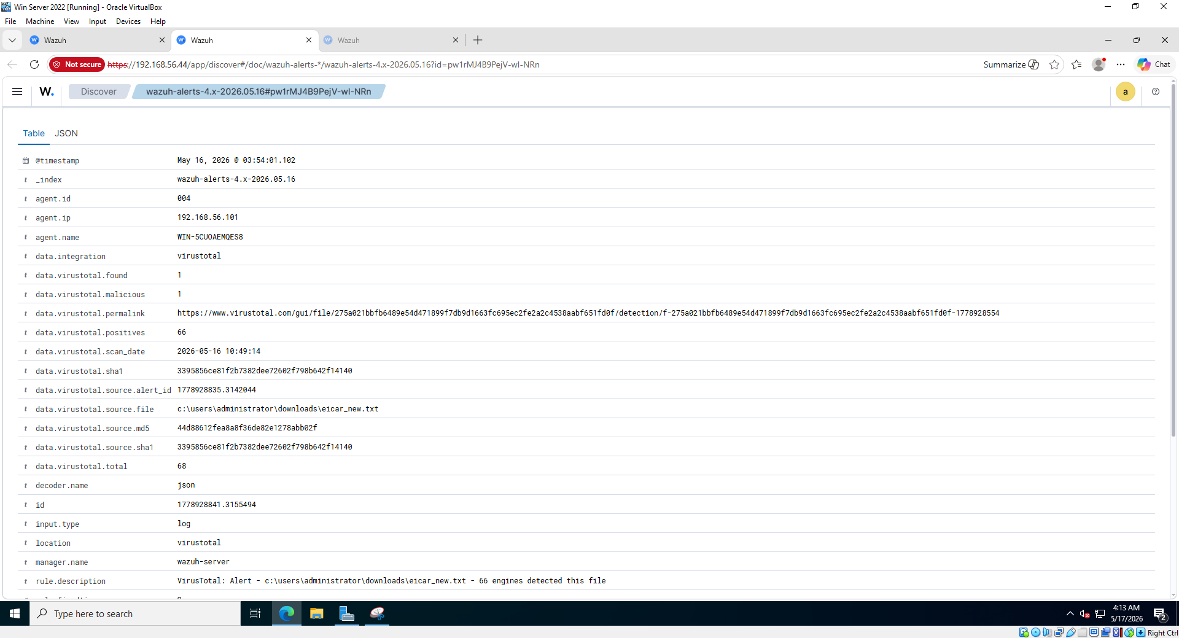

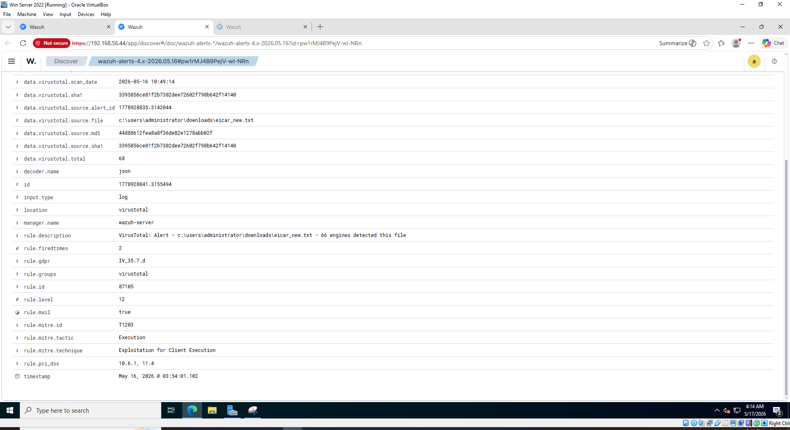Figures 86 & 87: Expanded rule 87105 alert showing VirusTotal enrichment fields; virustotal.found = 1, virustotal.malicious = 1, virustotal.positives = 66, virustotal.total = 68, permalink to scan report, and source file path eicar_new.txt.

Source 2: AbuseIPDB
Integration Method: API Integration via Custom Python Script
AbuseIPDB was integrated into Wazuh using a custom Python integration script. In Wazuh, custom integrations are supported by allowed Python scripts to be places in the integrations directory and configured to trigger on specific rule IDs. When a brute-force or authentication failure alert fires, Wazuh calls the Python script with the alert data, and the script then quieries the AbuseIPDB API to retrieve threat intelligence about the attacking IP address. The API response comes back with details, including: IP's abuse confidence score, the total number of times it has been reported by the global security community, also the country of origin, and the ISP information.
Configuration
As the Python requests library is required, it was verified to be installed on Wazuh. It is required by the integrations script to make HTTP requests to the AbuseIPDB API.

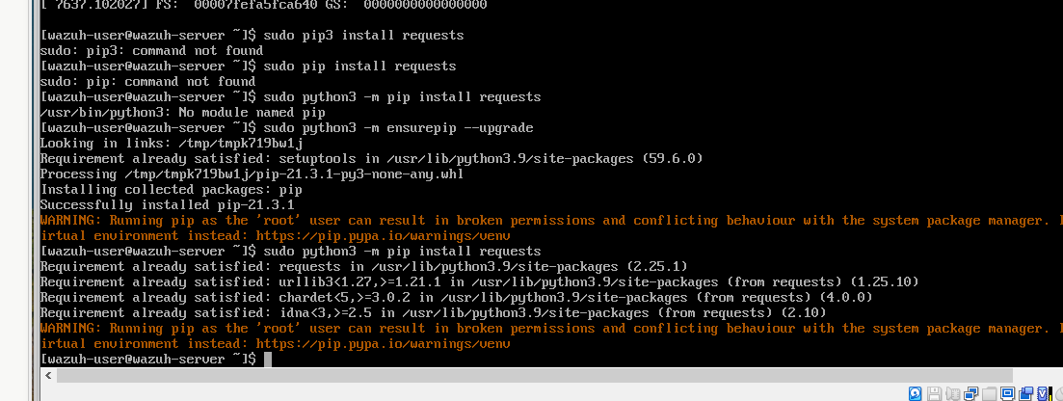Figure 88: Terminal showing the Python requests library successfully installed on Wazuh.

The custom integration script was created at /var/ossec/integrations/custom-abuseipdb. This script reads the Wazuh alert JSON file, it extracts the source IP address, and queries the AbuseIPDB API to get its threat intelligence profile.

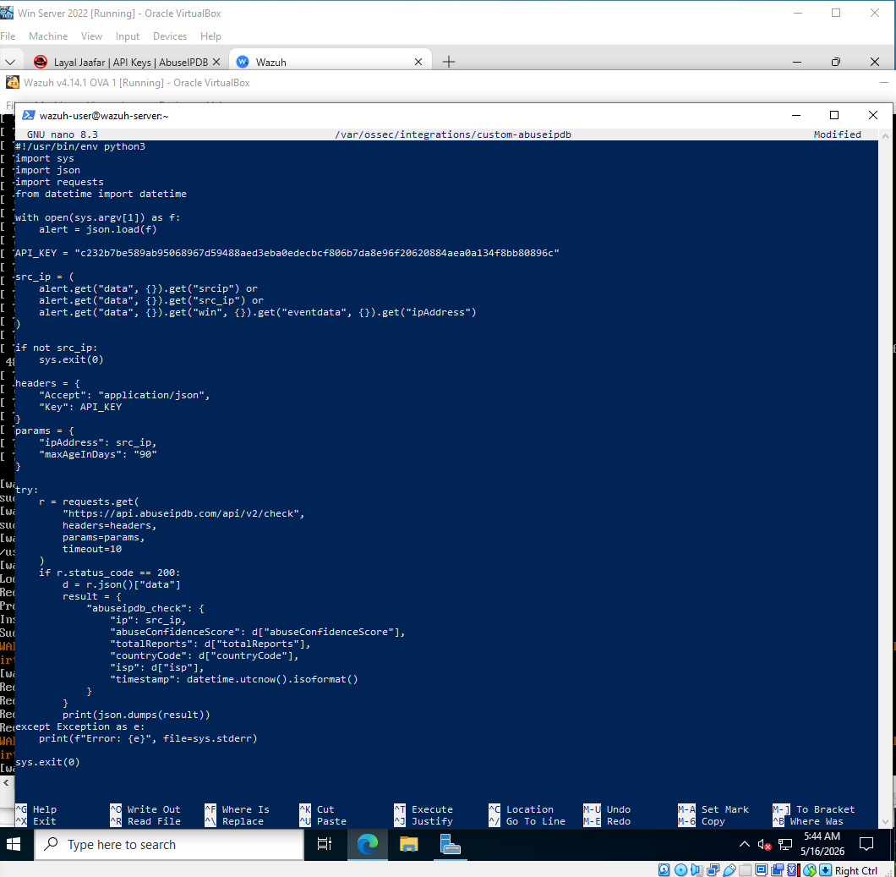Figure 89: The custom-abuseipdb integration script in nano with API key configured shown in Wazuh.

Following Wazuh’s security requirements for integration scripts, file permissions were applied to the script to ensure that it couldn’t only be executed/edited by the root and wazuh users.
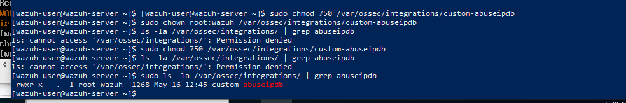Figure 90: Terminal output of ls -la showing custom-abuseipdb with permissions -rwxr-x--- and owner root:wazuh.

The AbuseIPDB integration block was added to the Wazuh Manager configuration file. The integration was configured to trigger on SSH authentication failure rules, specifically rule IDs 5710, 5711, 5712, 5763, and 5760.
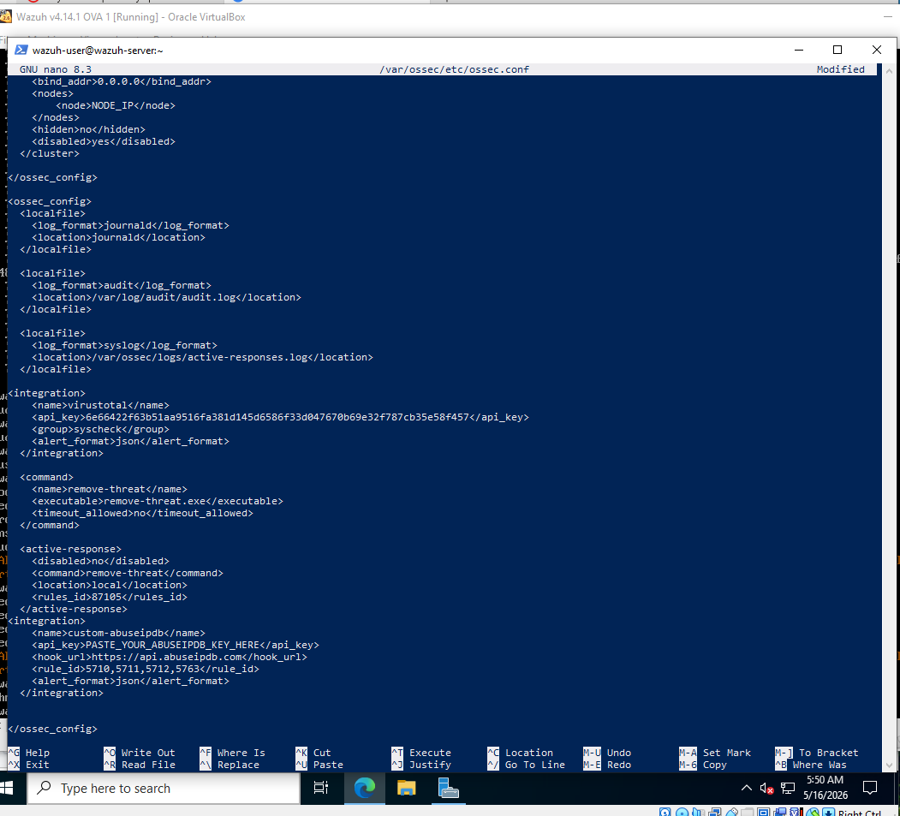Figure 91: Wazuh ossec.conf file showing the AbuseIPDB integration block with API key, hook URL, and rule IDs.
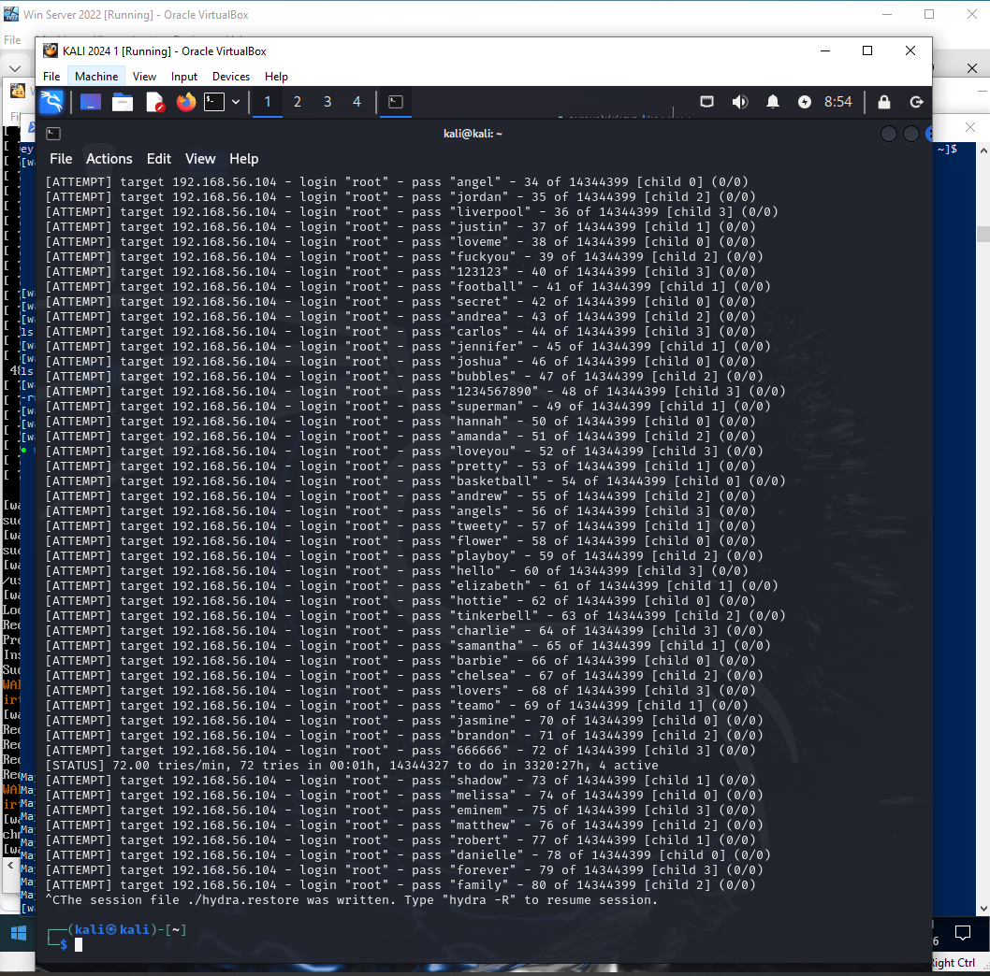Figure 92: Kali Linux terminal showing Hydra SSH brute-force attack running against Bodhi Linux at 192.168.56.104, making repeated login attempts.

Attack Simulation and Verification
An SSH brute-force attack was run from Kali Linux against Bodhi Linux using Hydra, in order of generating authentication failure events.

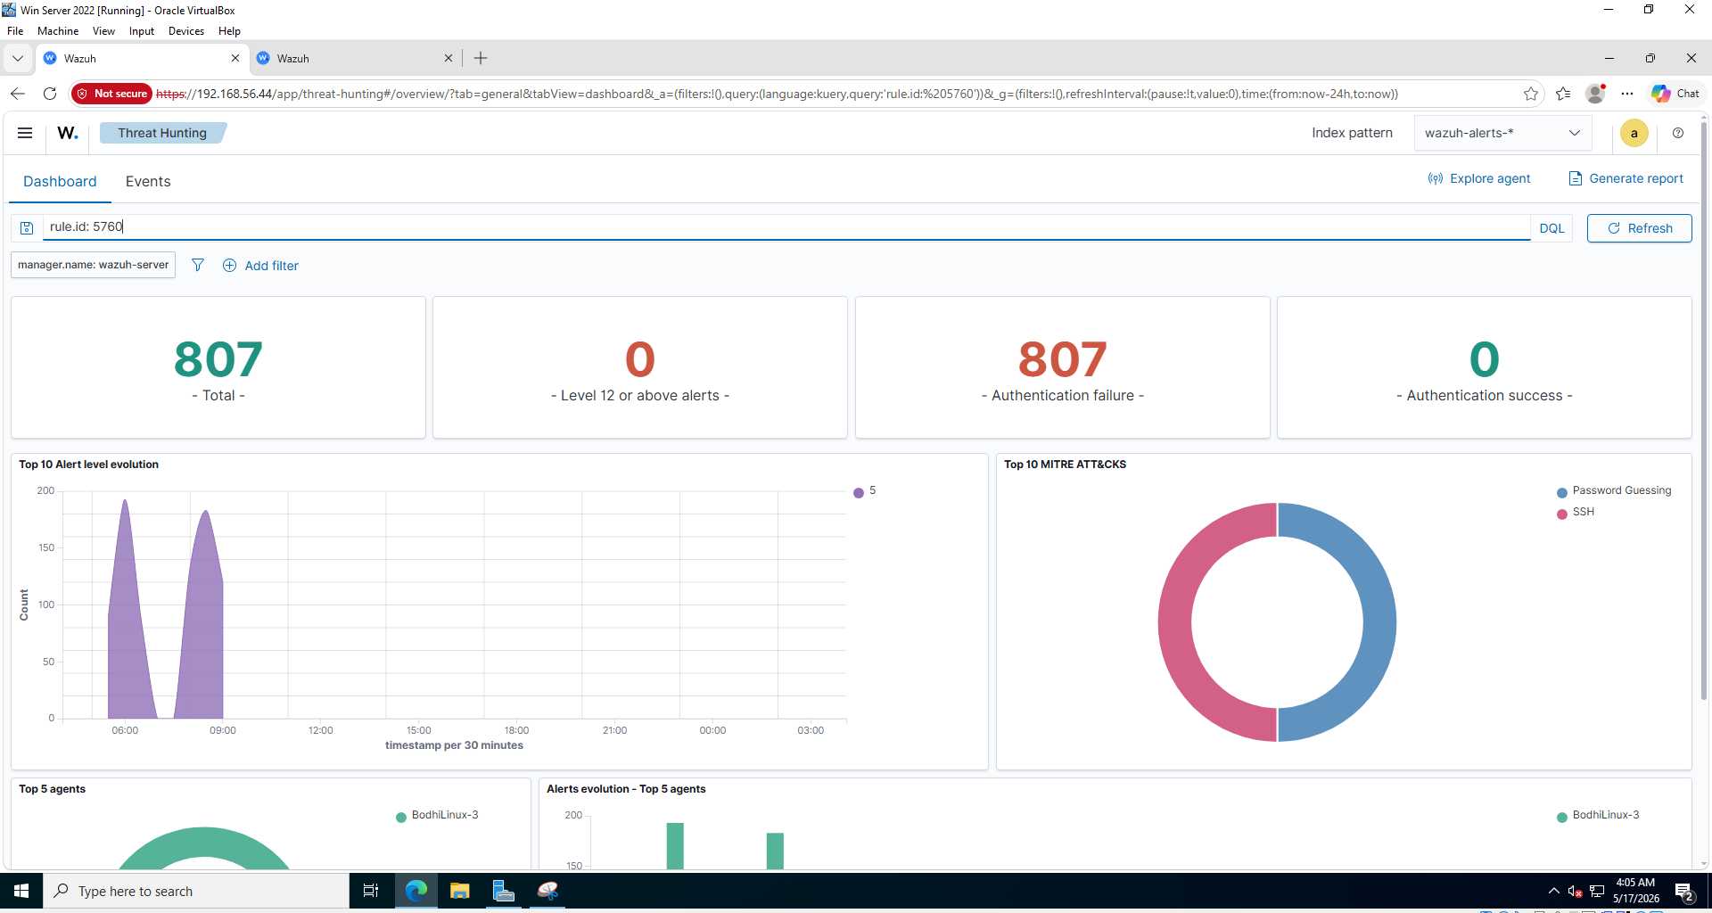Figure 93: Wazuh Dashboard (Threat Hunting) filtered by rule.id 5760, showing 807 SSH authentication failure alerts from BodhiLinux-3 with MITRE ATT&CK mapping to Password Guessing.

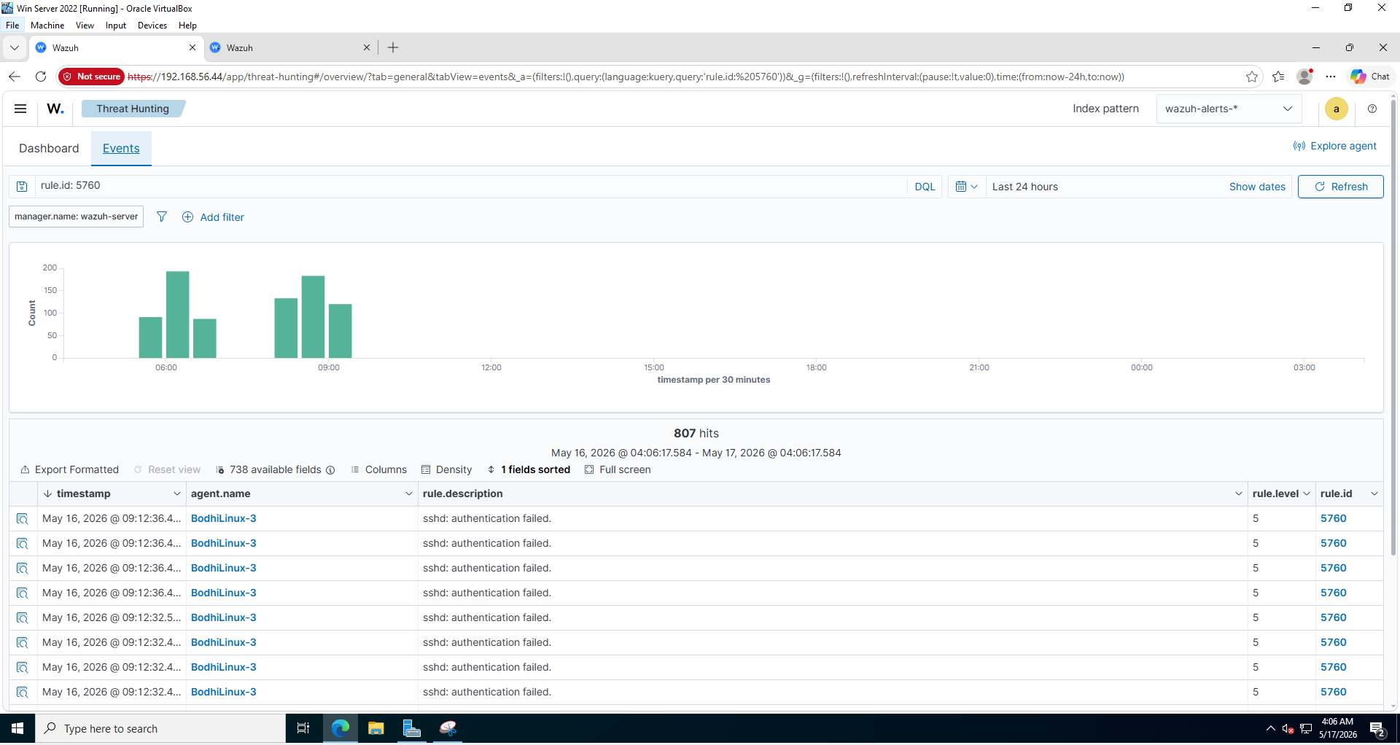Figure 94: Wazuh Threat Hunting Events filtered by rule.id 5760, showing 807 hits from BodhiLinux-3 with rule description "sshd: authentication failed."

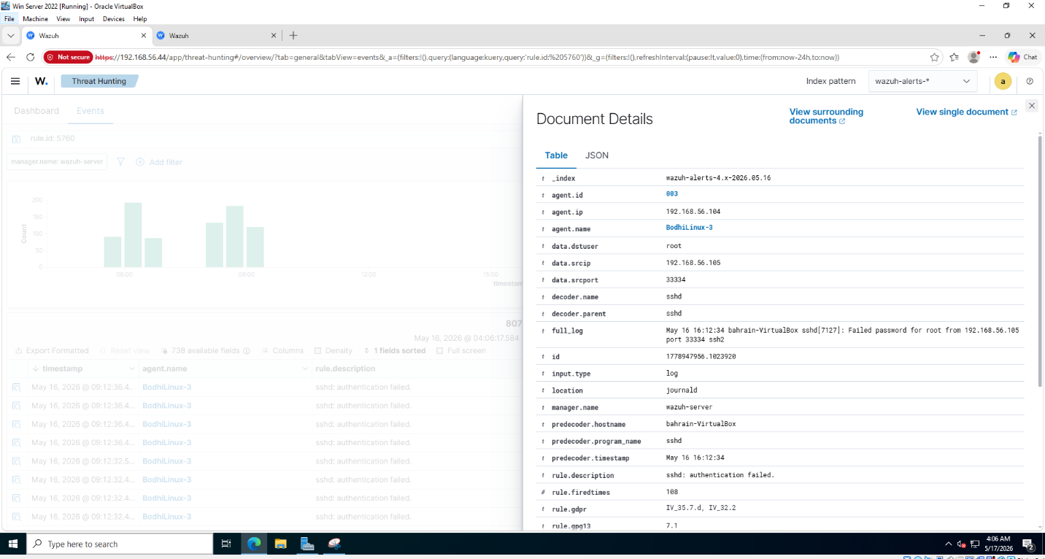Figure 95: Expanded rule 5760 alert details about Bodhi Linux and the brute-force attack.

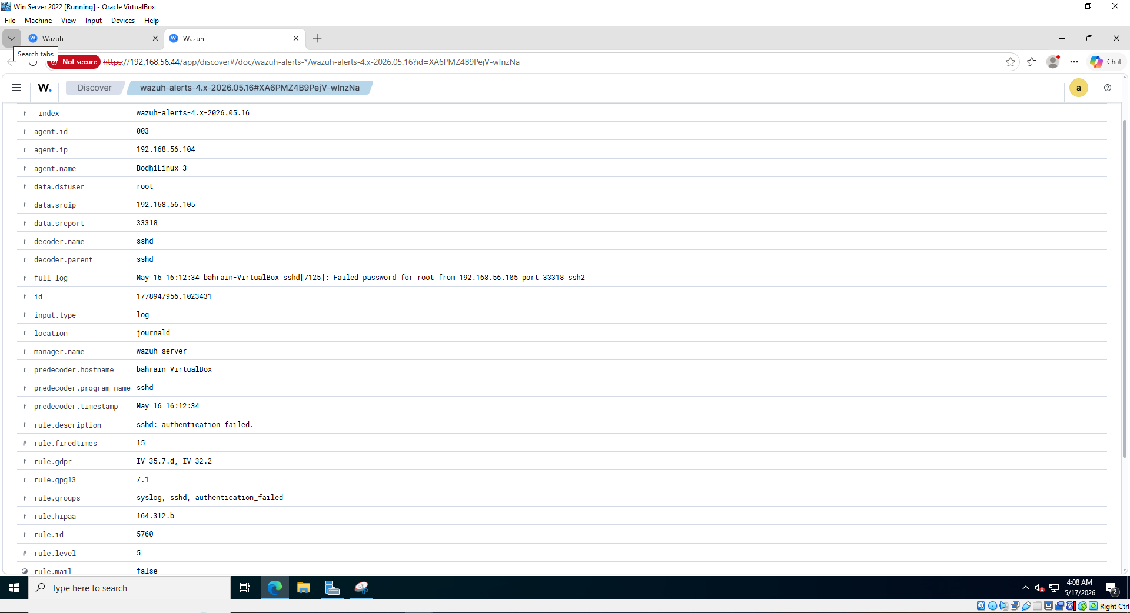Figure 96: Full Table view of rule 5760 alert showing different details, such as: rule groups syslog, sshd, and compliance mappings, etc.

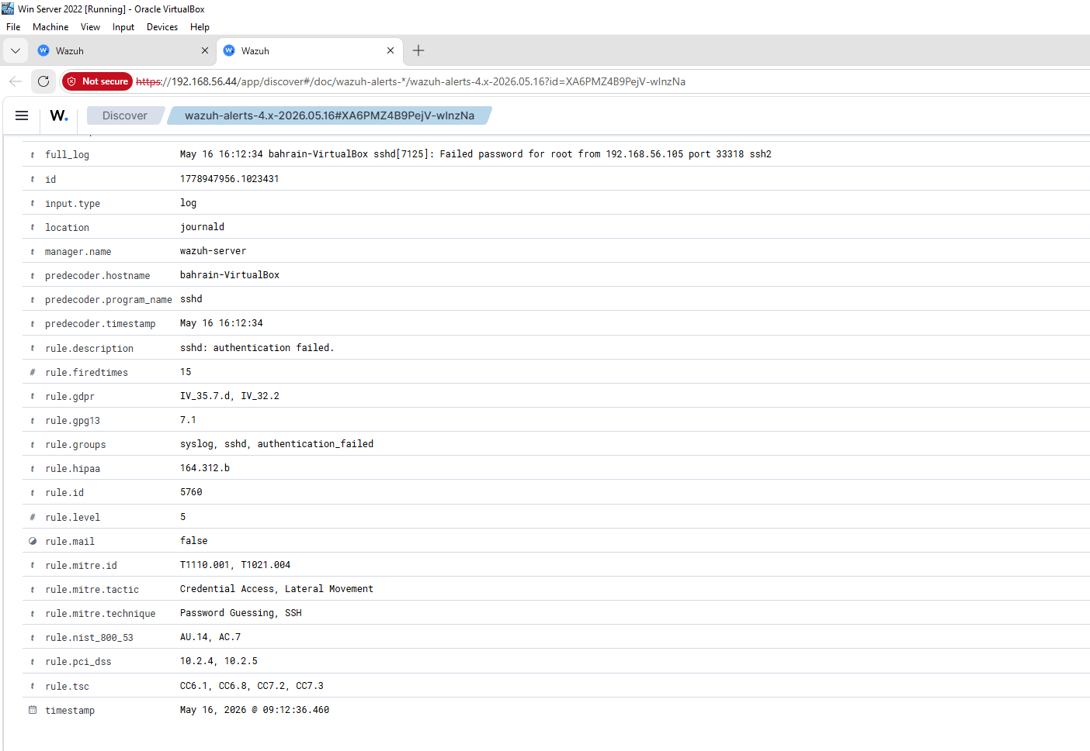Figure 97: Rule 5760 alert Table view showing details such as MITRE ATT&CK mapping, rule NIST – 800 – 53, etc.

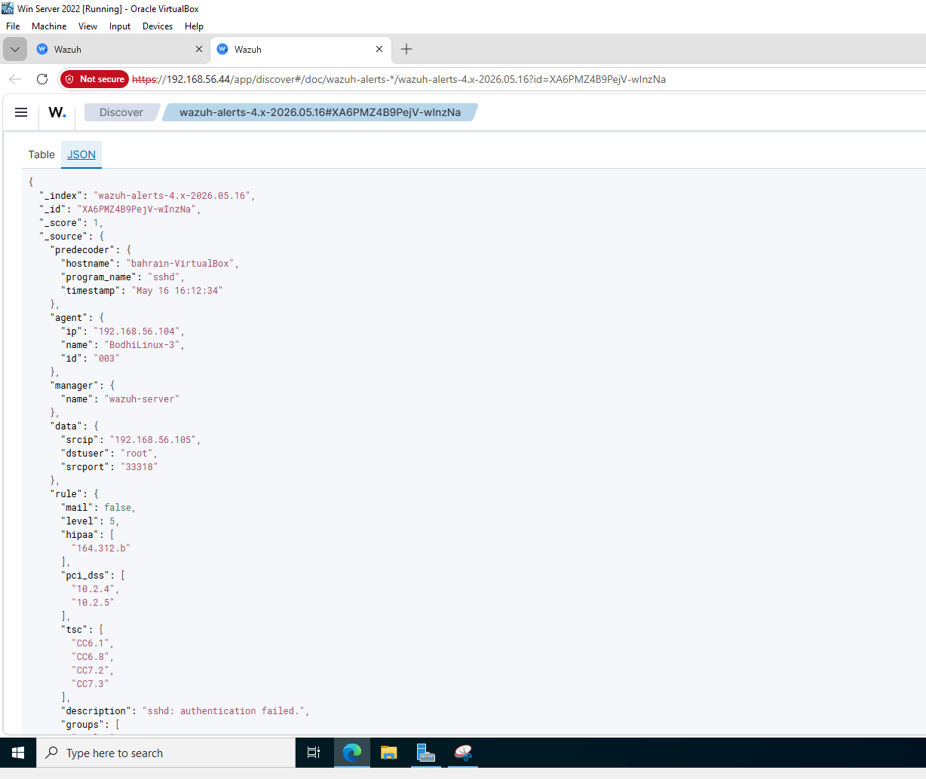Figure 98: Raw JSON view of rule 5760 alert showing the exact data structure passed to the AbuseIPDB integration script.

The AbuseIPDB integration script was confirmed to being fully functional by running it directly as the Wazuh user, using a test alert file that included the attacking IP address. The script then successfully connected to the AbuseIPDB API and returned with structured threat intelligence data.
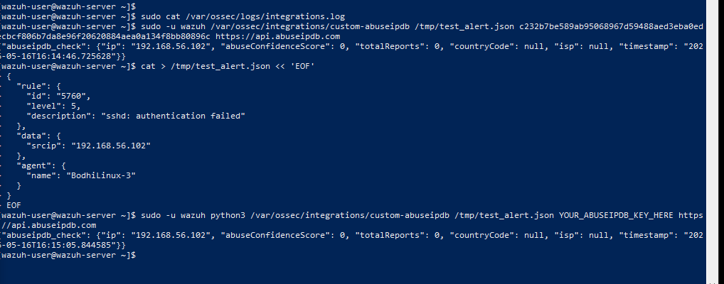Figure 99: Terminal showing the AbuseIPDB integration script executed as the Wazuh user, returning a JSON response for the attacking IP address 192.168.56.102.

Source 3: AlienVault OTX
Integration Method: Feed Ingestion into Wazuh CDB List
AlienVault OTX was integrated into Wazuh using feed ingestion into a Constant Database list (CDB). This approach pulls the most known/ most malicious IPv4 indicators from AlienVault OTX threat intelligence feeds and stores them locally in a Wazuh CDB lookup list. A custom detection rule was configured to compare the source IP address against this list in real time while alerts are coming in. Once a match is found, Wazuh generates a level 12 high-severity alert immediately.
Configuration
The AlienVault OTX Python SDK was successfully installed on Wazuh to allow the system to connect to and retrieve threat intelligence data from the AlienVault OTX platform.

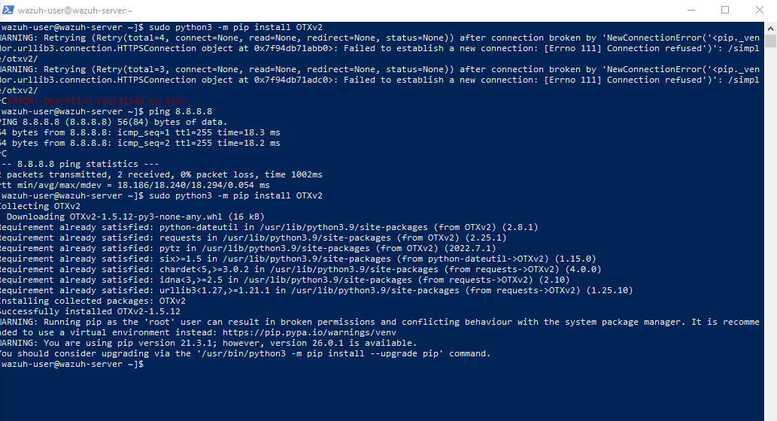Figure 100: Terminal showing pip install OTXv2 completing successfully on the Wazuh Manager.

A feed pull script was created to connect to the OTX API, and then retrieve the malicious IPv4 indicators. The script was configured with the OTX API key that was taken from the AlienVault OTX platform settings page.
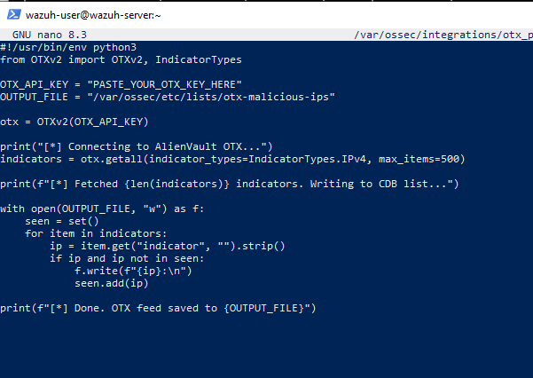Figure 101: The otx_pull.py script open in nano showing the script content on Wazuh.

The OTX threat intelligence feed was ingested and stored as a Wazuh CDB list at /var/ossec/etc/lists/otx-malicious-ips. This list contains the most known malicious IPv4 indicators that have been sourced from the AlientVault OTX public threat feeds.

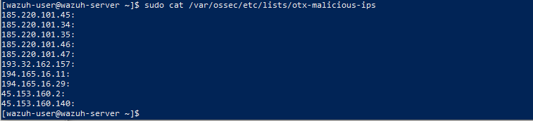Figure 102: Terminal showing the otx-malicious-ips CDB list containing malicious IP addresses.

The OTX CBD list was added in the Wazuh Manager configuration file, specifically under the ruleset section, making it available for use in detection rules.

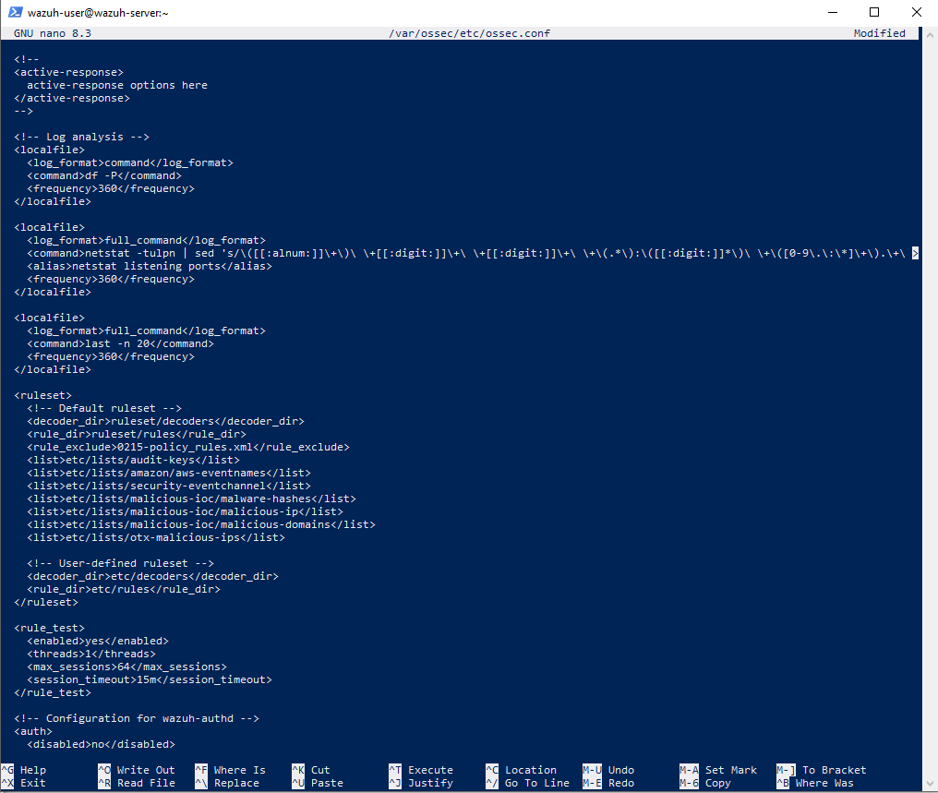Figure 103: Wazuh Manager ossec.conf showing the ruleset block with etc/lists/otx-malicious-ips registered as a CDB list.

Custom detection rule was created in /var/ossec/etc/rules/otx_rules.xml. This rule uses Wazuh's CDB list lookup mechanism to match the source IP of the incoming alerts against the OTX malicious IP address list, and it triggers at level 12 once a match is found.

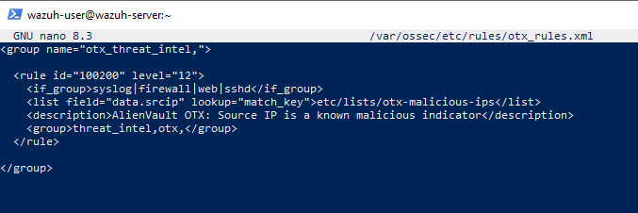Figure 104: otx_rules.xml showing rule 100200 with CDB list lookup, level 12 severity, and group tags.

The rule and CDB list were verified to be loaded correctly in the Wazuh Dashboard.
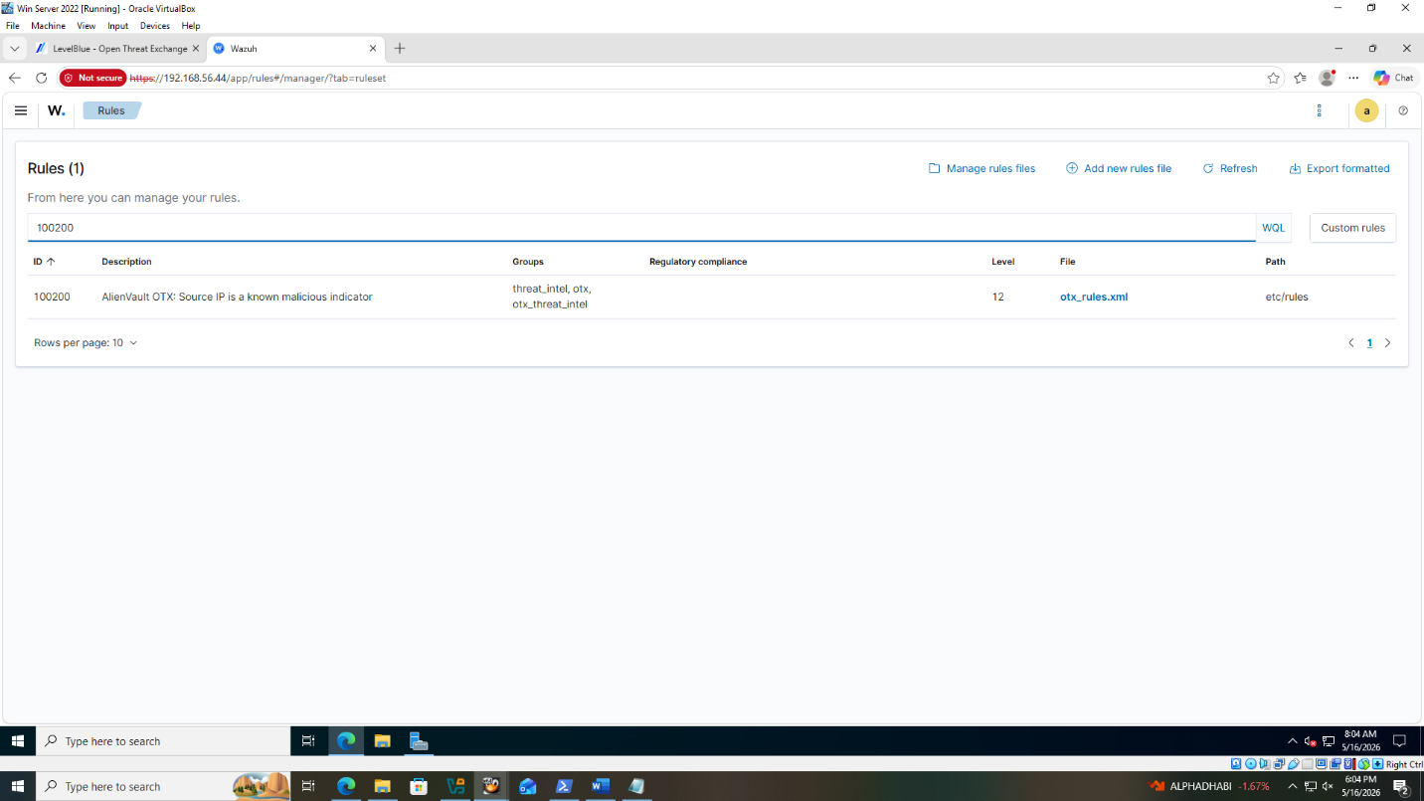Figure 105: Wazuh Dashboard Management Rules page showing rule 100200 successfully loaded.

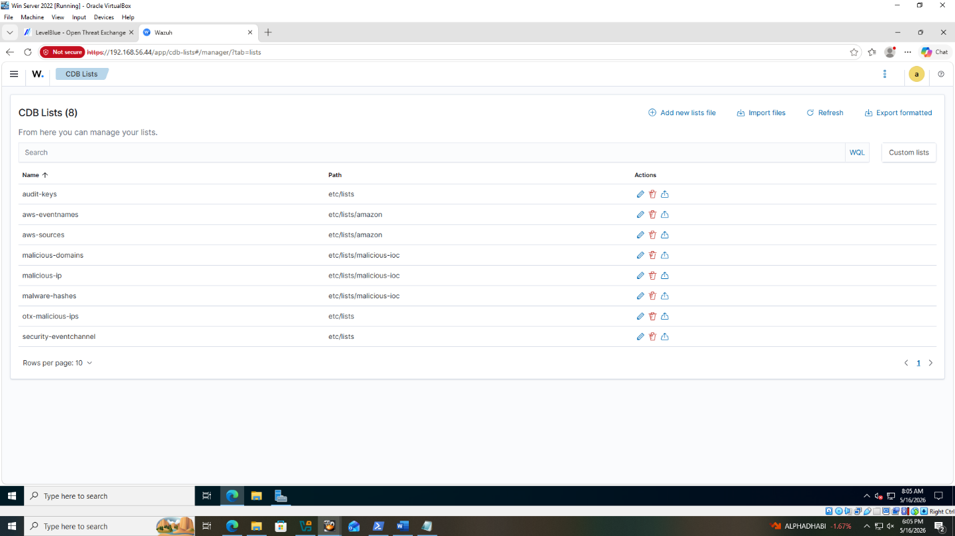Figure 106: Wazuh Dashboard Management CDB Lists page showing otx-malicious-ips successfully loaded and available for rule matching.

Attack Simulation and Verification
The rule was first tested using Wazuh's built-in log testing tool to confirm it fires correctly before live testing.
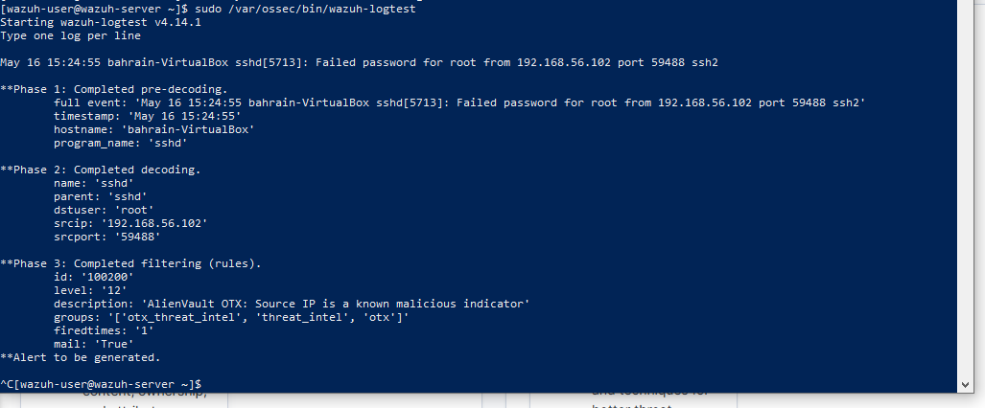
Figure 107: Wazuh-logtest output showing rule 100200 firing at level 12

To generate a live match in production, Kali's IP address was added to the malicious OTX IP list to simulate a case where the attacking machine is a recognized OTX threat indicator. An SSH brute-force attack was launched against Bodhi Linux.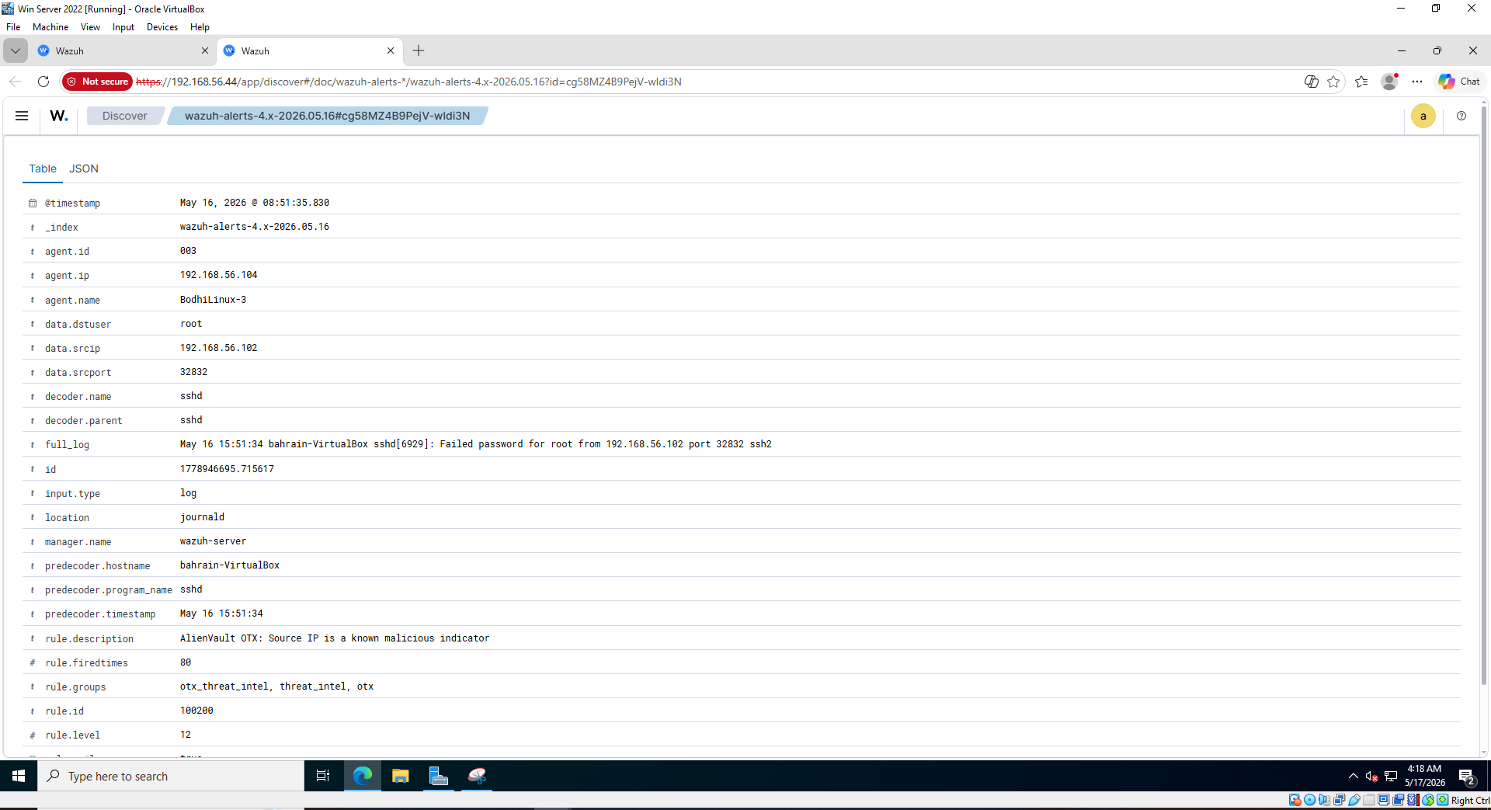Figure 108: Full Table view of rule 100200 alert showing details.

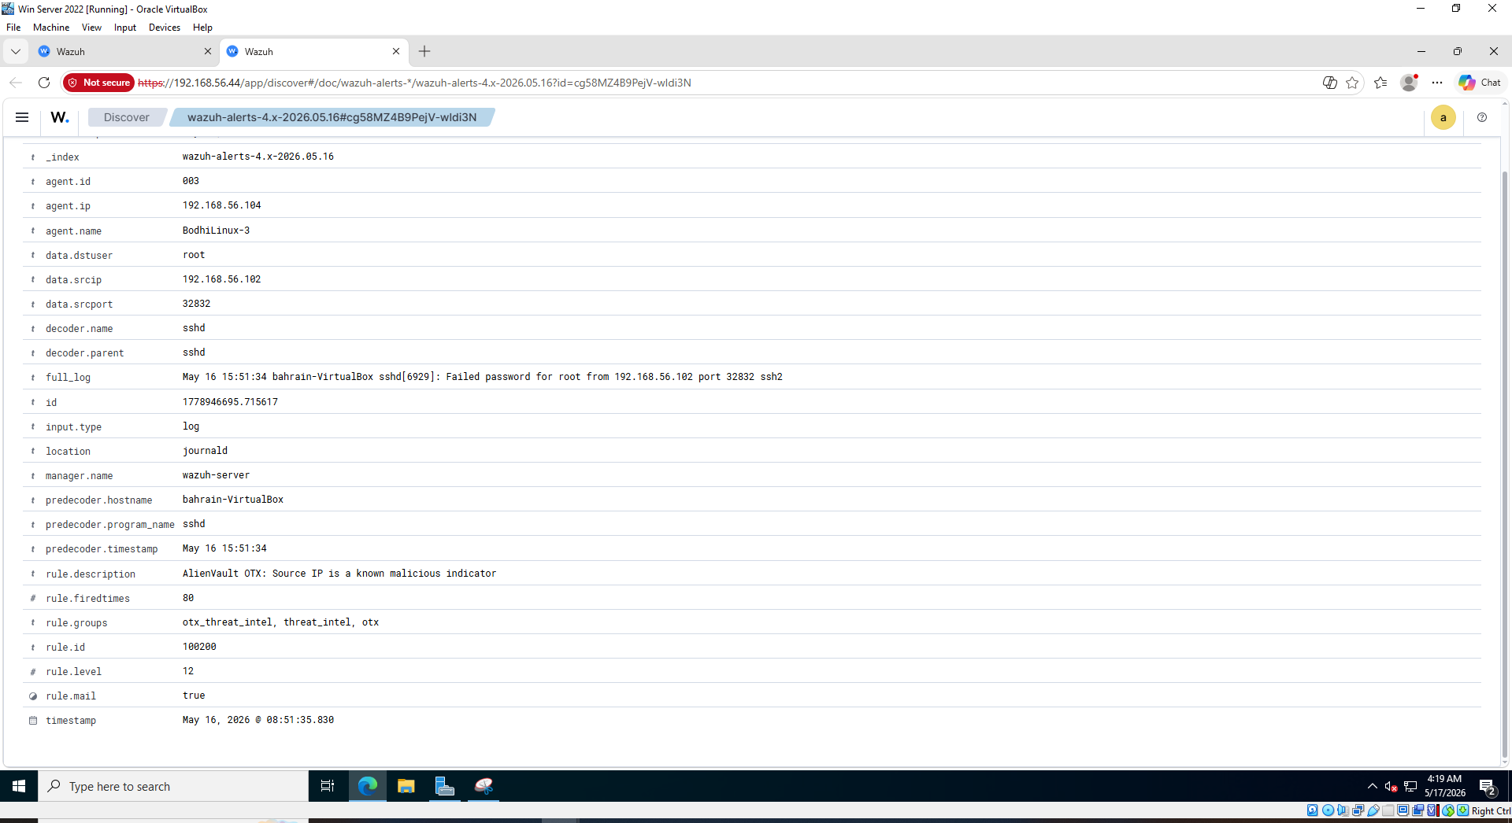Figure 109: Bottom section of the expanded rule 100200.

Conclusion

This project successfully delivered a fully functional SOC environment, that was built around Wazuh as the main SIEM platform. In Part A, a comprehensive SOC architecture was designed, integrating eight components with a defined workflow and roles, alongside a structured analysis of three threat intelligent sources : VirusTotal, AbuseIPDB, AlienVault OTX.
In Part B, Wazuh was deployed and integrated with Windows Server 2022, Bodhi Linux, and Snort IDS. Attack simulations were also run from Kali Linux across three XDR scenarios, a Shuffle SOAR playbook for automated notification, and all three threat intelligence sources were integrated directly into Wazuh.
Overall, this project demonstrated that an effective, layered SOC environment can be built together using open-source tools, where threat intelligence enrichment and SOAR automation meaningfully cut down the time, and the effort required to detect and respond to cyber threats.

References

VirusTotal. (n.d.). Home upload. https://www.virustotal.com/gui/home/upload
VirusTotal. (n.d.). Intelligence overview. https://www.virustotal.com/gui/intelligence-overview
VirusTotal. (n.d.). IP address search modifiers. https://docs.virustotal.com/docs/ip-address-search-modifiers
VirusTotal. (n.d.). URL search modifiers. https://docs.virustotal.com/docs/url-search-modifiers
AbuseIPDB. (n.d.). AbuseIPDB – IP address abuse reports. https://www.abuseipdb.com/
Drupal. (n.d.). AbuseIPDB (Drupal project). https://www.drupal.org/project/abuseipdb
SecureNow. (n.d.). Enriching threat intelligence with AbuseIPDB: Beyond basic IP reputation. SecureNow. https://www.securenow.ai/blog/enriching-threat-intelligence-with-abuseipdb-threat-intelligence
AbuseIPDB. (n.d.). AbuseIPDB API documentation: Introduction. https://docs.abuseipdb.com/#introduction

ThreatConnect. (n.d.). Alienvault OTX – Marketplace and integrations. https://threatconnect.com/marketplace/alienvault-otx/

ClearNetwork. (2025, August 13). What is AlienVault? Understanding the platform and its advantages. ClearNetwork. https://www.clearnetwork.com/what-is-alienvault-platform-advantages/
LevelBlue. (2024). Open Threat Exchange (OTX) user guide (PDF). https://cybersecurity.att.com/documentation/resources/pdf/otx-user-guide.pdf
Wazuh. (n.d.). Threat hunting (Use case). https://wazuh.com/resources/use-cases/threat-hunting/
Juaromu. (n.d.). wazuh-domain-stats-alienvault (GitHub repository). GitHub. https://github.com/juaromu/wazuh-domain-stats-alienvault

InfosecWriteups. (2023, March 10). Wazuh — the free SIEM that fights like a paid one. Medium. https://infosecwriteups.com/wazuh-the-free-siem-that-fights-like-a-paid-one-9554ed1272da
Fortress, S. (2024, April 5). DNS traffic insights using Domain Stats and Wazuh EDR. Medium. https://socfortress.medium.com/dns-traffic-insights-using-domain-stats-and-wazuh-edr-699b04427932
Snort. (2024). Snort user manual. https://www.snort.org/documents

Group Reflection & Peer Review Table

Student ID | Name | % of Workload Assigned | % of Work Completed | Project Tasks Contributed | Peer Review Remarks
 | Abdulelah  slais | 25% | 100% | XDR detection, response configuration, validation, screenshots, report writing, Formatting & References. | Excellent with time management and completed task within the given timeframe.
 | Abdulelah  slais | 25% | 100% | Shuffle SOAR automation, Wazuh alert integration, email notification, screenshots, report writing, Formatting & References. | Excellent attention to detail and communication skills.
 | Student 2 | 25% | 100% | SOC Architecture Design, Wazuh Setup & Integration, Event Generation, Report Writing, Formatting & References. | Completed tasks within a given timeframe and completed all of them independently.
 | Student 3 | 25% | 100% | Threat Intelligence Analysis, Threat Intelligence Integration into Wazuh, Report Writing, Formatting & References. | Completed all tasks on time and strong contribution in report writing.
Total |  | 100% | 100%

